COEN 241: Homework 1

Nisarg Bhalavat W1649219

# Hardware Setup

For conducting various experiments on OS Virtualization, the configurations can be listed as follows:

|  |  |  |
| --- | --- | --- |
| 1 | System | HP ZBook 14 G2 |
| 2 | Processor | Intel® Core™ i7-5600U CPU @ 2.60GHz |
| 3 | Memory | 8.0GiB RAM |
| 4 | Disk Capacity | 1.0 TB |
| 5 | Operating System | Ubuntu 22.04.01 LTS |

# Installing QEMU

QEMU is a free and open-source type 2 hypervisor. It emulates the machine’s process and provides a set of different hardware and device models to be enabled for running variety of guest operating systems.

## Download Ubuntu Guest Virtual Machine

As we are currently testing on 64-bit Linux operating system, we will be using the x86_64 architecture image for AMD.

[Ubuntu Server 20.04 for AMD](https://releases.ubuntu.com/focal/ubuntu-20.04.5-live-server-amd64.iso)

Once the iso image is downloaded, we need to place it in the appropriate directory.

## Install QEMU

From the terminal, we need to run the following commands as a root user.

$ sudo apt-get update

$ sudo apt-get upgrade

$ sudo apt-get install qemu qemu-utils qemu-system-x86

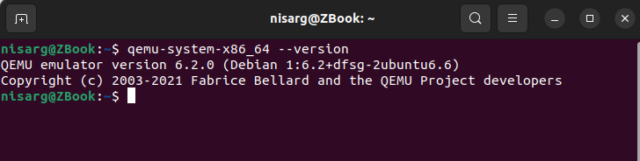

## Create QEMU Image

As we have installed QEMU, now we need to create an image to install guest VM with 10GB of storage using QCOW2 format (QEMU Copy-on-Write).

$ sudo qemu-img create ubuntu.img 10G -f qcow2

## Installing VM on QEMU image

Now, we need to install the Ubuntu guest OS on the newly created QEMU image. We run the following command:

$ sudo qemu-system-x86_64 \

-accel kvm -cpu host -m 2G -smp 2 \

-boot d -cdrom ./Downloads/ubuntu-20.04.5-live-server-amd64.iso \

-hda ubuntu.img \

-netdev user,id=net0,hostfwd=tcp::5555-:22 \

-device e1000,netdev=net0 \

-device ahci,id=ahci \

-device usb-ehci -device usb-kbd -device usb-mouse -usb

If we want to spin-up the same VM again, we can change the boot flag from ‘d’ to ‘c’ to change the booting order of the OS.

$ sudo qemu-system-x86_64 \

-accel kvm -cpu host -m 2G -smp 2 \

-boot c -cdrom ./Downloads/ubuntu-20.04.5-live-server-amd64.iso \

-hda ubuntu.img \

-netdev user,id=net0,hostfwd=tcp::5555-:22 \

-device e1000,netdev=net0 \

-device ahci,id=ahci \

-device usb-ehci -device usb-kbd -device usb-mouse –usb

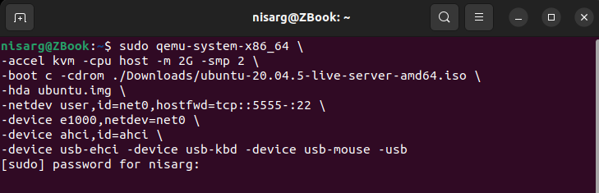

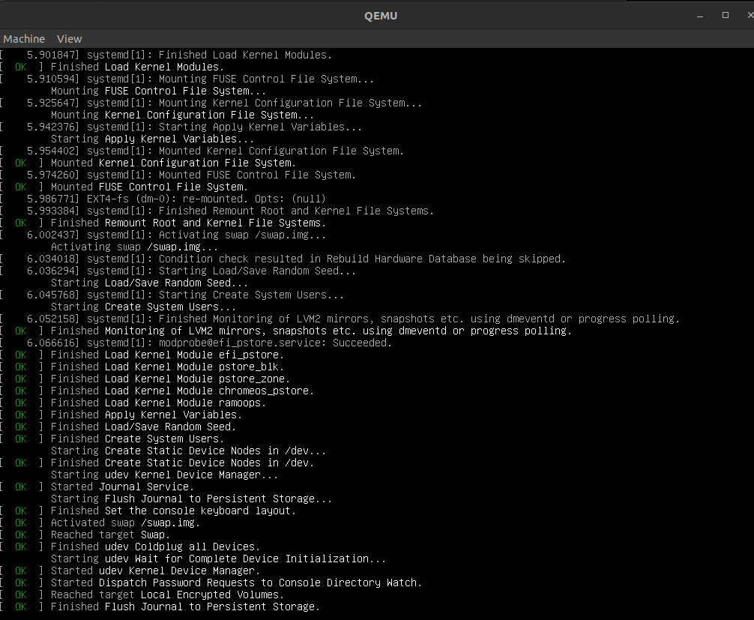

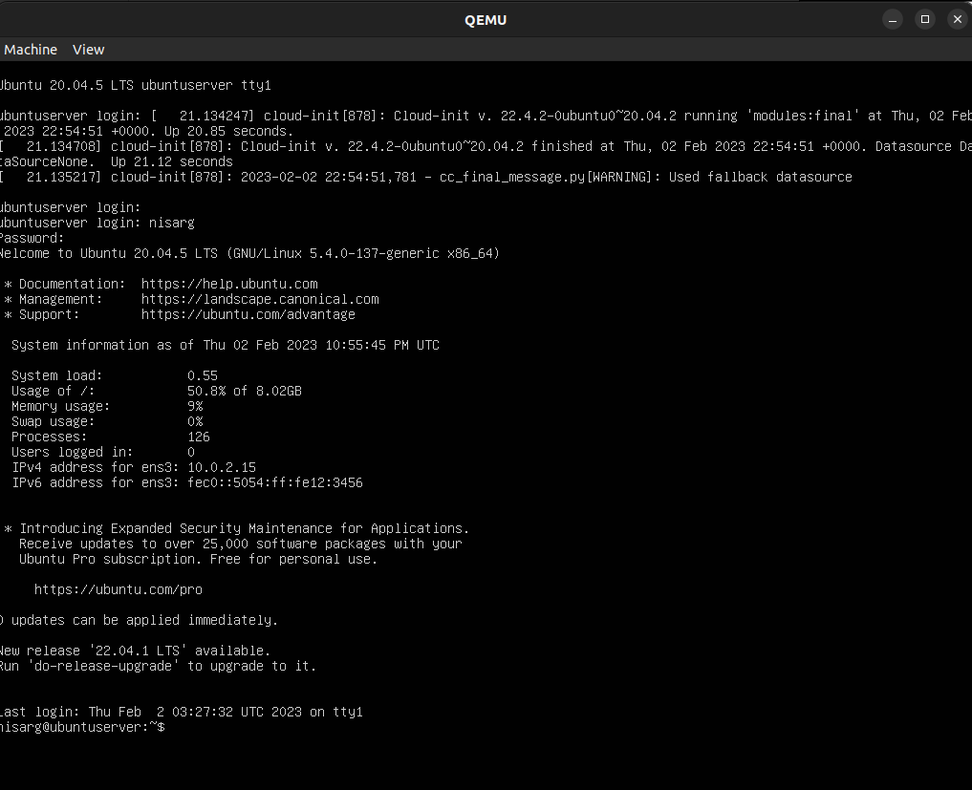

Now, if we want to connect to the same VM from the terminal, we can use following command:

$ sudo qemu-system-x86_64 \

-accel kvm -cpu host -m 2G -smp 2 \

-boot c -cdrom ./Downloads/ubuntu-20.04.5-live-server-amd64.iso \

-hda ubuntu.img \

-netdev user,id=net0,hostfwd=tcp::5555-:22 \

-device e1000,netdev=net0 \

-device ahci,id=ahci \

-device usb-ehci -device usb-kbd -device usb-mouse -usb -nographic

Since, we are forwarding the SSH port 22 to localhost port 5555, we can also connect to the VM via SSH if it is up and running using following command:

$ ssh -p 5555 localhost

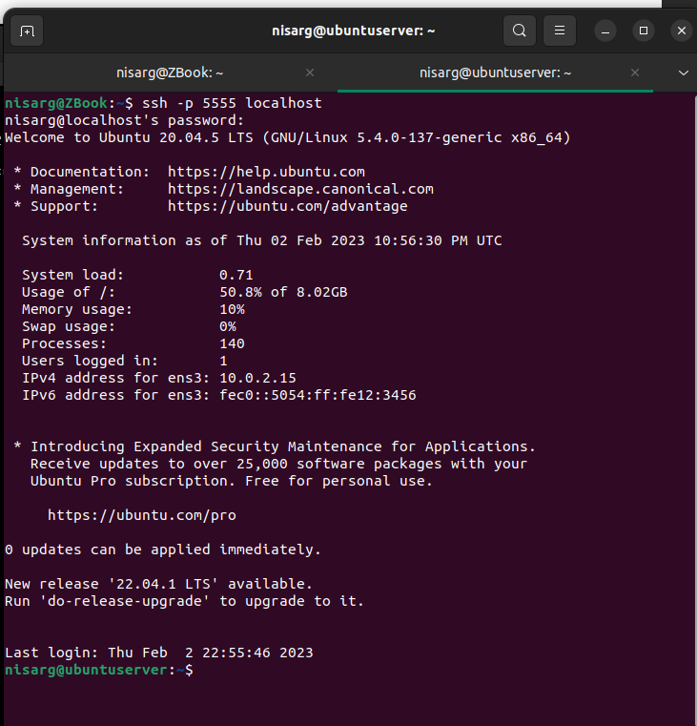

The arguments used with QEMU are:

1. accel: hardware acceleration
2. m: memory
3. smp: total cores allocated
4. hda: virtual hard drive
5. netdev: network device
6. device: I/O devices
7. nographic: run without GUI loader

# Installing Docker

Docker is a set of PaaS products that use OS-level virtualization to deliver software in packages called containers. It is a software framework for building, running, and managing containers on servers and the cloud.

## Install Docker Desktop

We need to install Docker desktop application from the below link and follow the steps mentioned:

[Docker Installation Guide for Ubuntu](https://docs.docker.com/desktop/install/ubuntu/)

Once, the application is installed, from terminal we need to run:

$ systemctl --user start docker-desktop

There is an **optional** step where we can manage Docker as non-root user which can be done using the below link.

[Manage Docker as a non-root user](https://docs.docker.com/engine/install/linux-postinstall/)

Then we are checking the version of Docker Engine, Docker Compose and Docker Desktop

$ docker compose version

$ docker --version

$ docker version

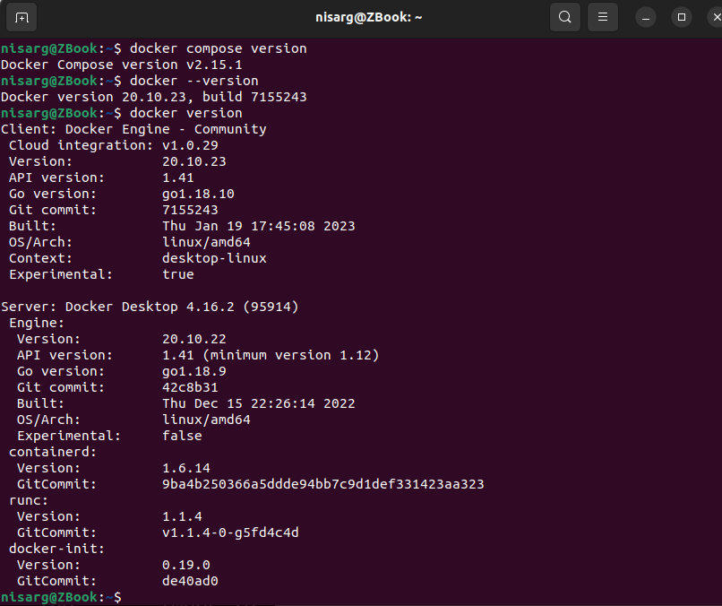

Once we know that the docker is running, we check whether the docker containers are working as expected. Hereafter running the command, since the image “hello-world” was not available locally, it pulled the latest image from Docker Repository and ran it.

$ docker images

$ docker run hello-world

$ docker images

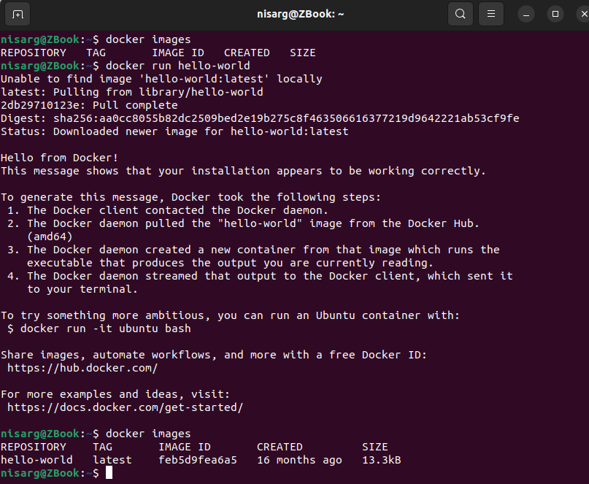

## Create Container

Now we need to pull the image from Docker repository of Ubuntu 20.04 and spin-up the container.

$ docker run -it --cpus=2 --memory=2G ubuntu:20.04 /bin/bash

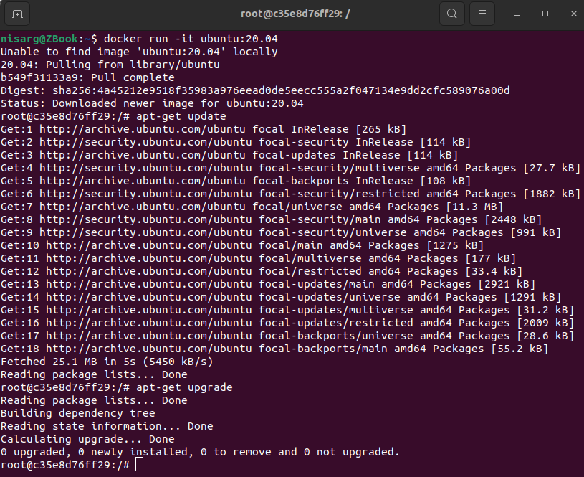

|  |  |
| --- | --- |
| Docker Commands | Description |
| docker pull [image_name]:[tag] | To pull a docker image having a specific tag |
| docker images | To list out all locally available images |
| docker run [image_name] | To run a docker image |
| docker ps | To list out all the running containers |
| docker commit [container_id] [image_name] | To commit current container as a new image |
| docker history | To show history of an image |

# Test Conditions

For the VM, we will consider these two test conditions to conduct the experiment. The same conditions will be repeated for QEMU and Docker for consistency between results. We will be using [Sysbench](https://github.com/akopytov/sysbench) for system benchmark testing.

**Note: Due to system restrictions on total number of cores and Sysbench only supports memory up to 3GB, only these test conditions were successfully completed.**

|  |  |
| --- | --- |
| Cores | Memory Allocation (RAM) |
| 2 | 2 GB |
| 2 | 3 GB |

# Experimentation and Reports

## Condition 1: 2GB RAM and 2 Cores on QEMU

### CPU Testing

For CPU testing, we will be using 3 test cases to check the system performance with varying max-prime argument.

$ sysbench cpu --cpu-max-prime=<random_value> --num-threads=<random_value> --time=<random_value> run

#### Test Run 1: Prime Limit = 2000

Now, we will be running the test script having cpu-max-prime=2000

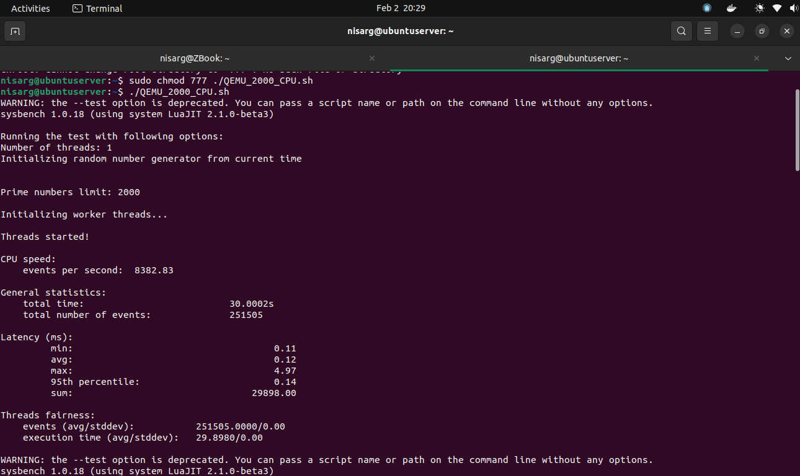

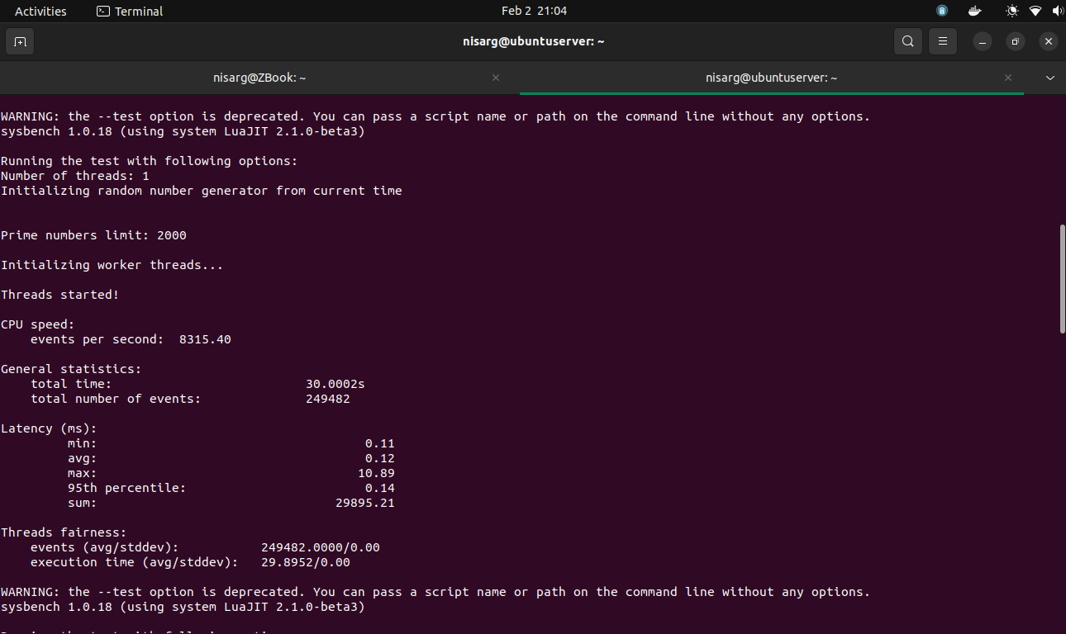

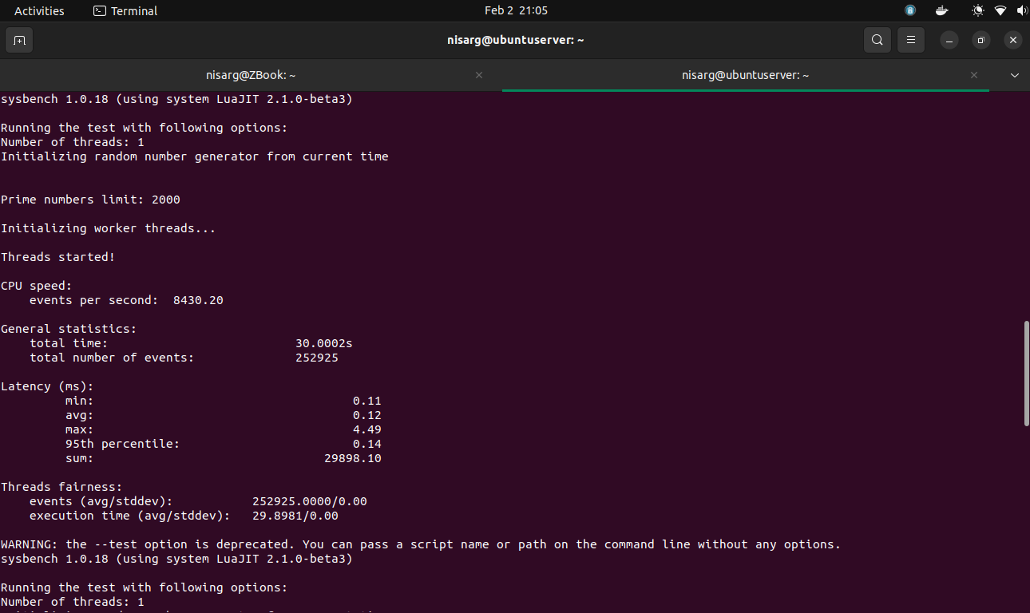

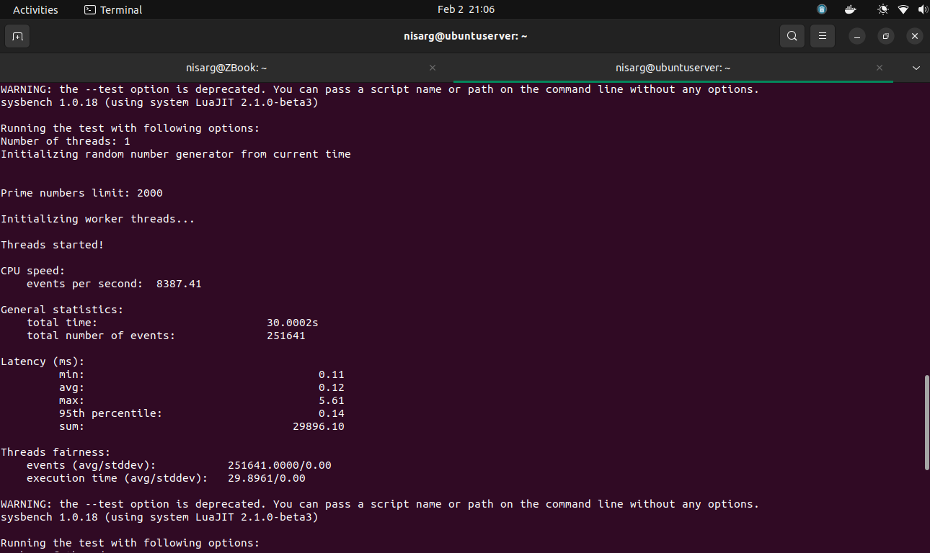

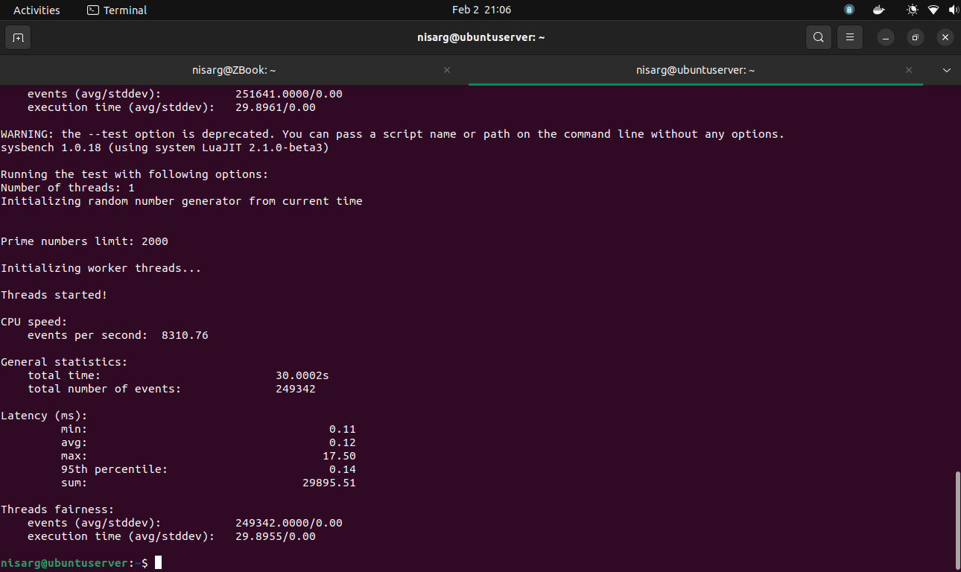

|  |  |
| --- | --- |
| Iteration Number | Number of Events per Second |
| 1 | 8382.83 |
| 2 | 8315.40 |
| 3 | 8430.20 |
| 4 | 8387.41 |
| 5 | 8310.76 |

Statistics for Test Run 1:

* Average number of events per second: 8365.82
* Maximum number of events per second: 8430.20
* Minimum number of events per second: 8310.76

#### Test Run 2: Prime Limit = 20000

Now, we will be running the test script having cpu-max-prime=20000

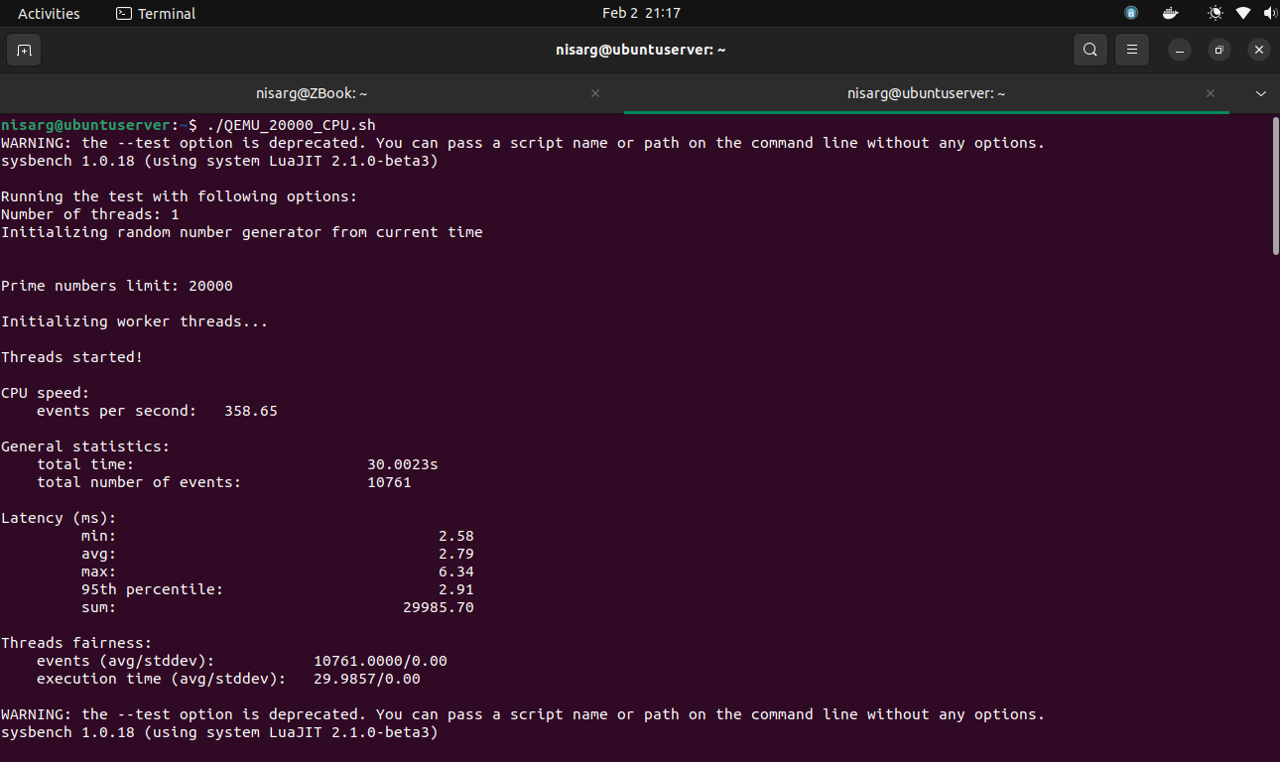

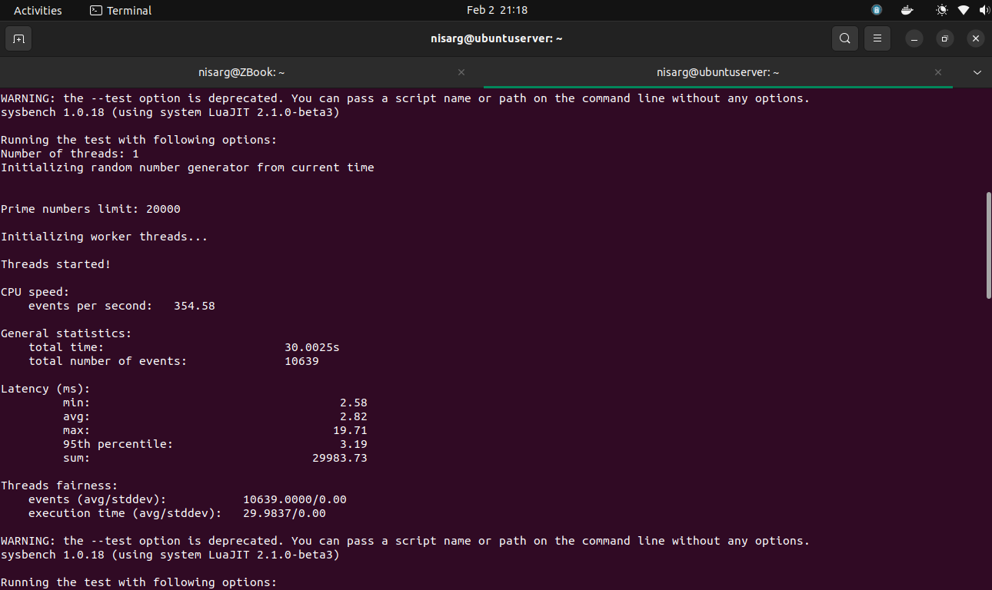

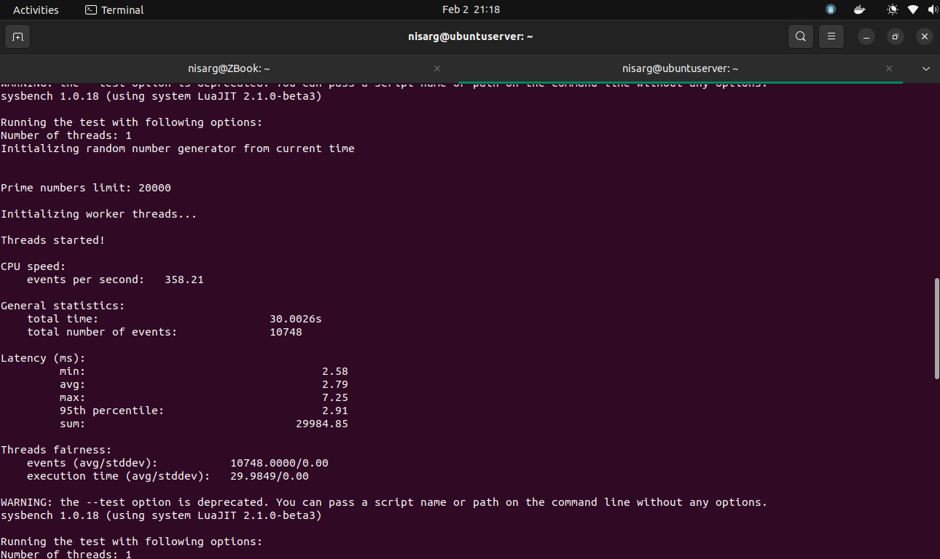

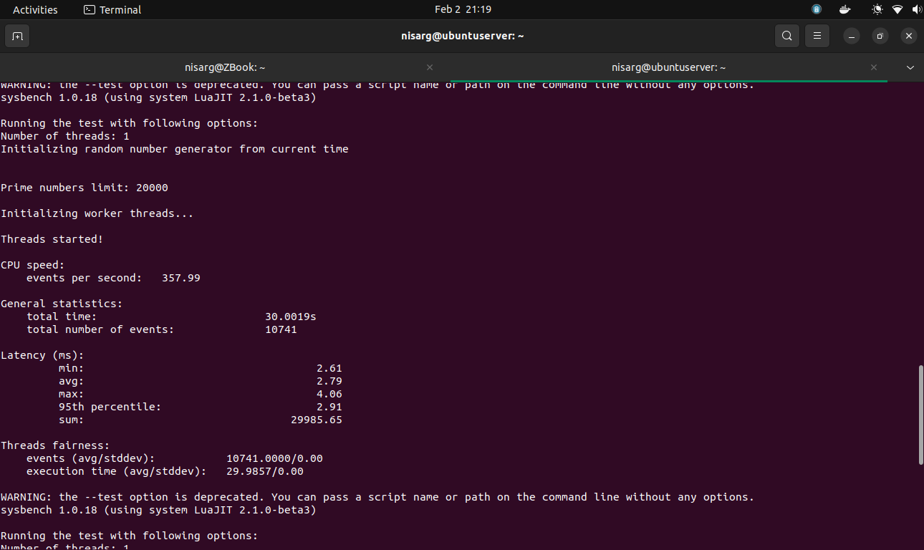

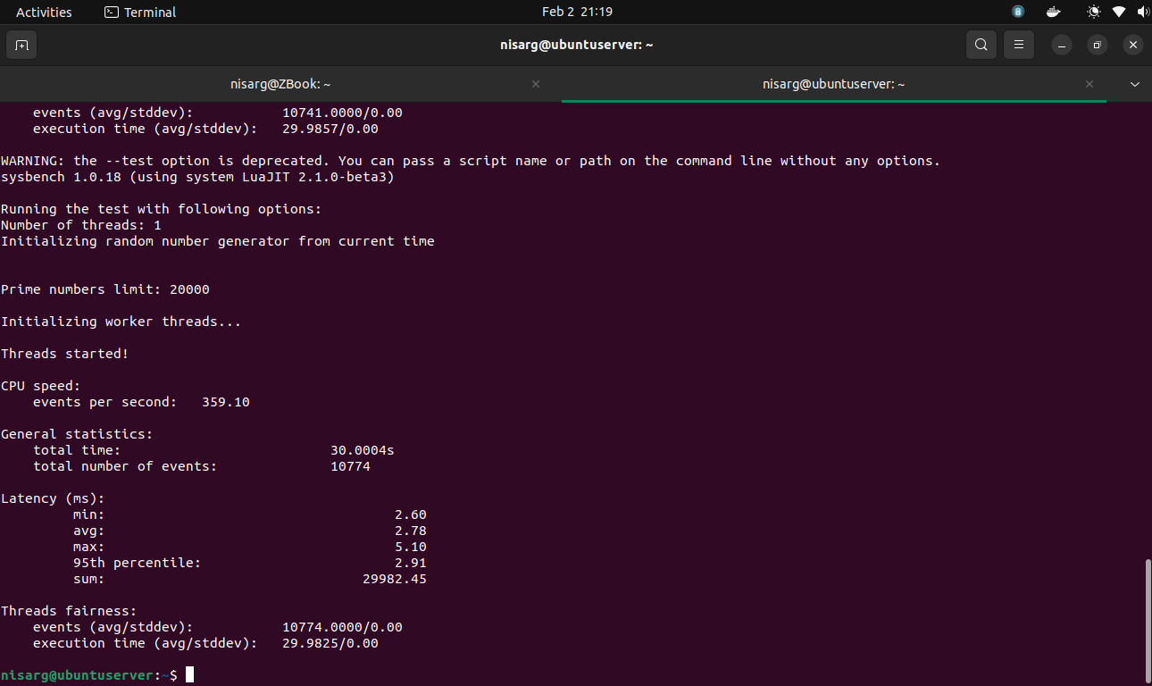

|  |  |
| --- | --- |
| Iteration Number | Number of Events per Second |
| 1 | 358.65 |
| 2 | 358.58 |
| 3 | 358.21 |
| 4 | 357.99 |
| 5 | 359.10 |

Statistics for Test Run 2:

* Average number of events per second: 358.51
* Maximum number of events per second: 359.10
* Minimum number of events per second: 357.99

#### Test Run 3: Prime Limit = 200000

Now, we will be running the test script having cpu-max-prime=200000

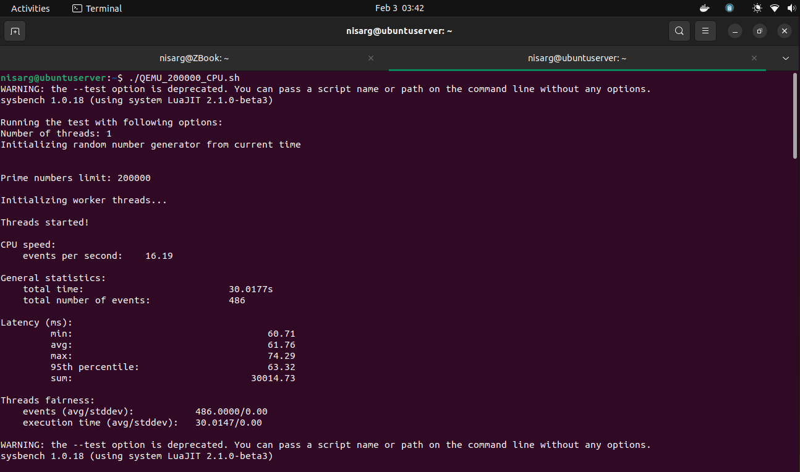

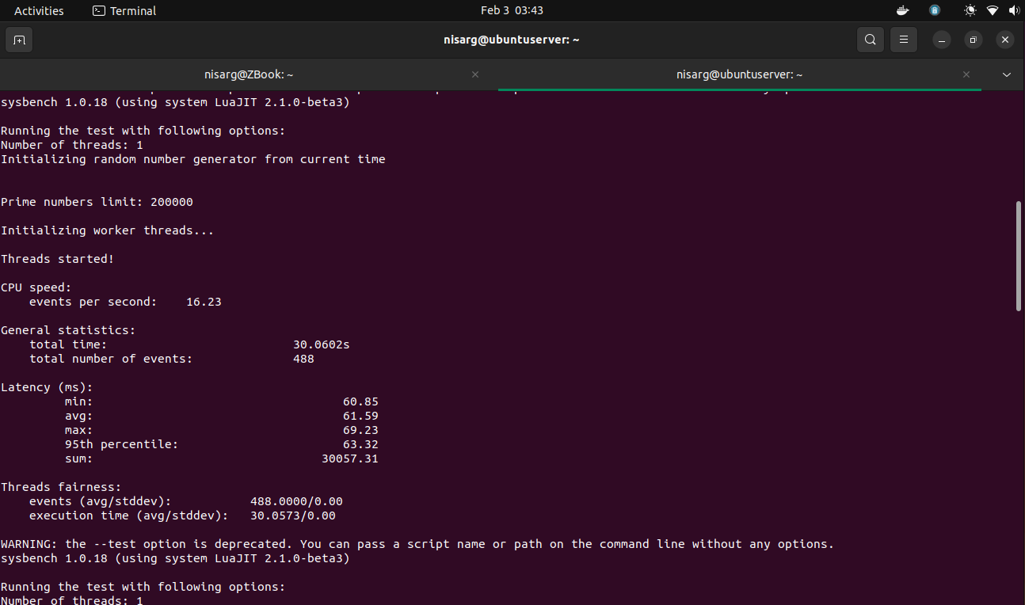

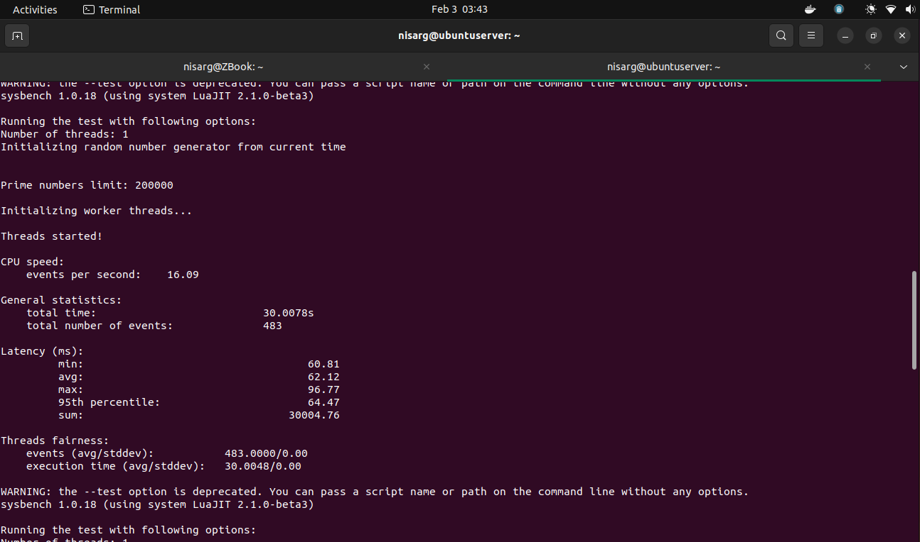

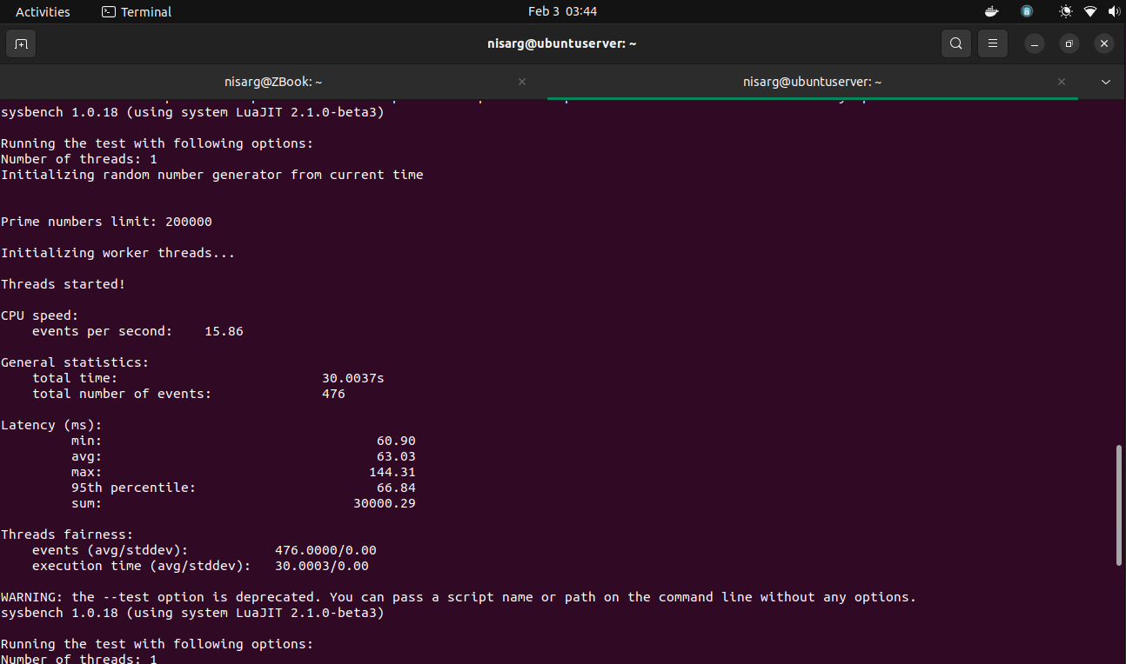

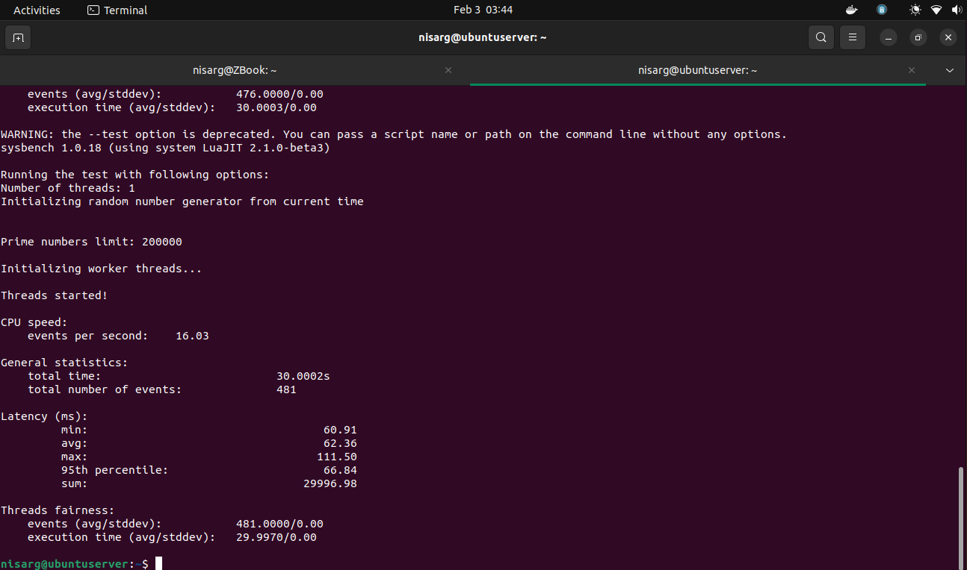

|  |  |
| --- | --- |
| Iteration Number | Number of Events per Second |
| 1 | 16.19 |
| 2 | 16.23 |
| 3 | 16.09 |
| 4 | 15.86 |
| 5 | 16.03 |

Statistics for Test Run 3:

* Average number of events per second: 16.08
* Maximum number of events per second: 16.23
* Minimum number of events per second: 15.86

### File I/O Testing

For file testing, we will be testing a system with sequential rewrite and combined random read-write.

$ sysbench --num-threads=16 --test=fileio --file-total-size=2G --time=30 --file-test-mode=<test_mode> prepare

$ sysbench --num-threads=16 --test=fileio --file-total-size=2G --time=30 --file-test-mode=<test_mode> run

$ sysbench --num-threads=16 --test=fileio --file-total-size=2G --time=30 --file-test-mode=<test_mode> cleanup

#### Test Run 1: Mode = Sequential

Here, the sysbench is generating 128 files summing up to 2 GB

***Iteration 1***

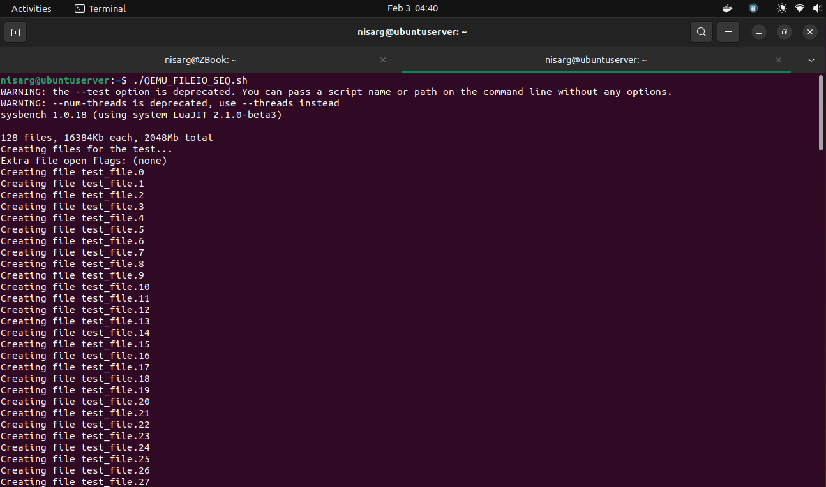

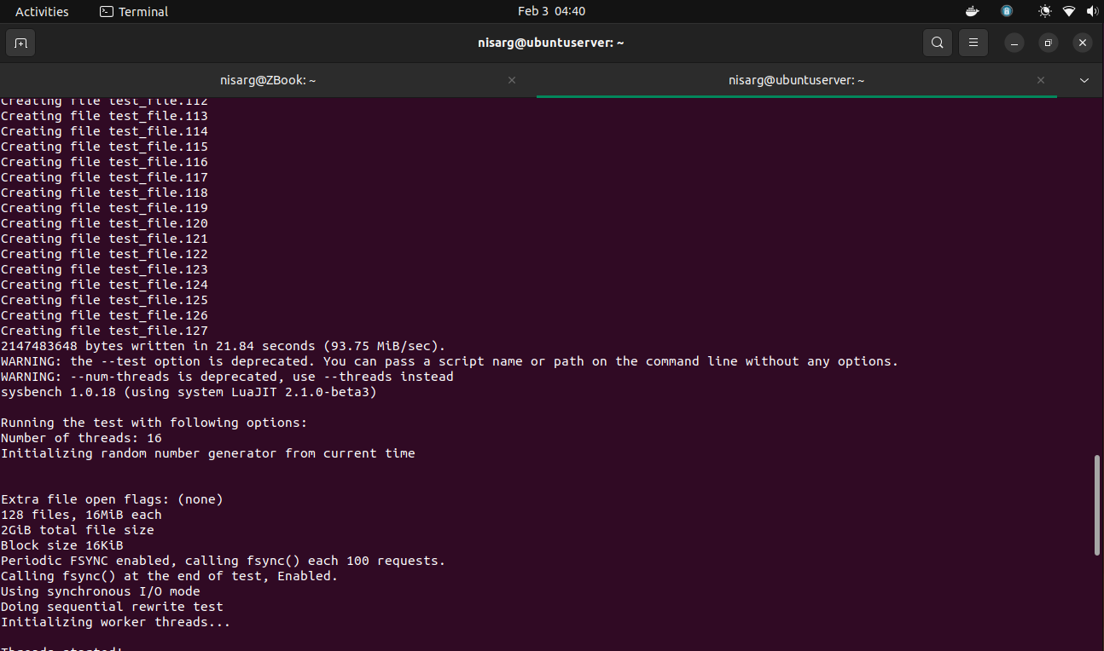

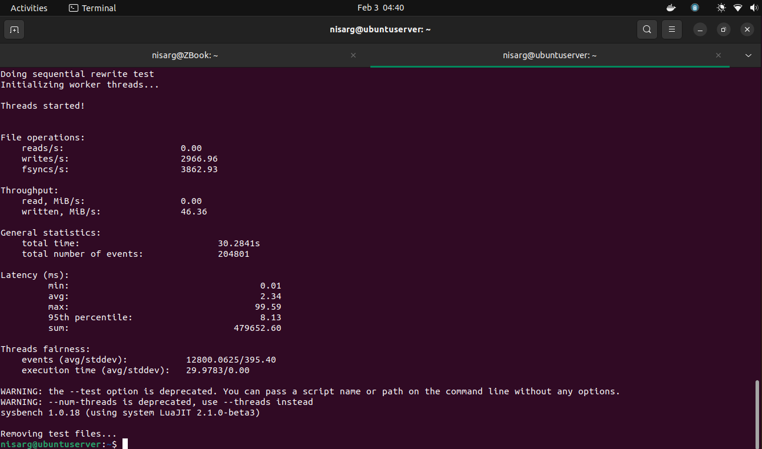

***Iteration 2***

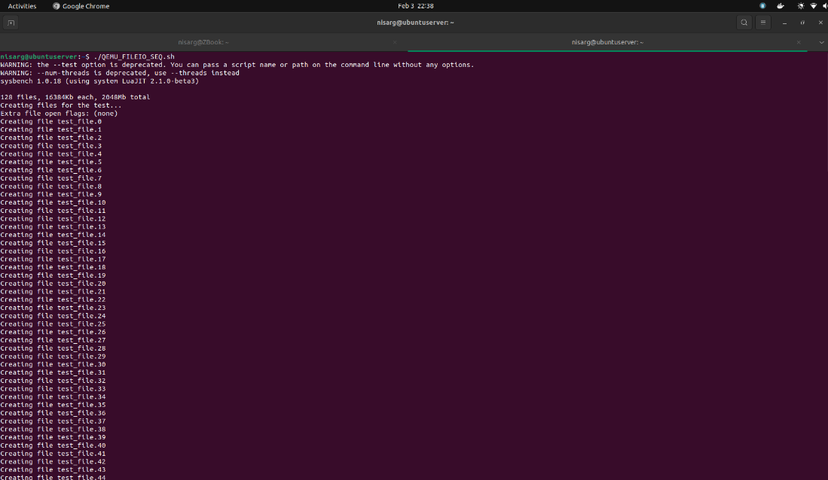

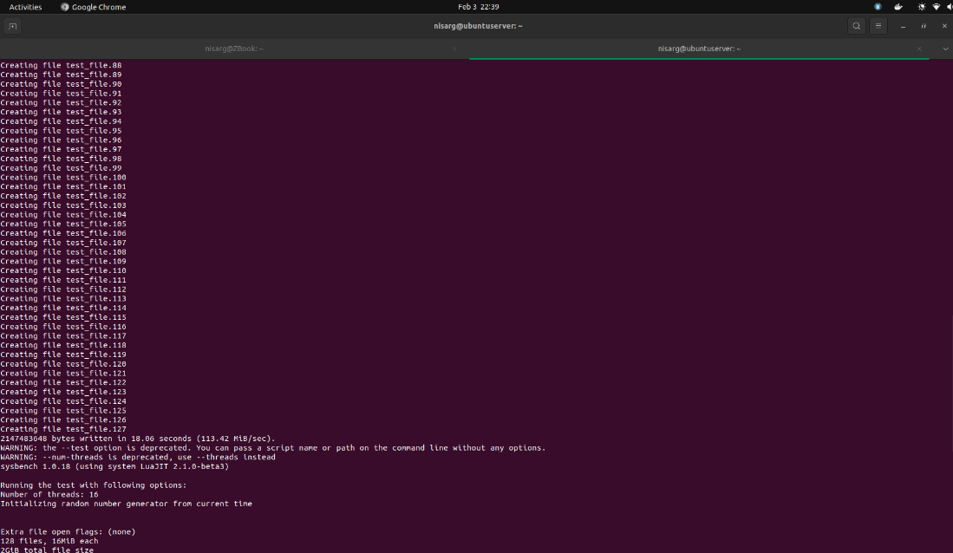

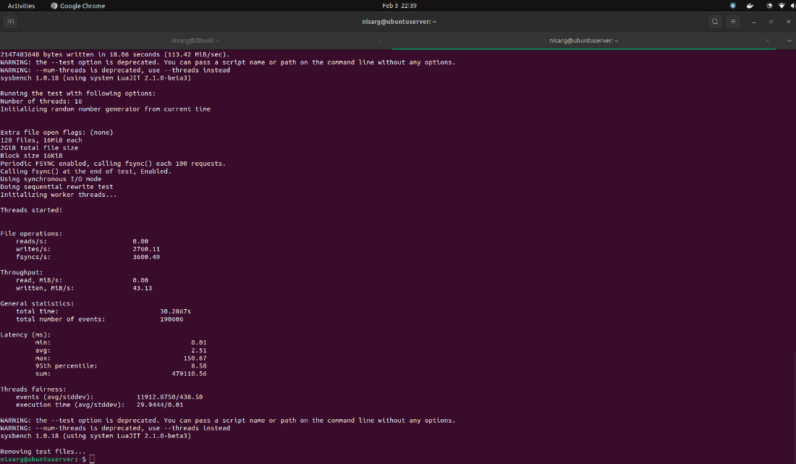

***Iteration 3***

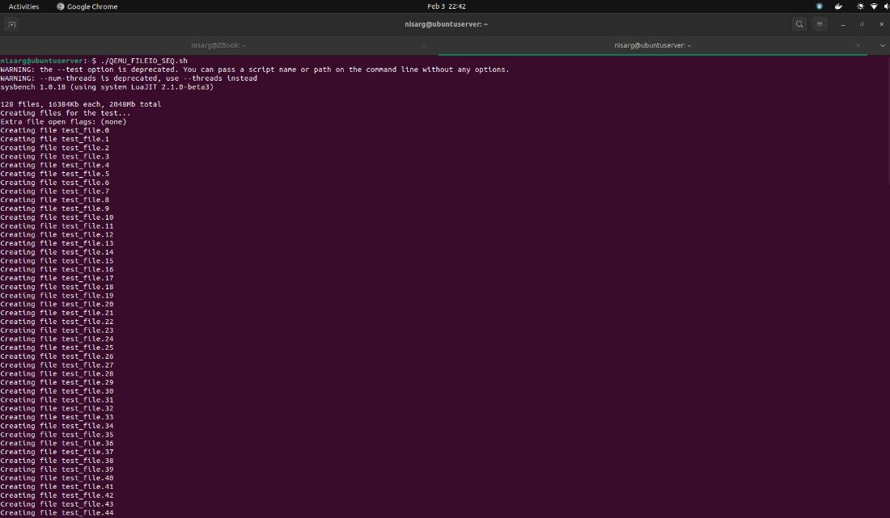

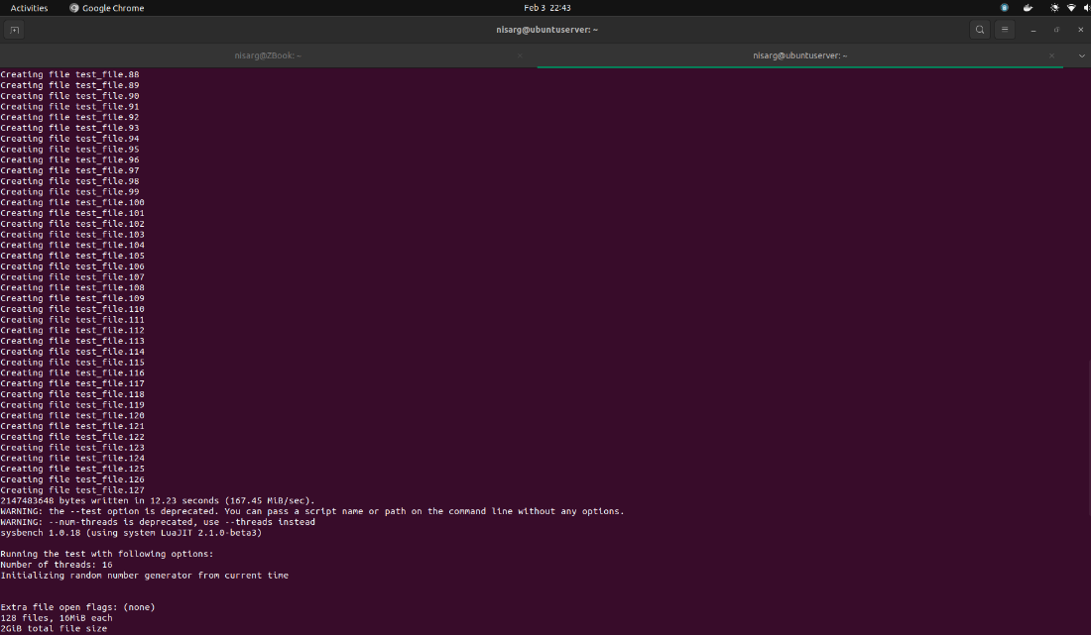

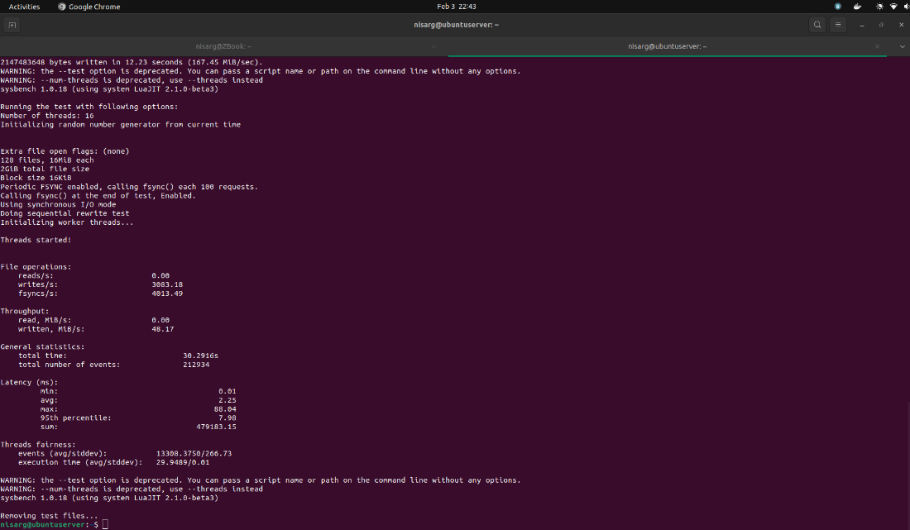

|  |  |  |
| --- | --- | --- |
| Serial run iterations | Results | |
| 1 | reads/s | 0.00 |
| writes/sec | 2966.96 |
| fsyncs/s | 3862.93 |
| events/s | 6762.66 |
| 2 | reads/s | 0.00 |
| writes/sec | 2760.11 |
| fsyncs/s | 3600.49 |
| events/s | 6293.39 |
| 3 | reads/s | 0.00 |
| writes/sec | 3083.18 |
| fsyncs/s | 4013.49 |
| events/s | 7029.47 |

#### Test Run 2: Mode = Combined Random

Here, the sysbench is generating 128 files summing up to 2 GB

***Iteration 1***

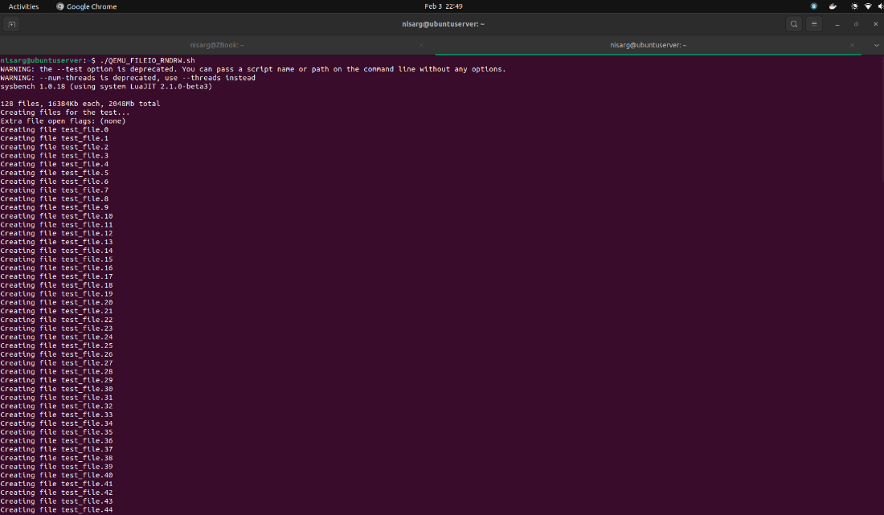

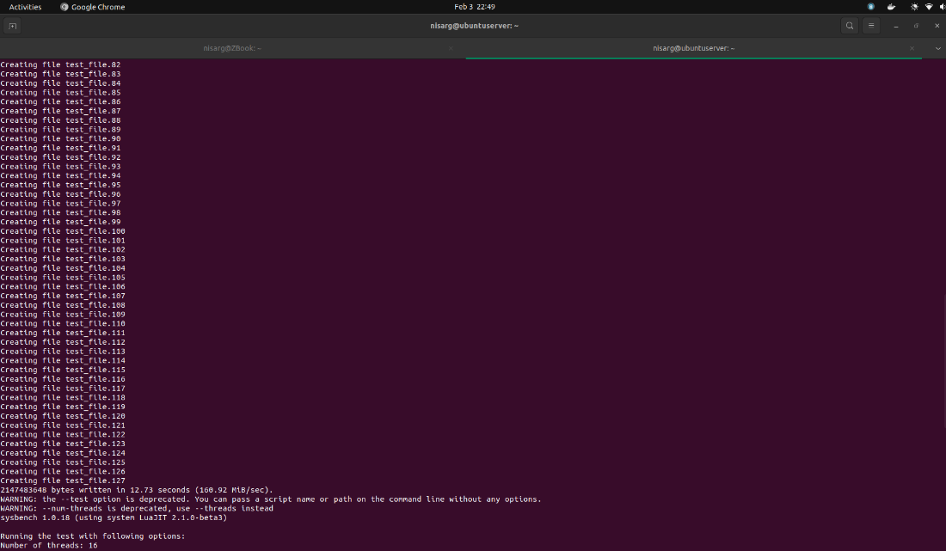

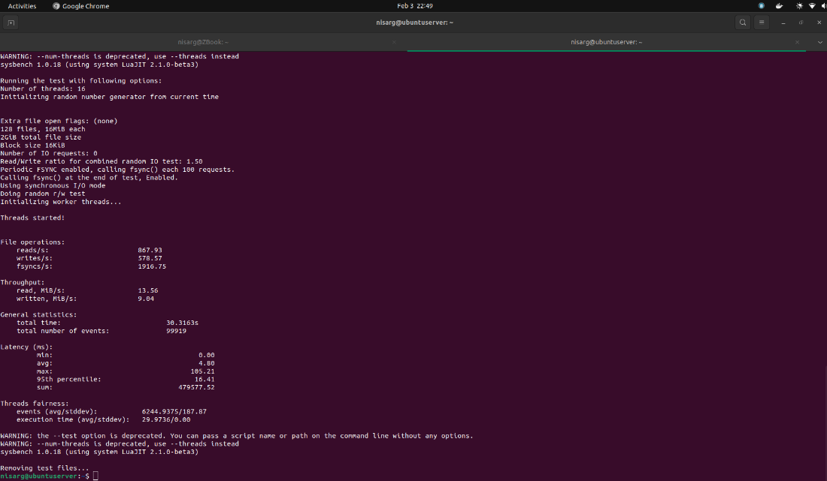

***Iteration 2***

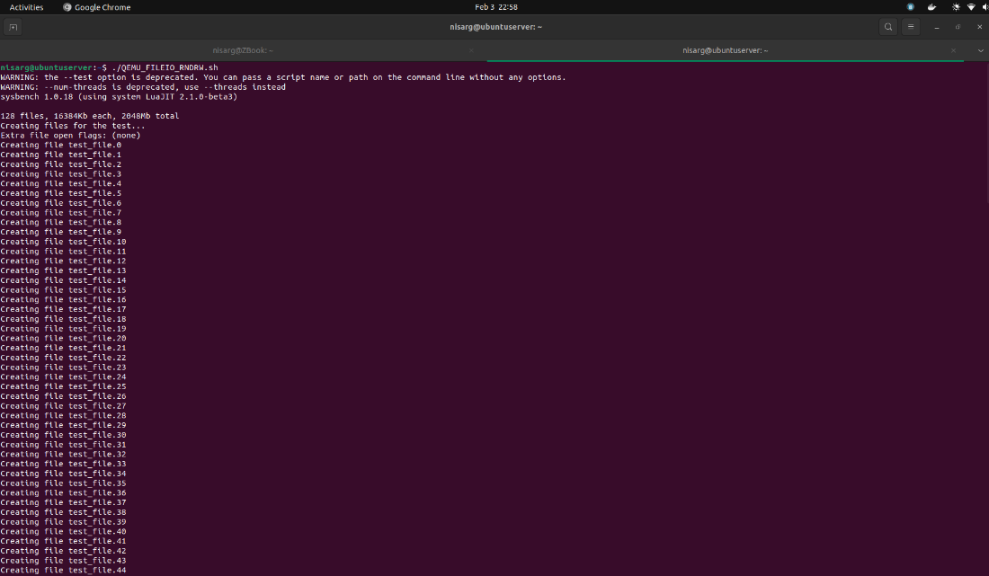

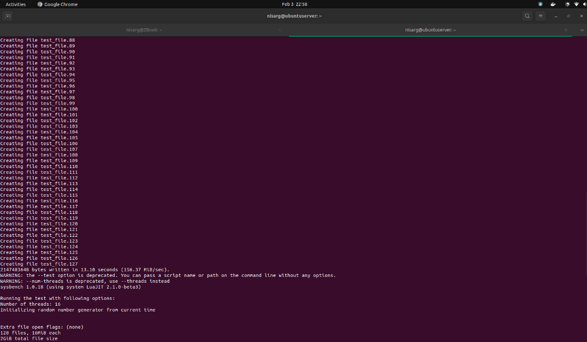

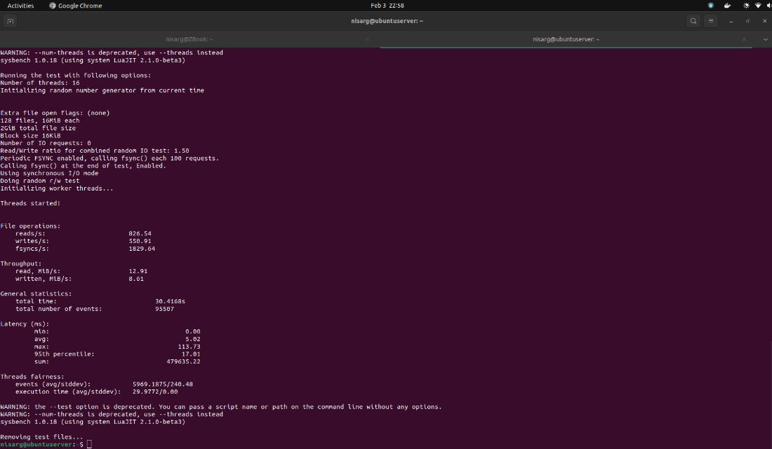

***Iteration 3***

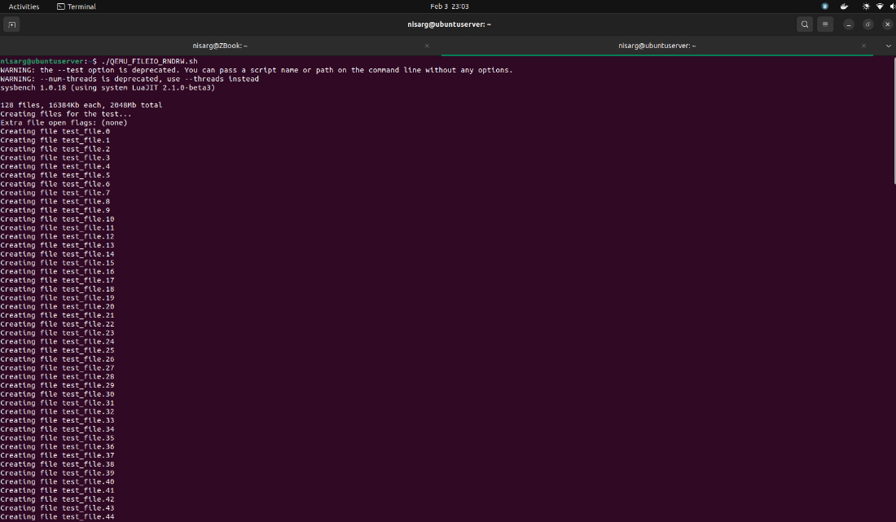

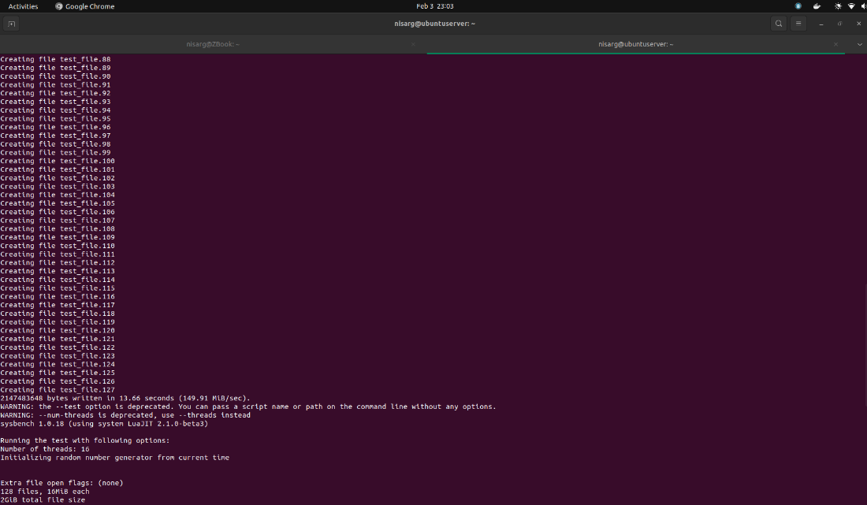

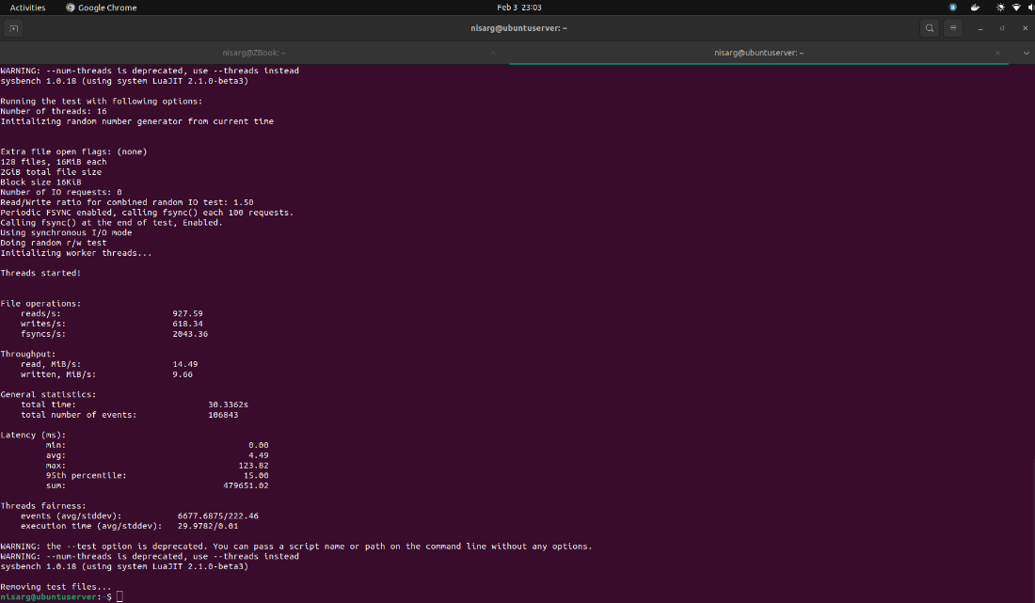

|  |  |  |
| --- | --- | --- |
| Combined run iterations | Results | |
| 1 | reads/s | 867.93 |
| writes/sec | 578.57 |
| fsyncs/s | 1916.75 |
| events/s | 3295.88 |
| 2 | reads/s | 826.54 |
| writes/sec | 550.91 |
| fsyncs/s | 1829.64 |
| events/s | 3139.94 |
| 3 | reads/s | 927.59 |
| writes/sec | 618.34 |
| fsyncs/s | 2043.36 |
| events/s | 3521.96 |

## Condition 2: 3GB RAM and 2 Cores on QEMU

### CPU Testing

For CPU testing, we will be using 3 test cases to check the system performance with varying max-prime argument.

$ sysbench cpu --cpu-max-prime=<random_value> --num-threads=<random_value> --time=<random_value> run

#### Test Run 1: Prime Limit = 2000

Now, we will be running the test script having cpu-max-prime=2000

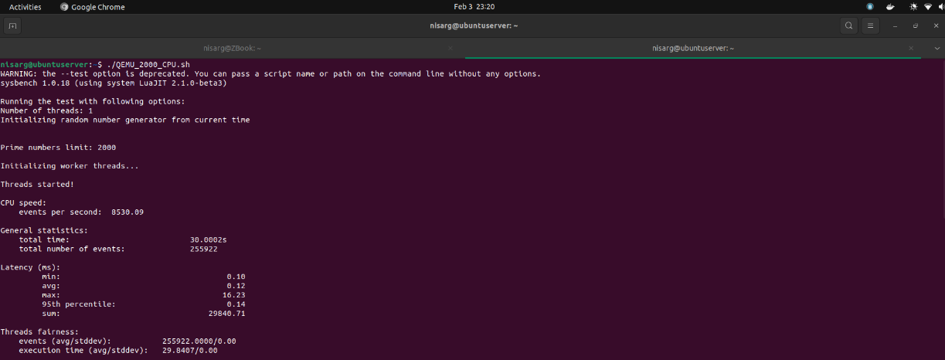

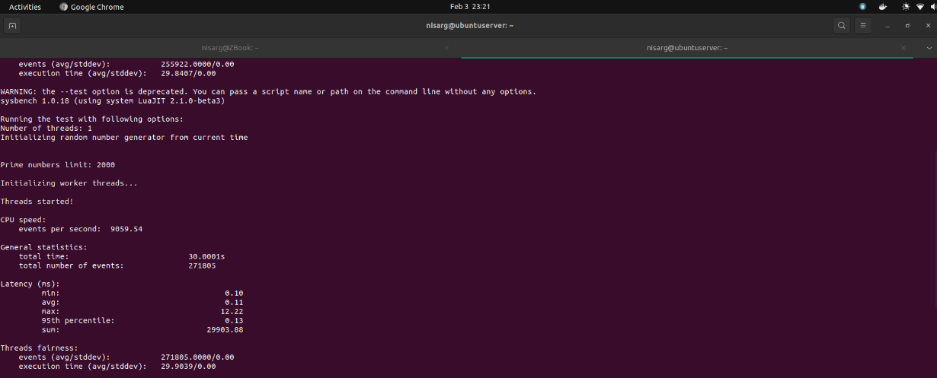

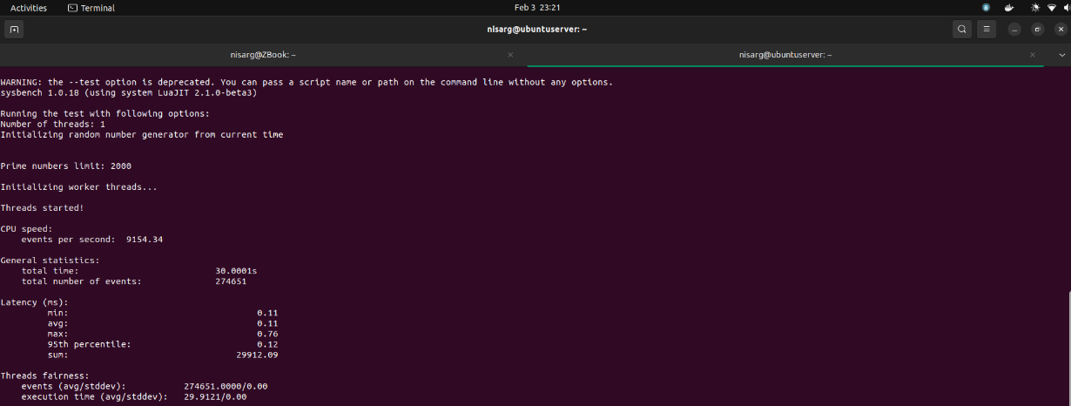

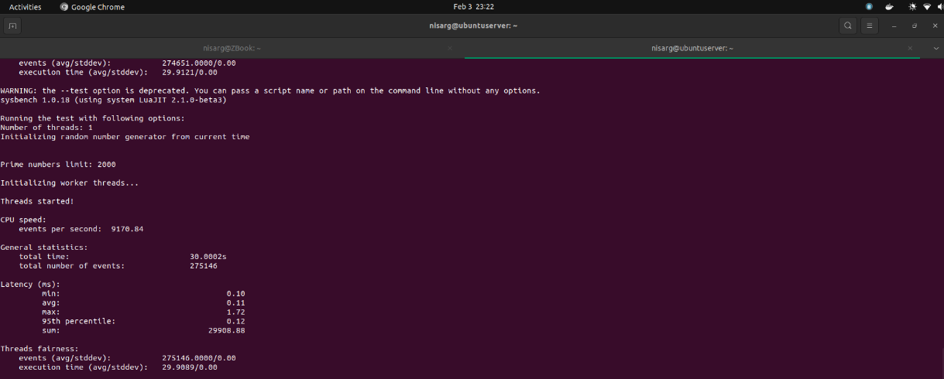

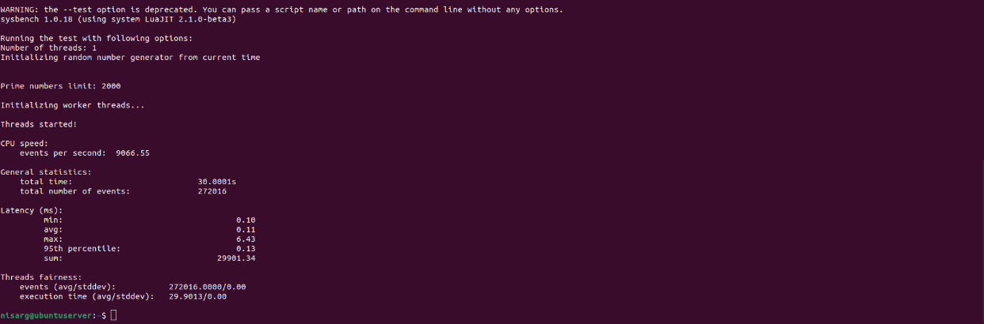

|  |  |
| --- | --- |
| Iteration Number | Number of Events per Second |
| 1 | 8530.09 |
| 2 | 9059.54 |
| 3 | 9154.34 |
| 4 | 9170.84 |
| 5 | 9066.55 |

Statistics for Test Run 1:

* Average number of events per second: 8996.27
* Maximum number of events per second: 9170.84
* Minimum number of events per second: 8530.09

#### Test Run 2: Prime Limit = 20000

Now, we will be running the test script having cpu-max-prime=20000

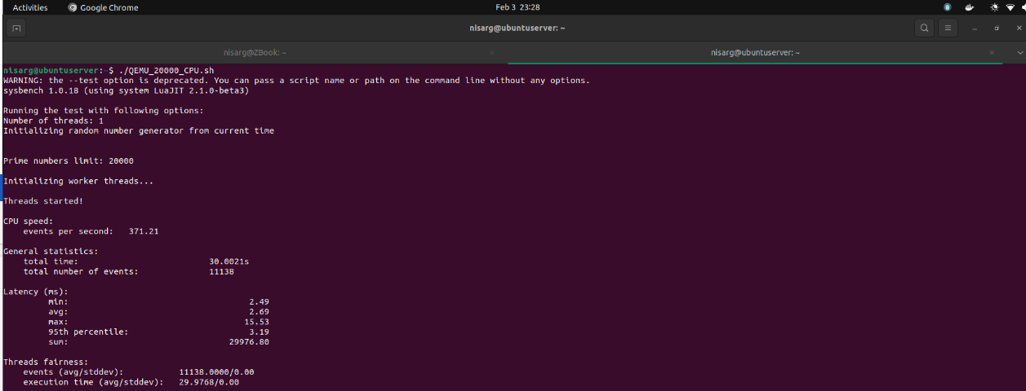

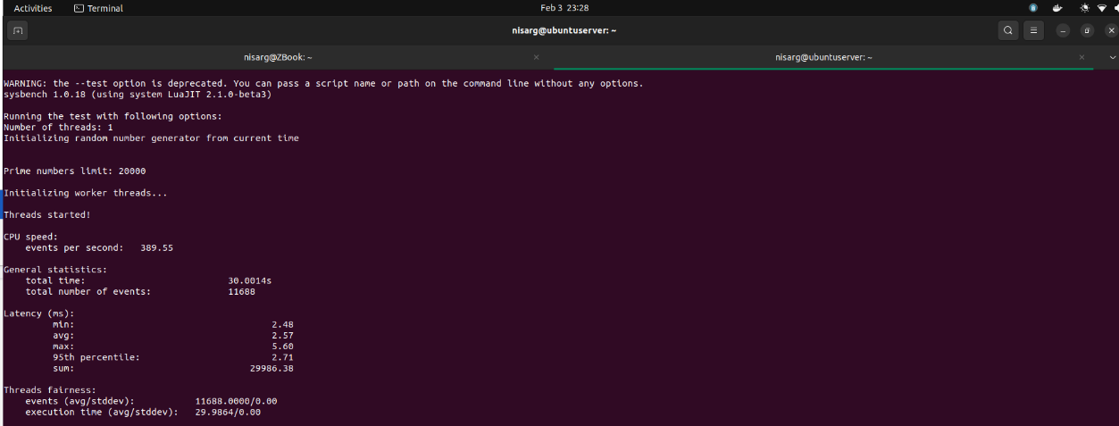

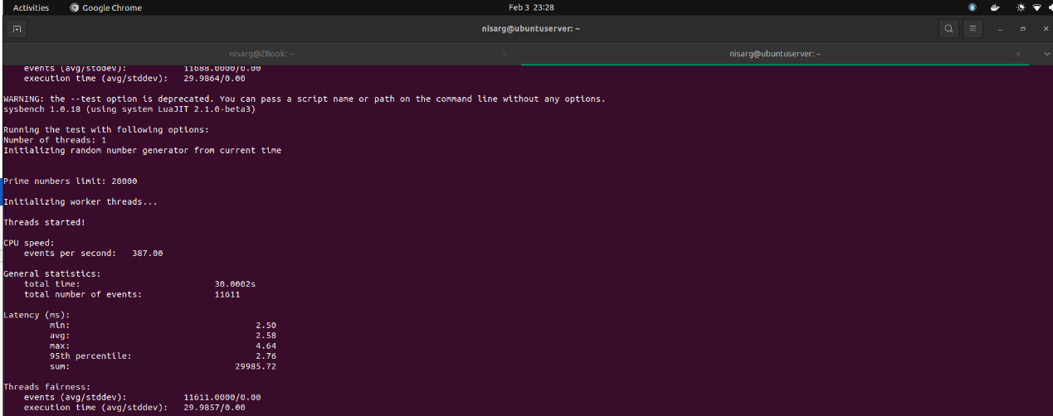

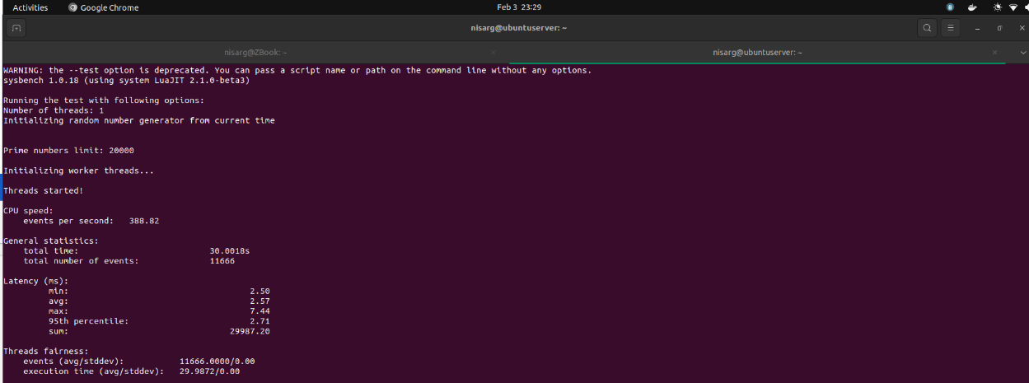

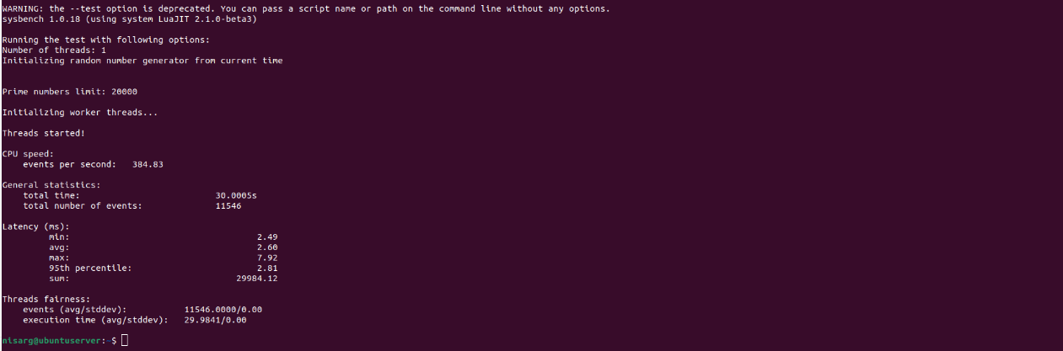

|  |  |
| --- | --- |
| Iteration Number | Number of Events per Second |
| 1 | 371.21 |
| 2 | 389.55 |
| 3 | 387.00 |
| 4 | 388.82 |
| 5 | 384.83 |

Statistics for Test Run 2:

* Average number of events per second: 384.28
* Maximum number of events per second: 389.55
* Minimum number of events per second: 371.21

#### Test Run 3: Prime Limit = 200000

Now, we will be running the test script having cpu-max-prime=200000

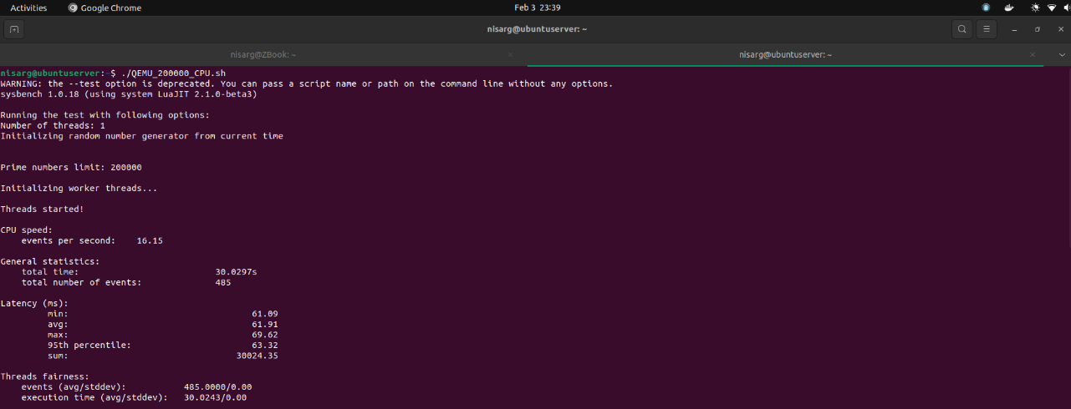

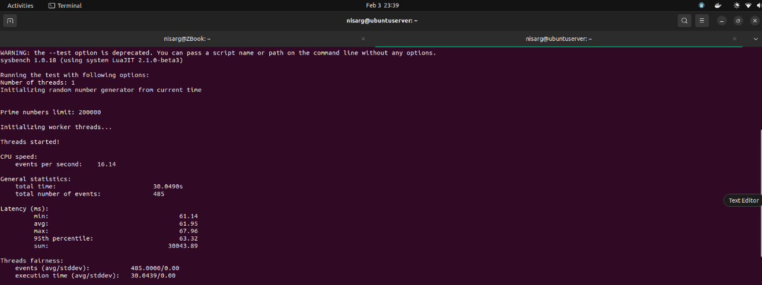

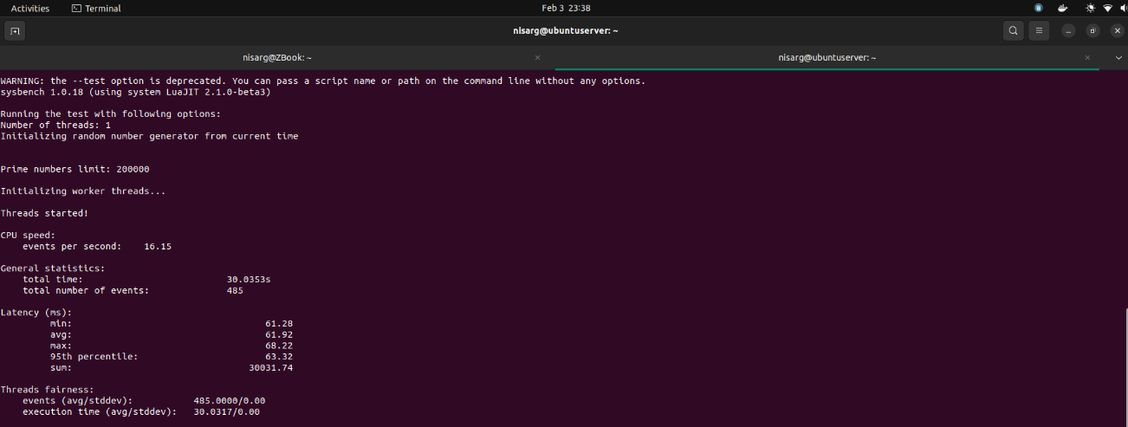

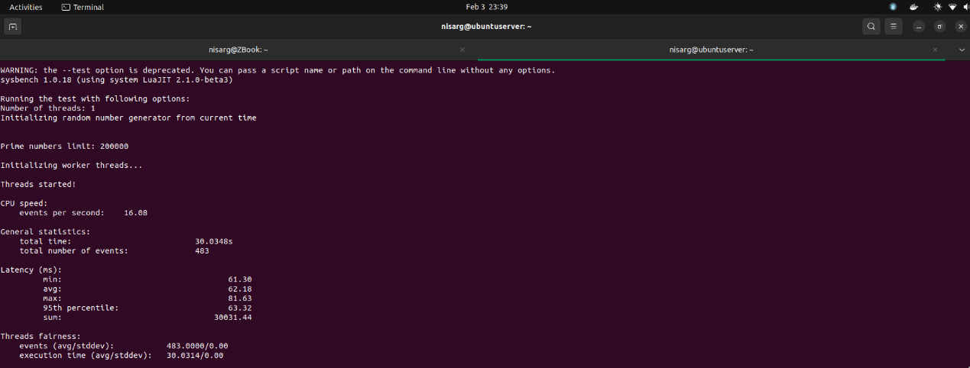

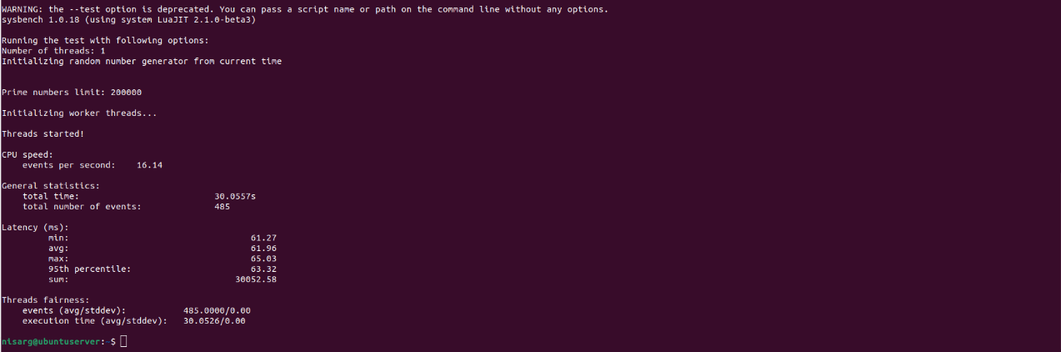

|  |  |
| --- | --- |
| Iteration Number | Number of Events per Second |
| 1 | 16.15 |
| 2 | 16.14 |
| 3 | 16.15 |
| 4 | 16.08 |
| 5 | 16.14 |

Statistics for Test Run 3:

* Average number of events per second: 16.13
* Maximum number of events per second: 16.08
* Minimum number of events per second: 16.15

### File I/O Testing

For file testing, we will be testing a system with sequential read-write and combined random read-write.

$ sysbench --num-threads=16 --test=fileio --file-total-size=2G --time=30 --file-test-mode=<test_mode> prepare

$ sysbench --num-threads=16 --test=fileio --file-total-size=2G --time=30 --file-test-mode=<test_mode> run

$ sysbench --num-threads=16 --test=fileio --file-total-size=2G --time=30 --file-test-mode=<test_mode> cleanup

#### Test Run 1: Mode = Sequential

Here, the sysbench is generating 128 files summing up to 2 GB

***Iteration 1***

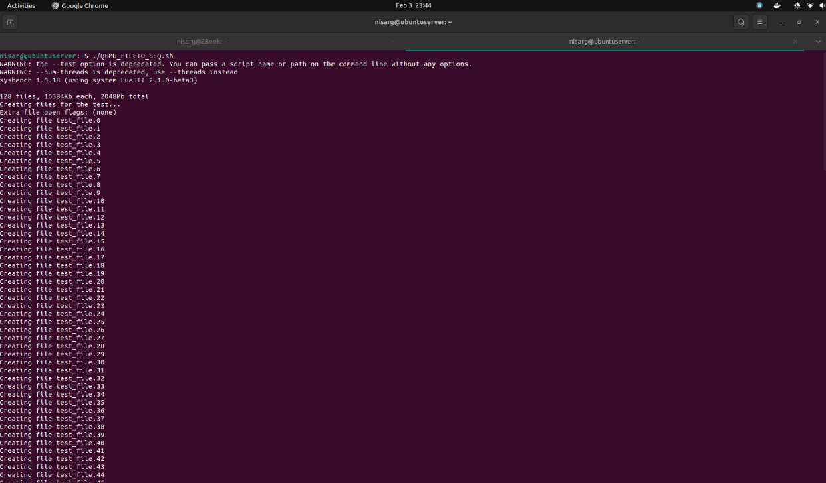

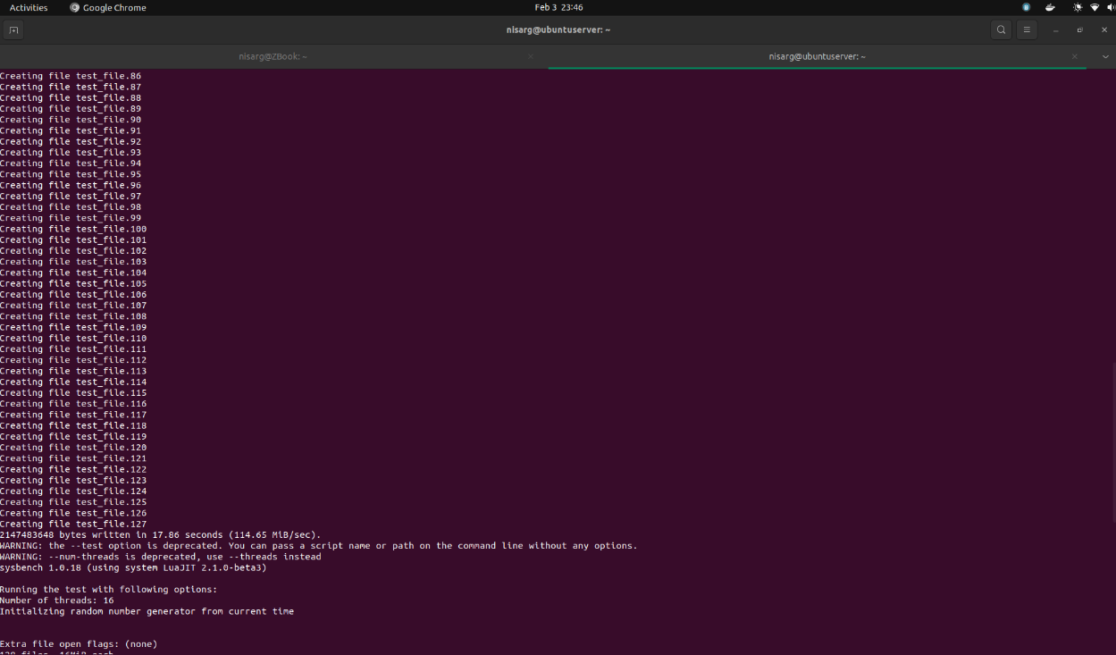

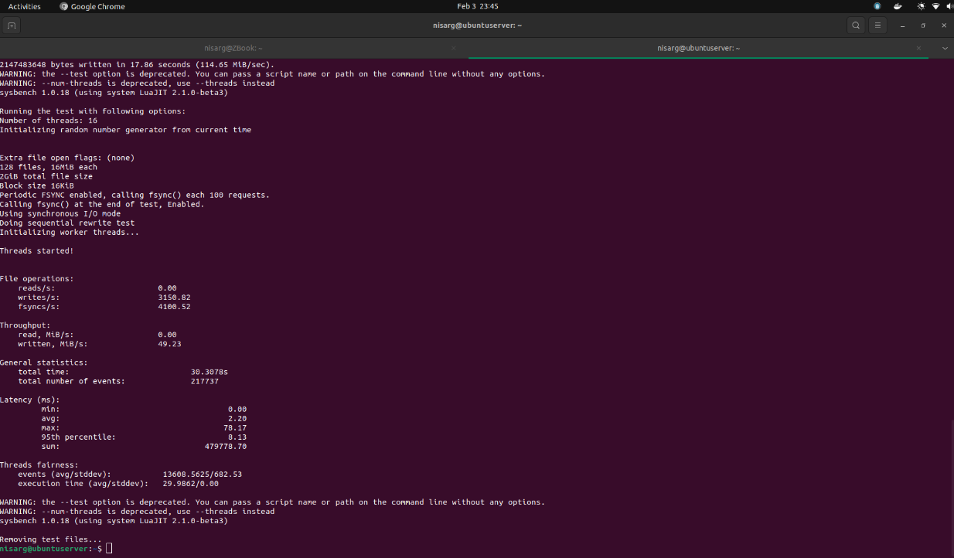

***Iteration 2***

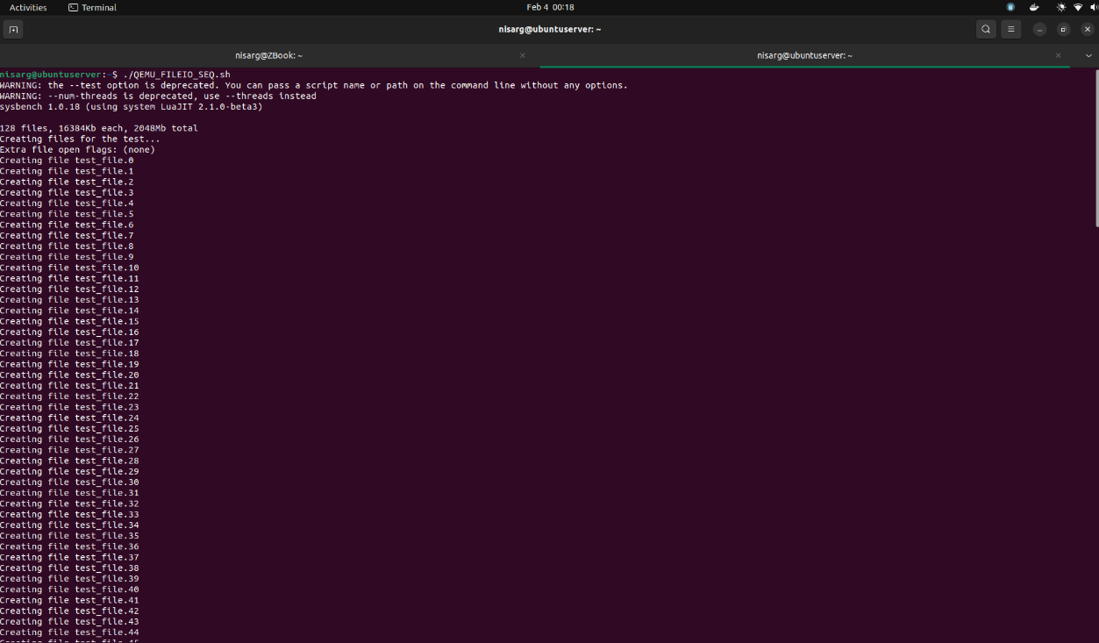

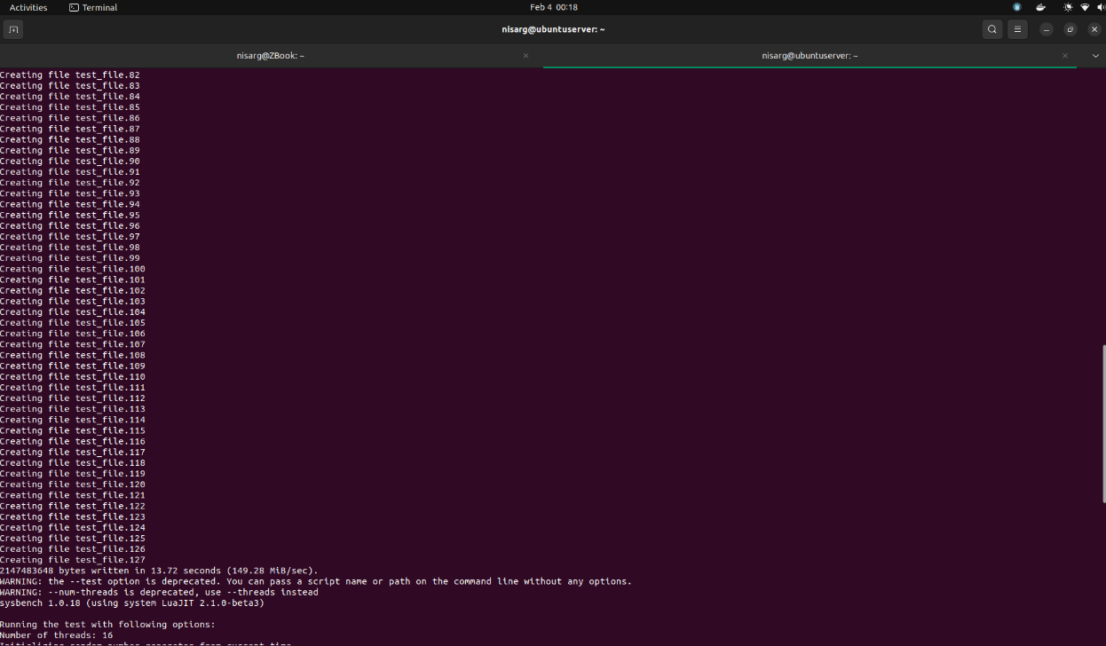

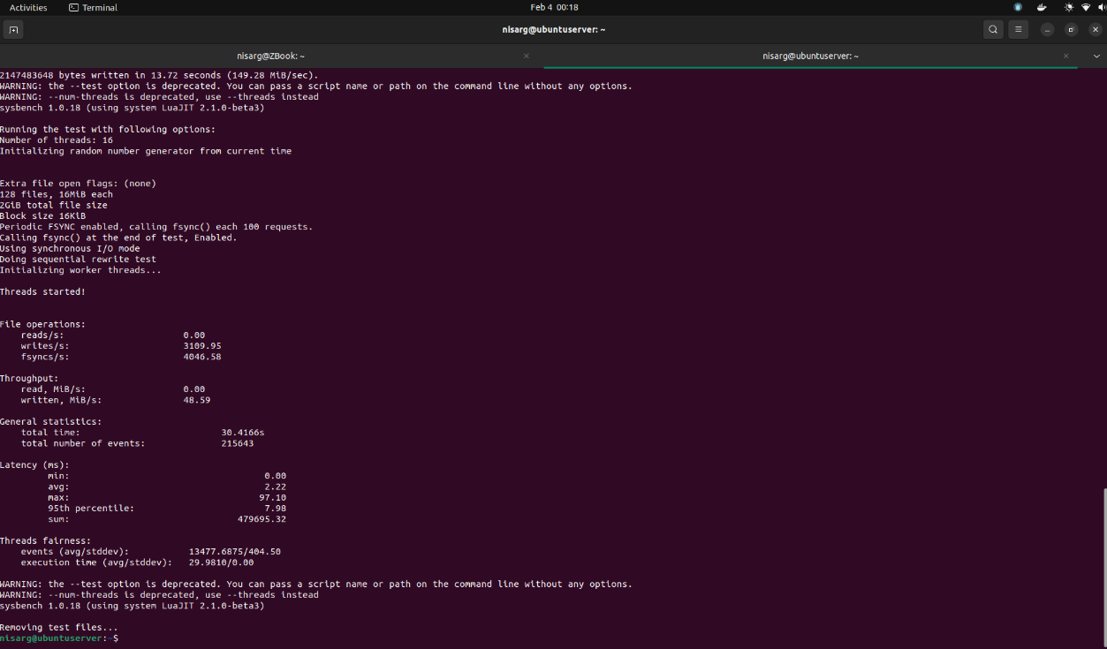

***Iteration 3***

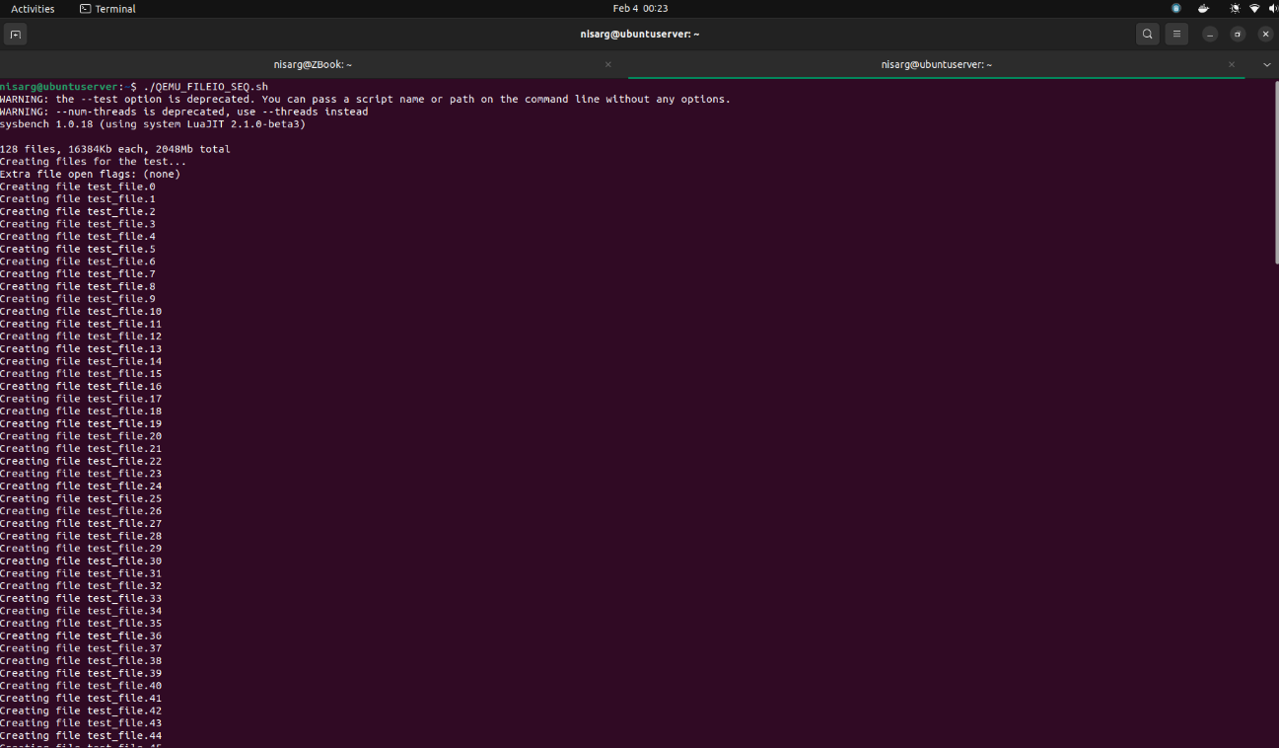

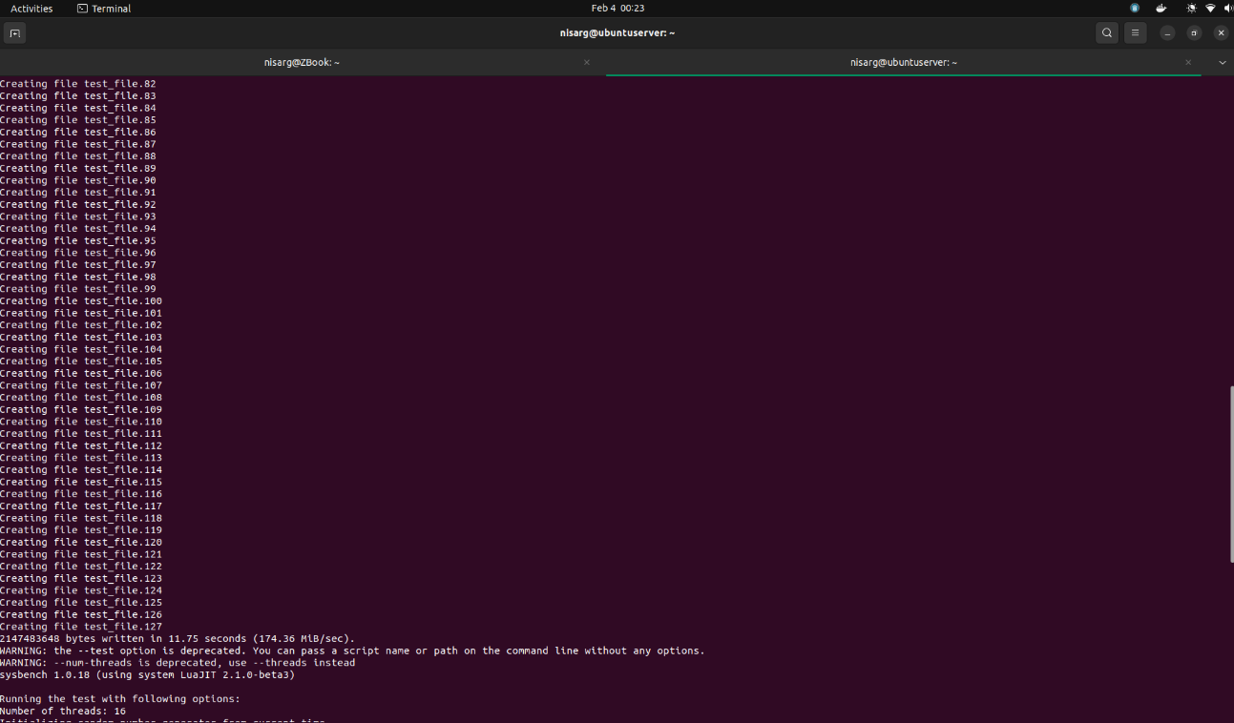

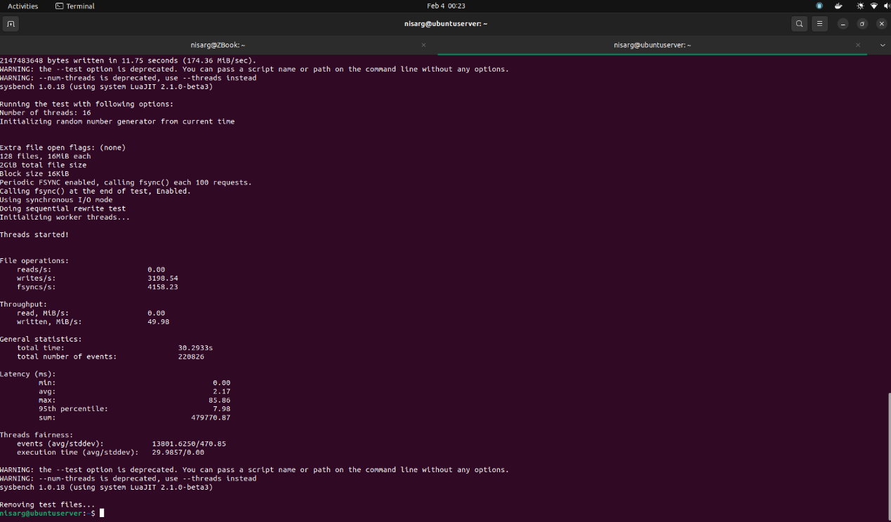

|  |  |  |
| --- | --- | --- |
| Serial run iterations | Results | |
| 1 | reads/s | 0.00 |
| writes/sec | 3150.82 |
| fsyncs/s | 4100.52 |
| events/s | 7184.19 |
| 2 | reads/s | 0.00 |
| writes/sec | 3109.95 |
| fsyncs/s | 4046.58 |
| events/s | 7089.65 |
| 3 | reads/s | 0.00 |
| writes/sec | 3198.54 |
| fsyncs/s | 4158.23 |
| events/s | 7289.60 |

#### Test Run 2: Mode = Combined Random

Here, the sysbench is generating 128 files summing up to 2 GB

***Iteration 1***

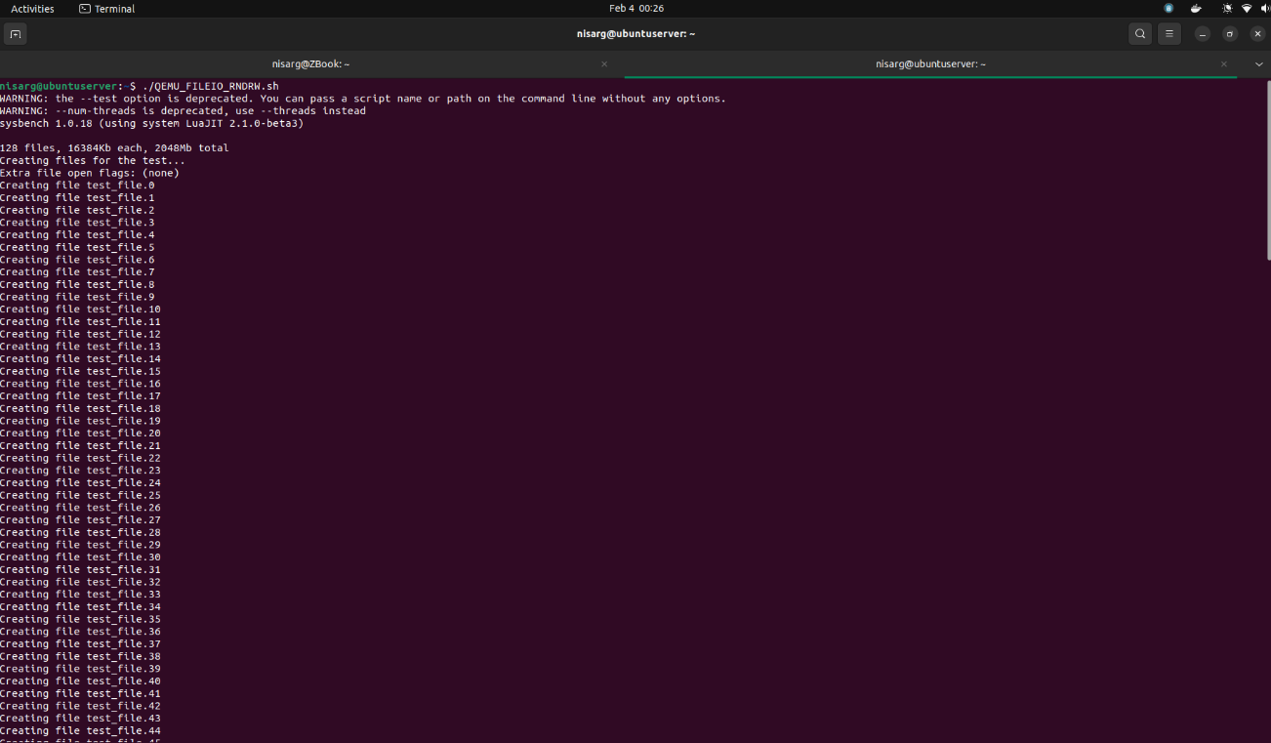

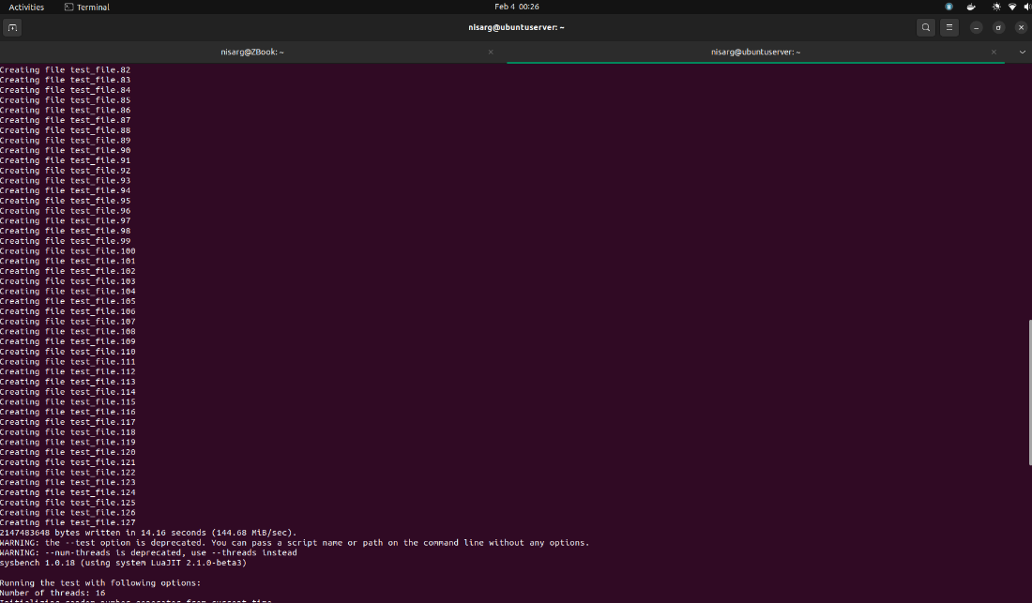

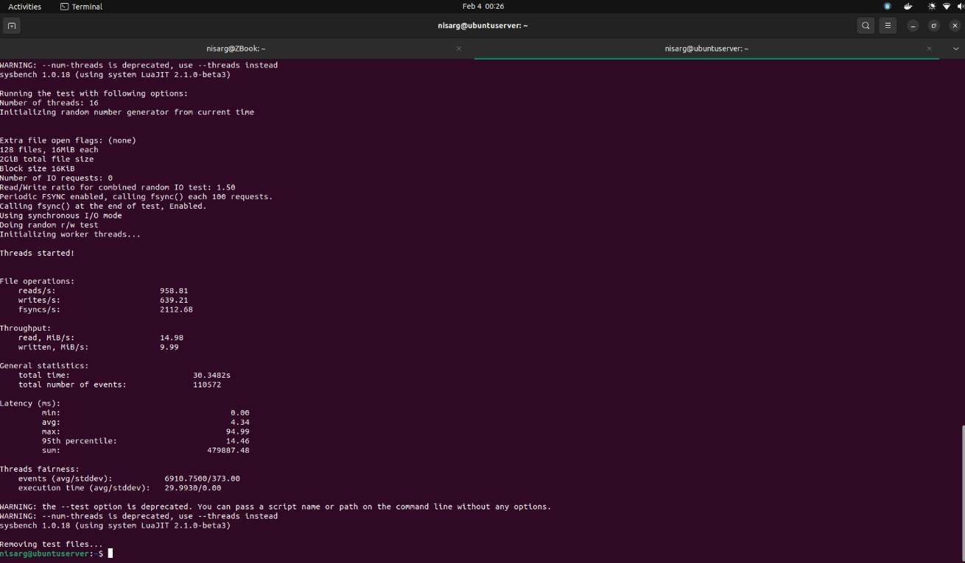

***Iteration 2***

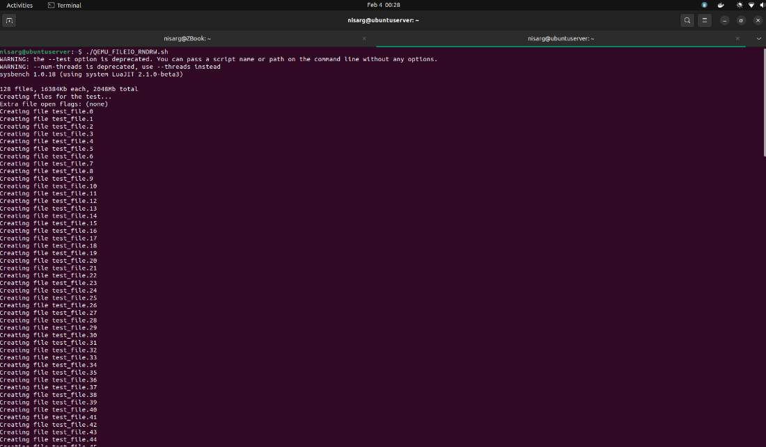

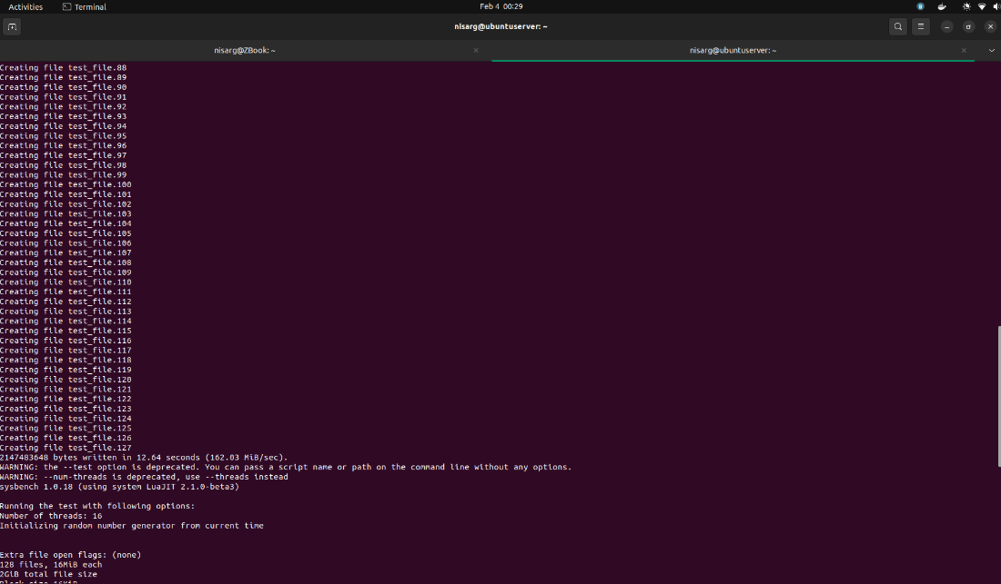

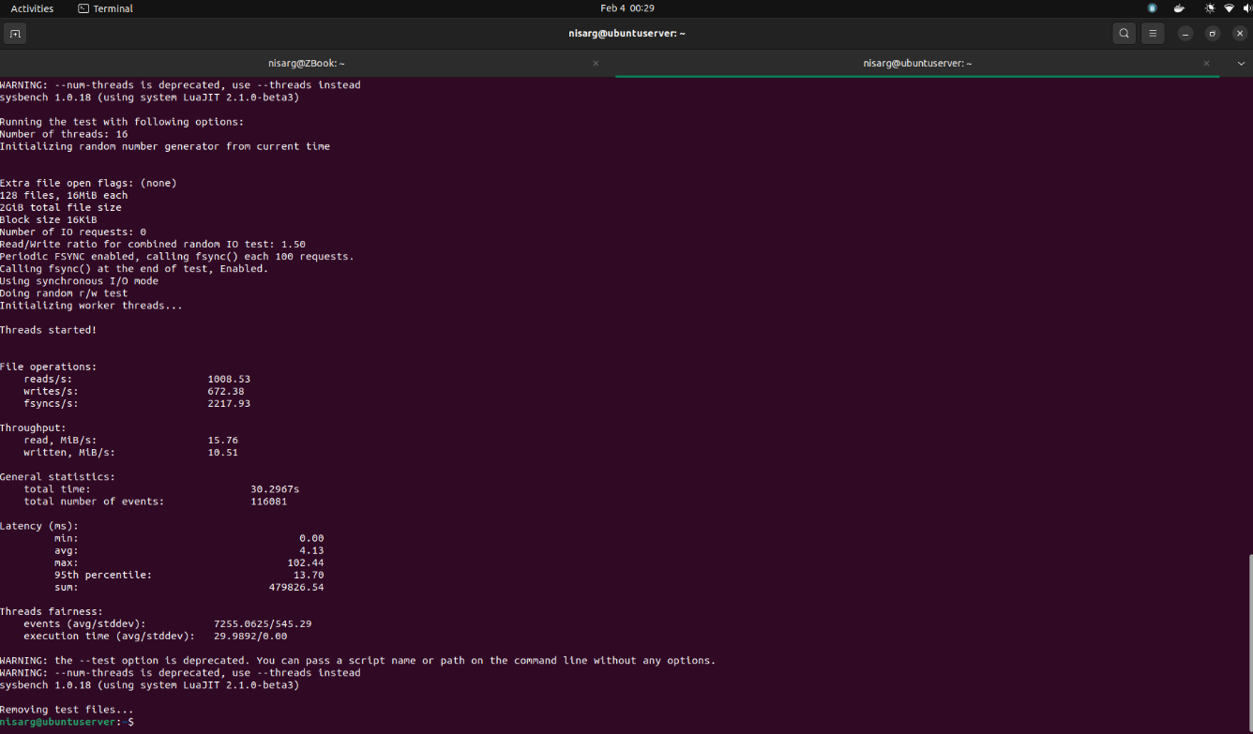

***Iteration 3***

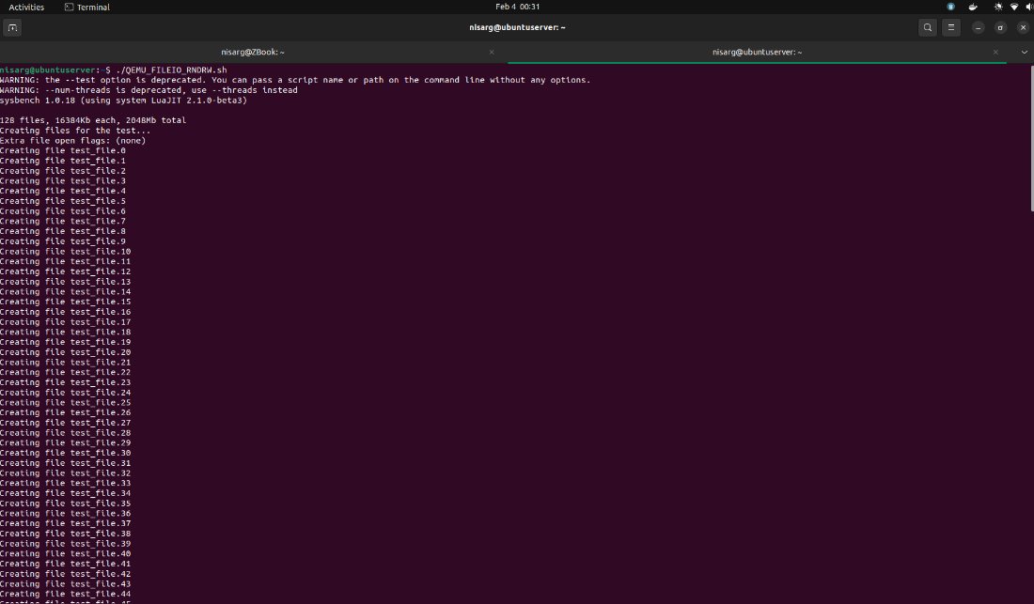

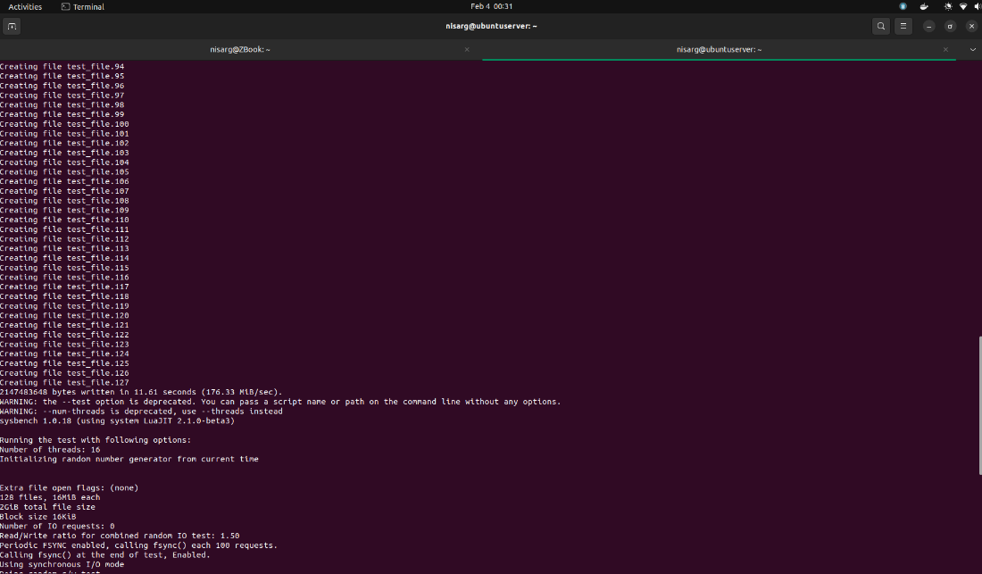

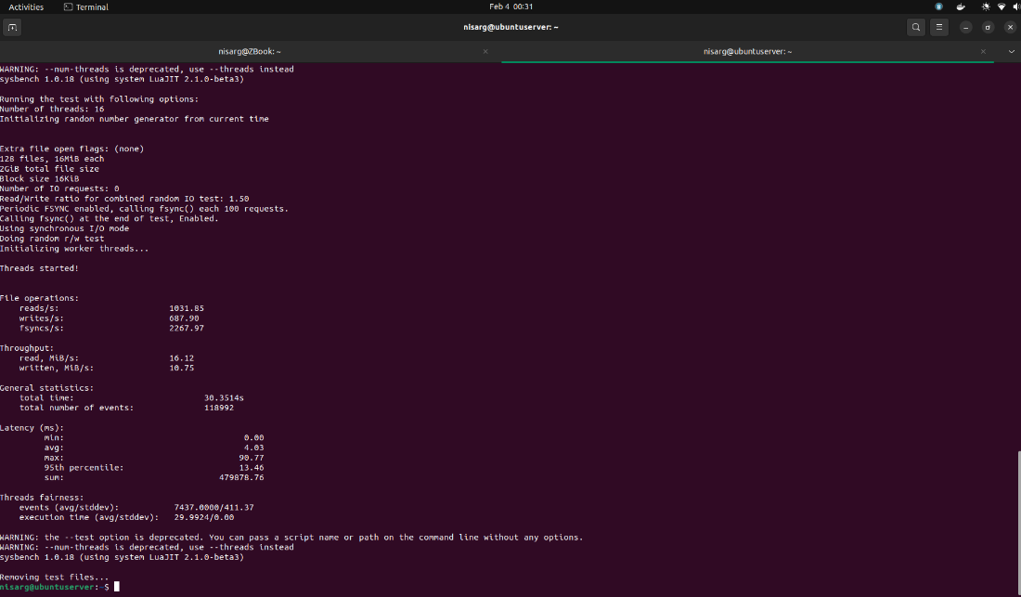

|  |  |  |
| --- | --- | --- |
| Combined run iterations | Results | |
| 1 | reads/s | 958.81 |
| writes/sec | 639.21 |
| fsyncs/s | 2112.68 |
| events/s | 3643.45 |
| 2 | reads/s | 1008.53 |
| writes/sec | 672.38 |
| fsyncs/s | 2217.93 |
| events/s | 3831.47 |
| 3 | reads/s | 1031.85 |
| writes/sec | 687.90 |
| fsyncs/s | 2267.97 |
| events/s | 3920.48 |

## Condition 3: 2GB RAM and 2 Cores on Docker

### CPU Testing

For CPU testing, we will be using 3 test cases to check the system performance with varying max-prime argument.

$ sysbench cpu --cpu-max-prime=<random_value> --num-threads=<random_value> --time=<random_value> run

#### Test Run 1: Prime Limit = 2000

Now, we will be running the test script having cpu-max-prime=2000

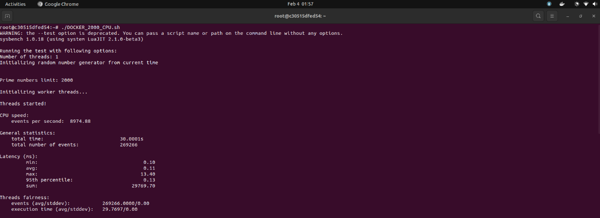

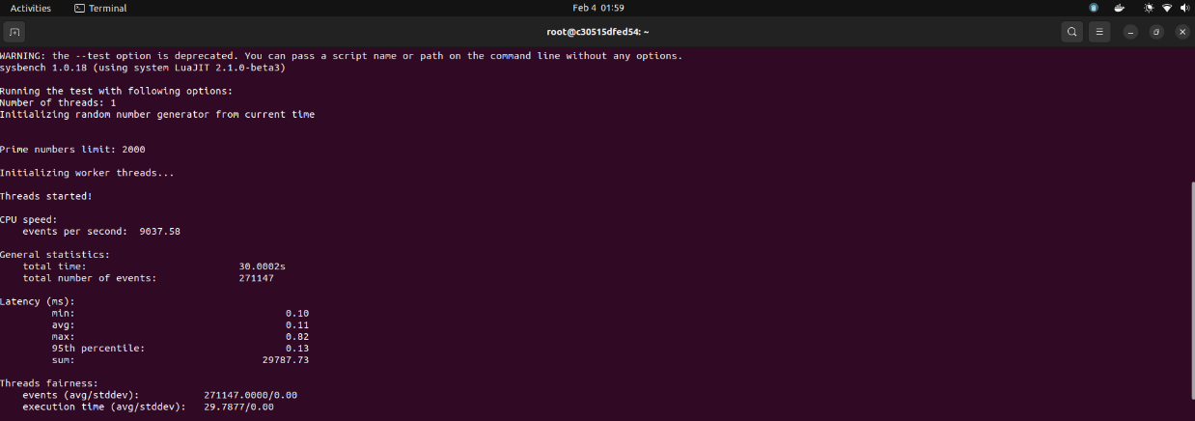

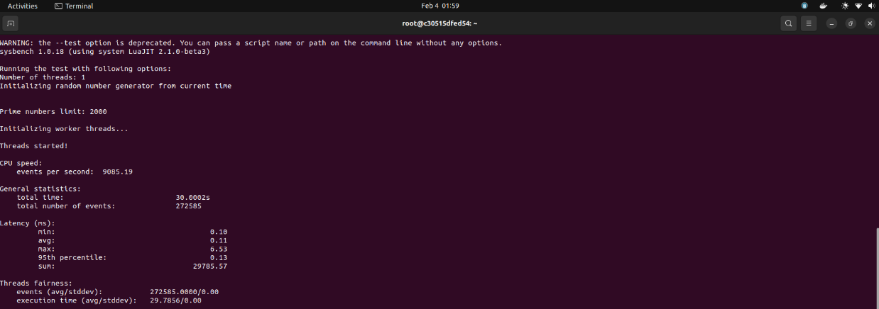

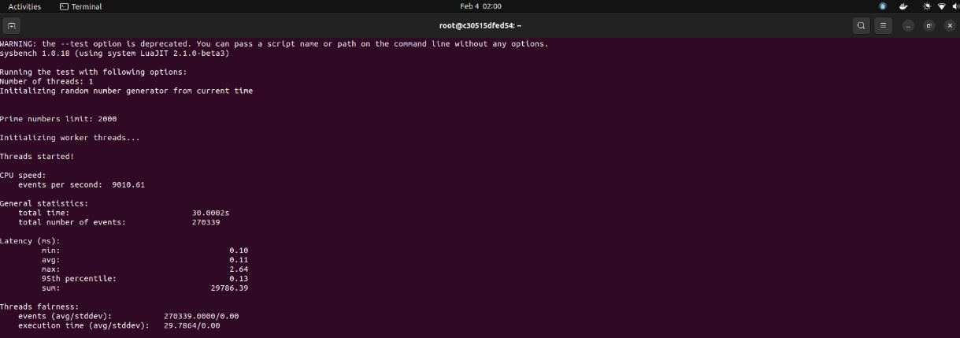

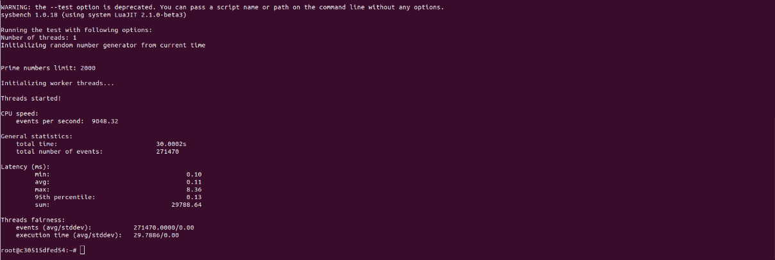

|  |  |
| --- | --- |
| Iteration Number | Number of Events per Second |
| 1 | 8974.88 |
| 2 | 9037.58 |
| 3 | 9085.19 |
| 4 | 9010.61 |
| 5 | 9048.32 |

Statistics for Test Run 1:

* Average number of events per second: 9031.32
* Maximum number of events per second: 9085.19
* Minimum number of events per second: 8974.88

#### Test Run 2: Prime Limit = 20000

Now, we will be running the test script having cpu-max-prime=20000

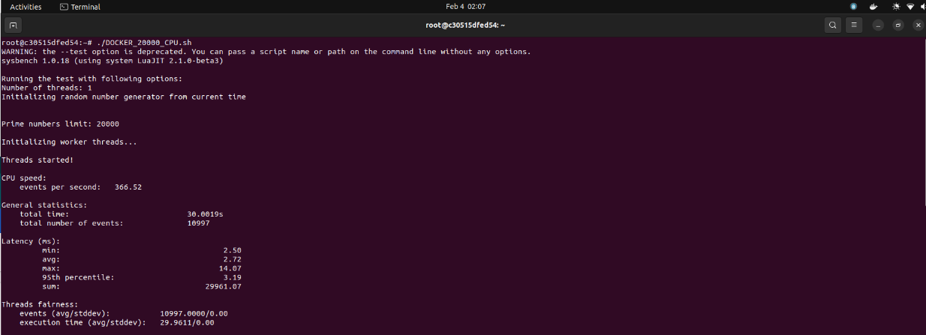

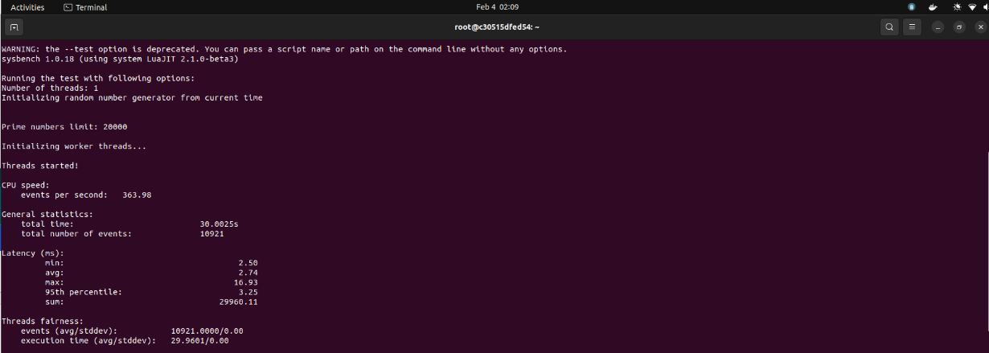

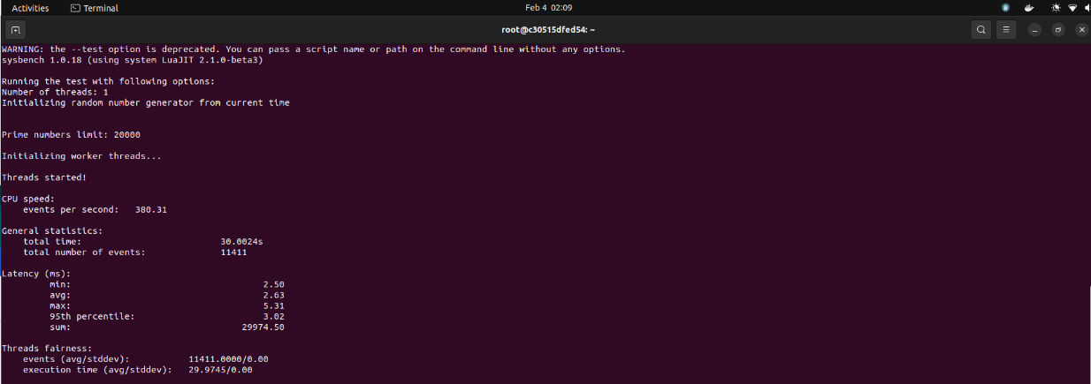

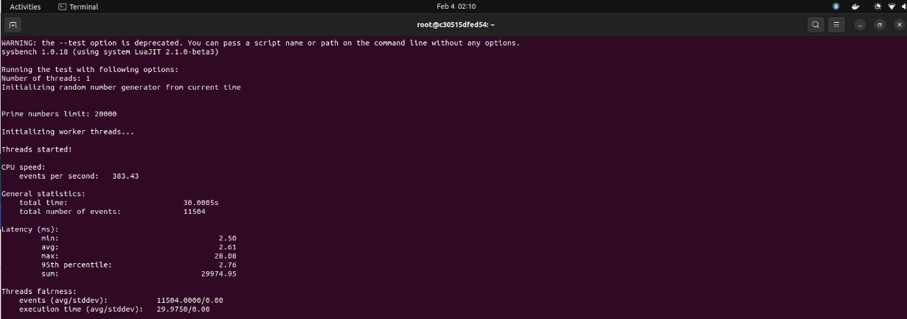

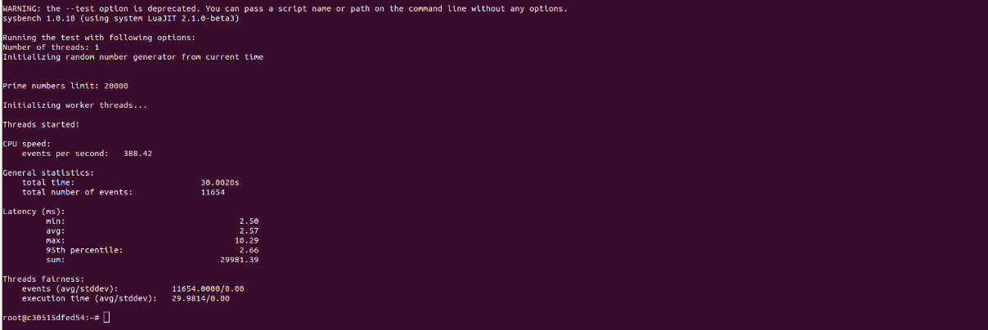

|  |  |
| --- | --- |
| Iteration Number | Number of Events per Second |
| 1 | 366.52 |
| 2 | 363.98 |
| 3 | 380.31 |
| 4 | 383.43 |
| 5 | 388.42 |

Statistics for Test Run 2:

* Average number of events per second: 376.53
* Maximum number of events per second: 388.42
* Minimum number of events per second: 363.98

#### Test Run 3: Prime Limit = 200000

Now, we will be running the test script having cpu-max-prime=200000

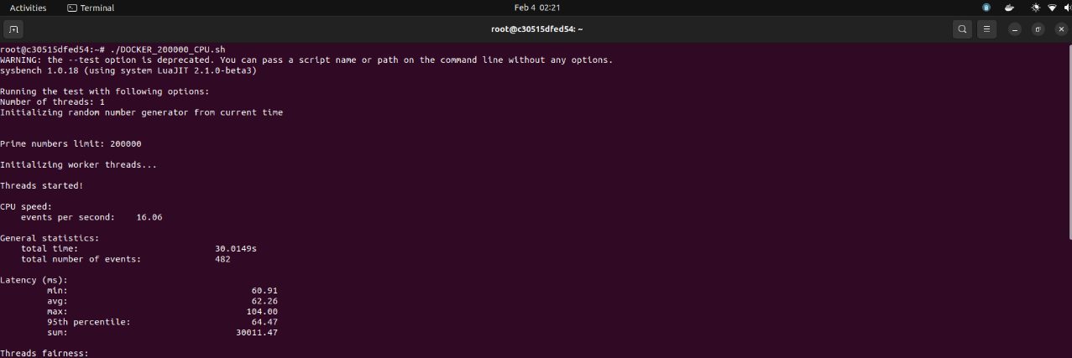

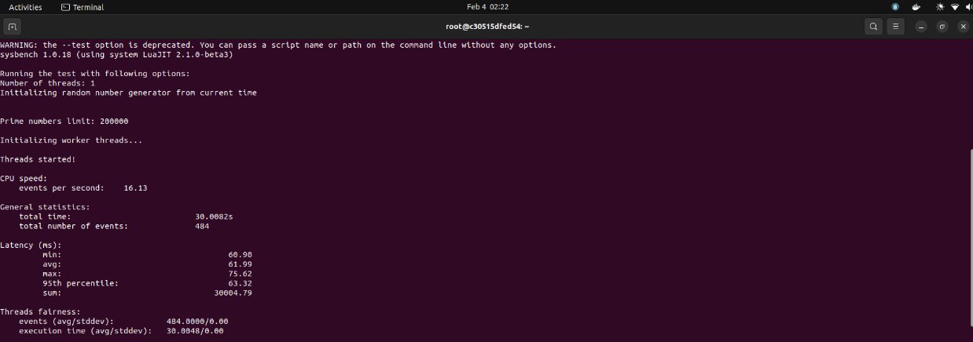

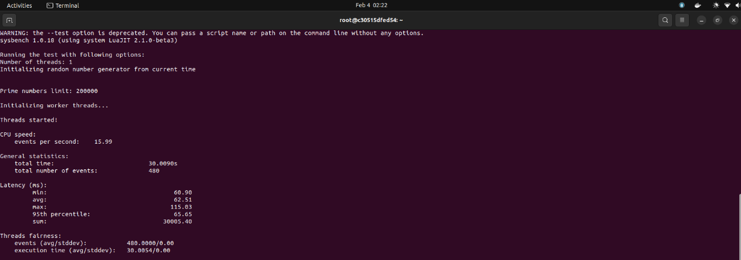

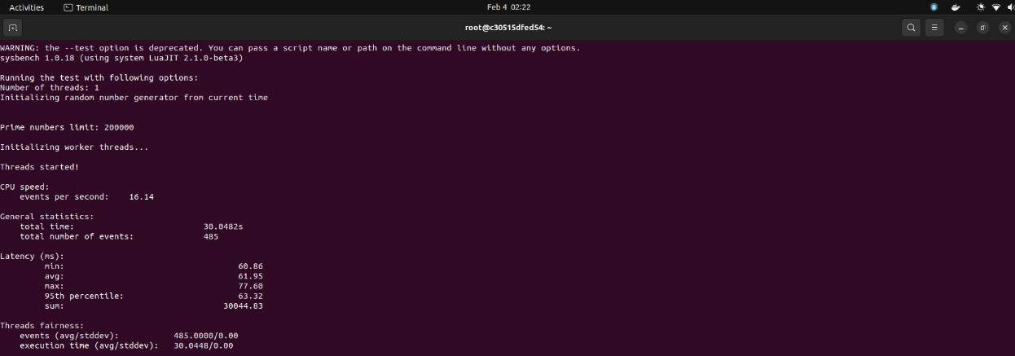

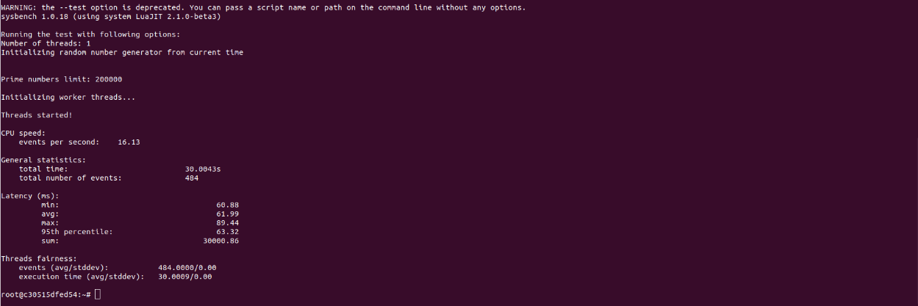

|  |  |
| --- | --- |
| Iteration Number | Number of Events per Second |
| 1 | 16.06 |
| 2 | 16.13 |
| 3 | 15.99 |
| 4 | 16.14 |
| 5 | 16.13 |

Statistics for Test Run 3:

* Average number of events per second: 16.09
* Maximum number of events per second: 16.14
* Minimum number of events per second: 15.99

### File I/O Testing

For file testing, we will be testing a system with sequential read-write and combined random read-write.

$ sysbench --num-threads=16 --test=fileio --file-total-size=2G --time=30 --file-test-mode=<test_mode> prepare

$ sysbench --num-threads=16 --test=fileio --file-total-size=2G --time=30 --file-test-mode=<test_mode> run

$ sysbench --num-threads=16 --test=fileio --file-total-size=2G --time=30 --file-test-mode=<test_mode> cleanup

#### Test Run 1: Mode = Sequential

Here, the sysbench is generating 128 files summing up to 2 GB

***Iteration 1***

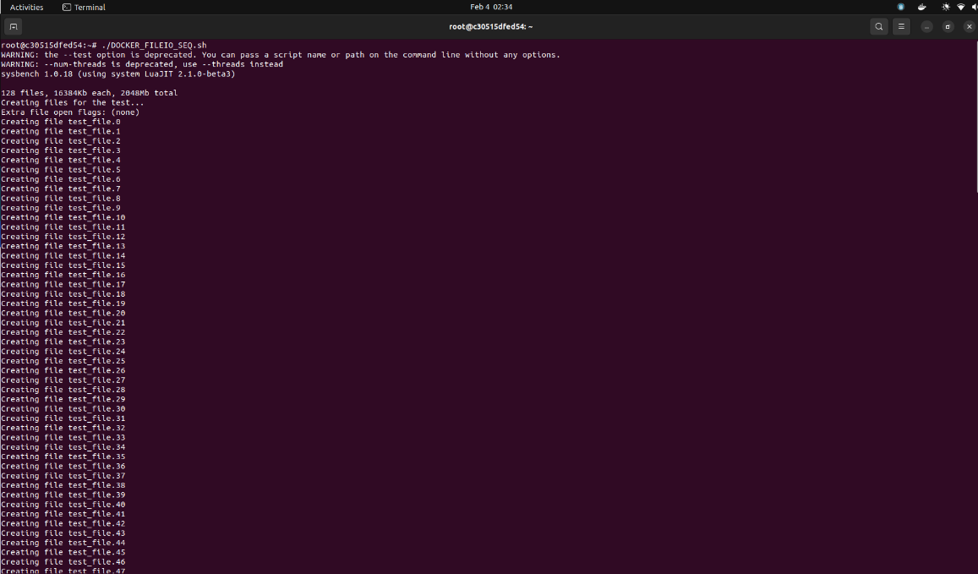

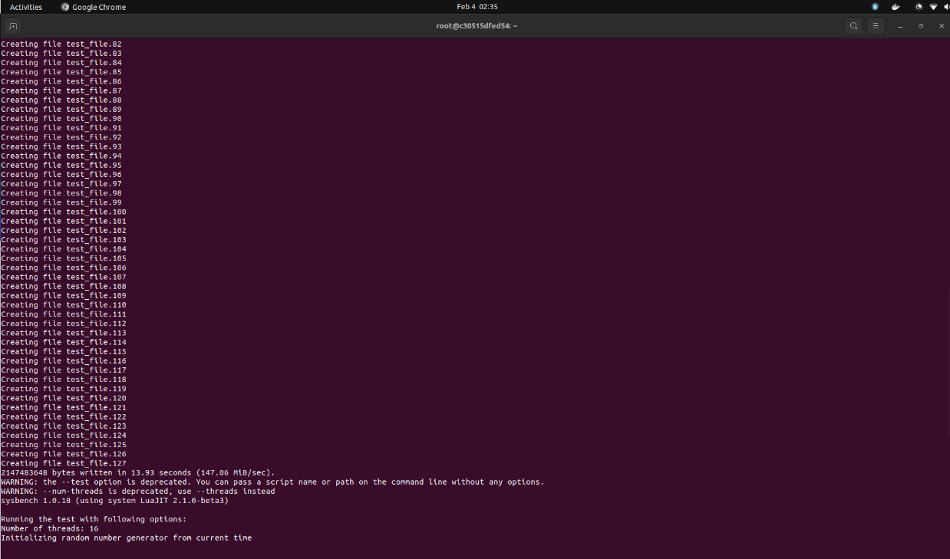

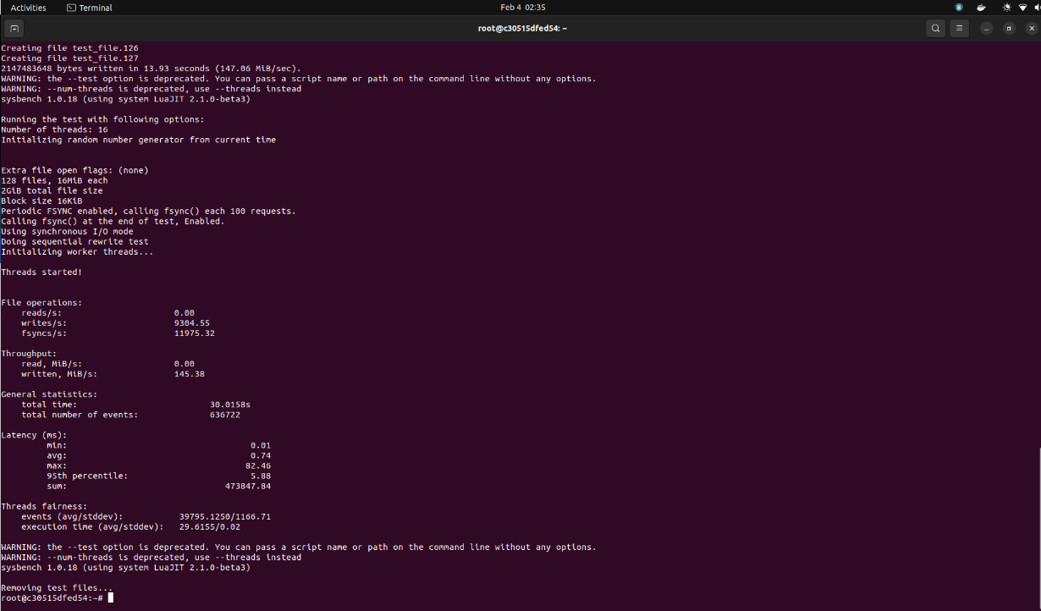

***Iteration 2***

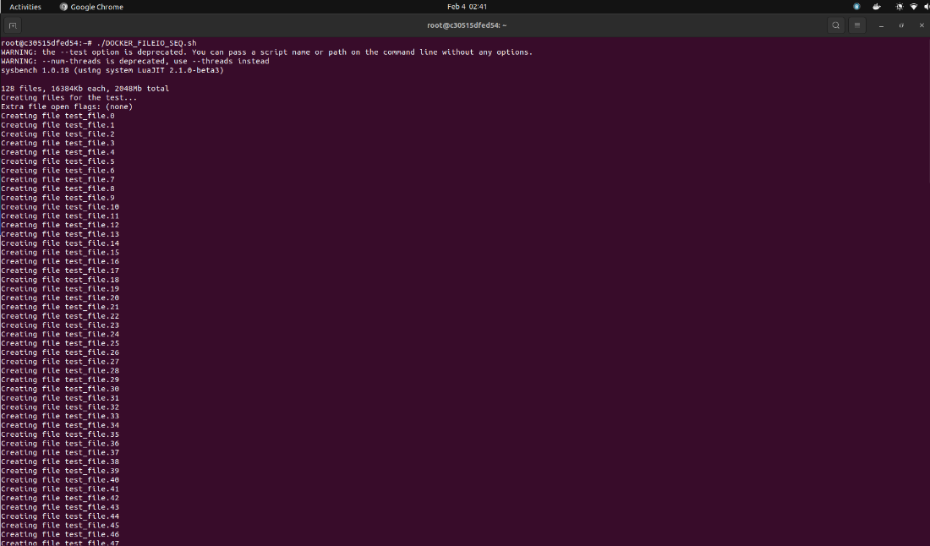

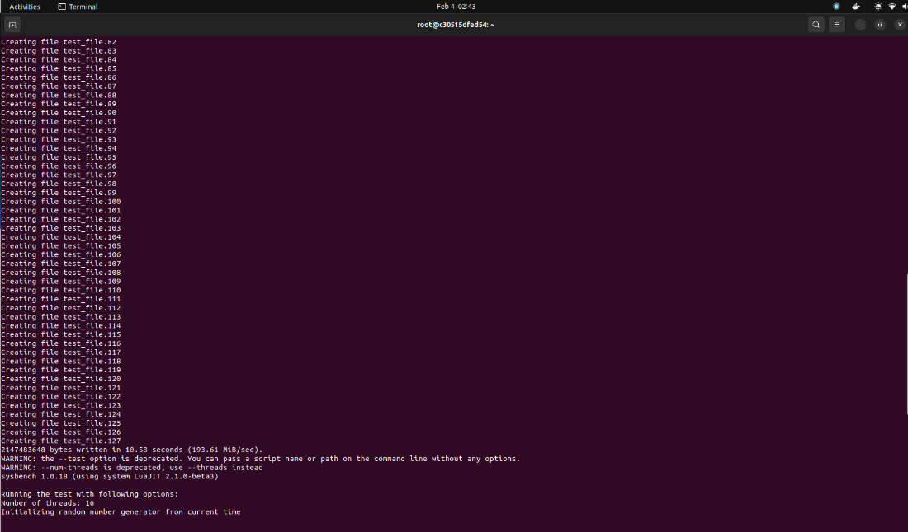

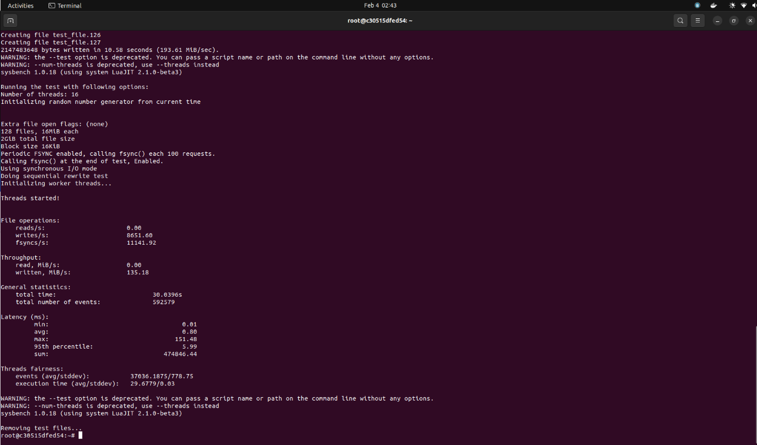

***Iteration 3***

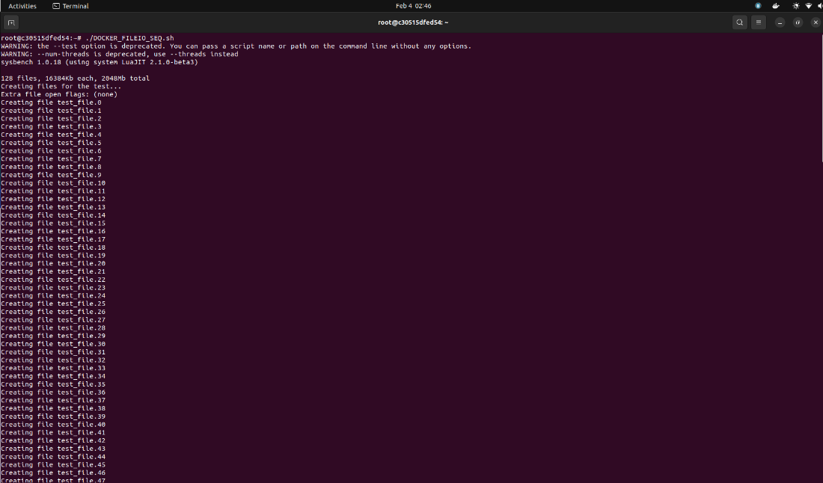

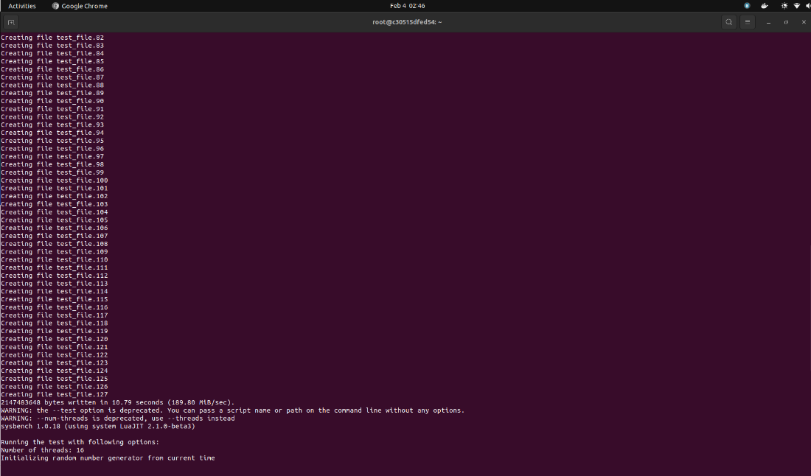

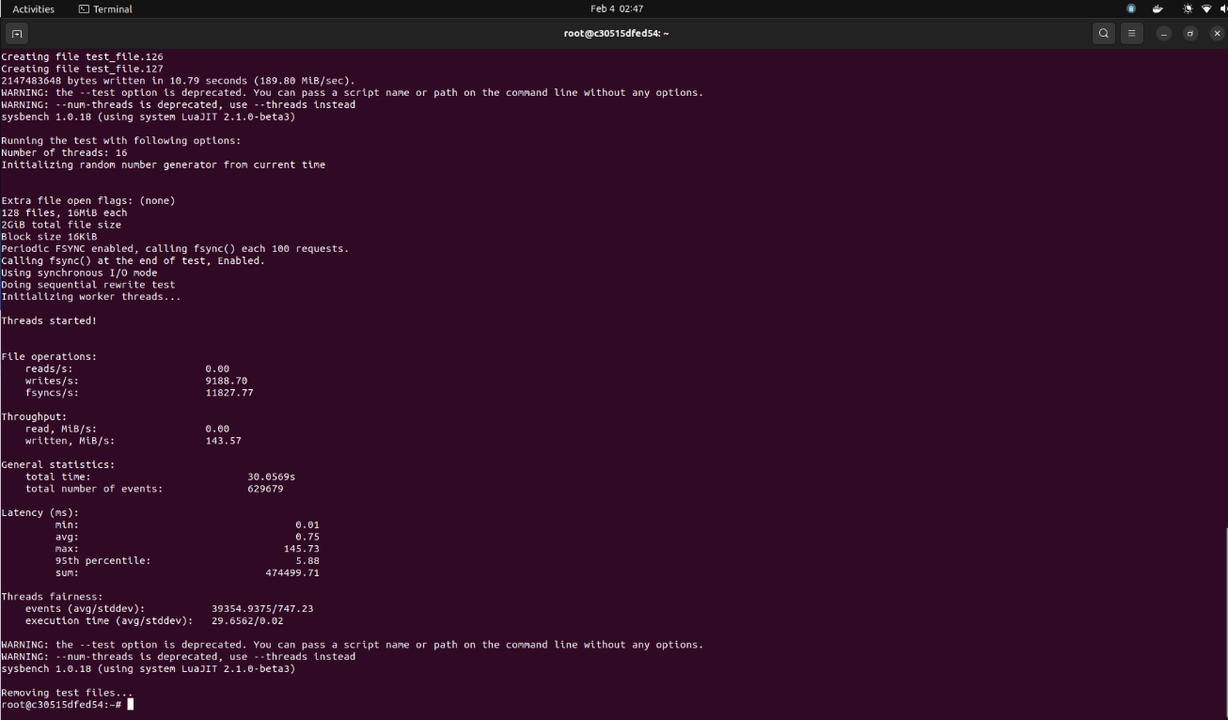

|  |  |  |
| --- | --- | --- |
| Serial run iterations | Results | |
| 1 | reads/s | 0.00 |
| writes/sec | 9304.55 |
| fsyncs/s | 11975.32 |
| events/s | 21212.89 |
| 2 | reads/s | 0.00 |
| writes/sec | 8651.60 |
| fsyncs/s | 11141.92 |
| events/s | 19726.59 |
| 3 | reads/s | 0.00 |
| writes/sec | 9188.70 |
| fsyncs/s | 11827.77 |
| events/s | 20949.57 |

#### Test Run 2: Mode = Combined Random

Here, the sysbench is generating 128 files summing up to 2 GB

***Iteration 1***

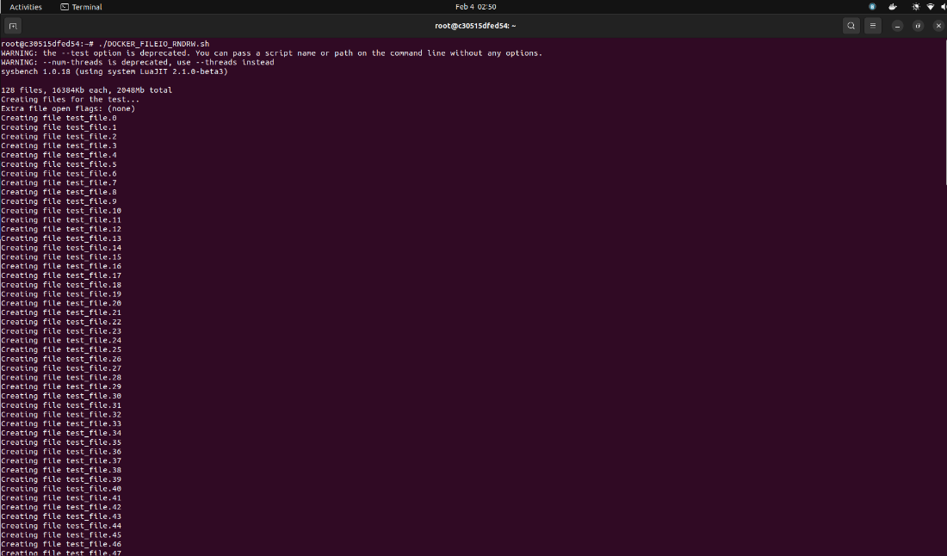

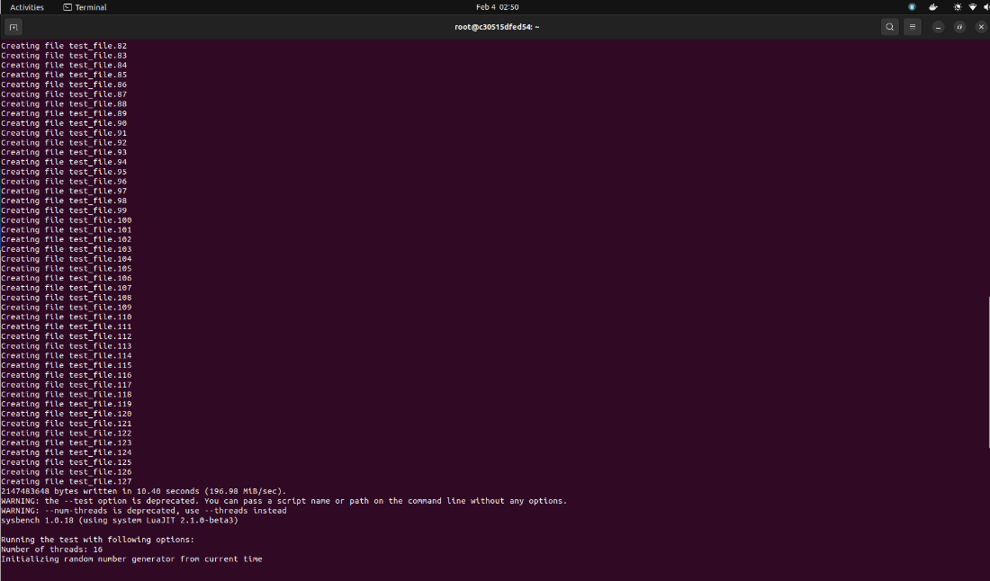

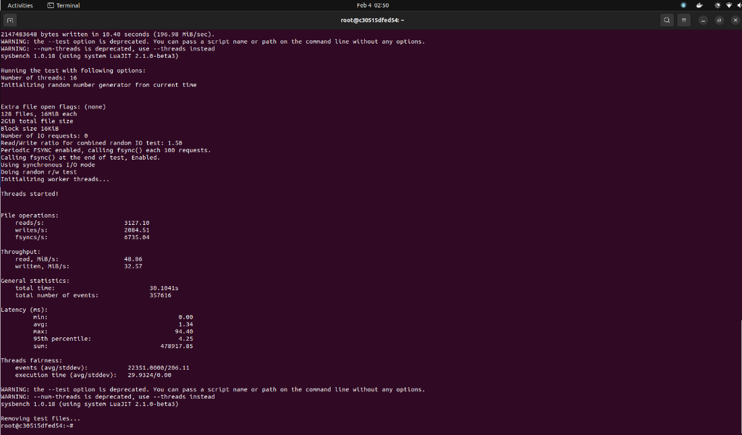

***Iteration 2***

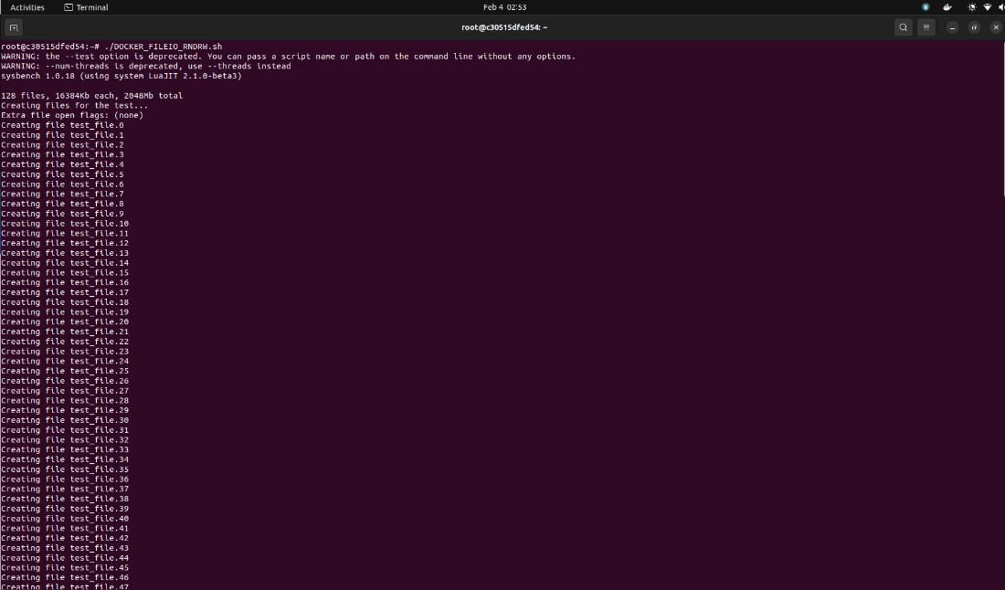

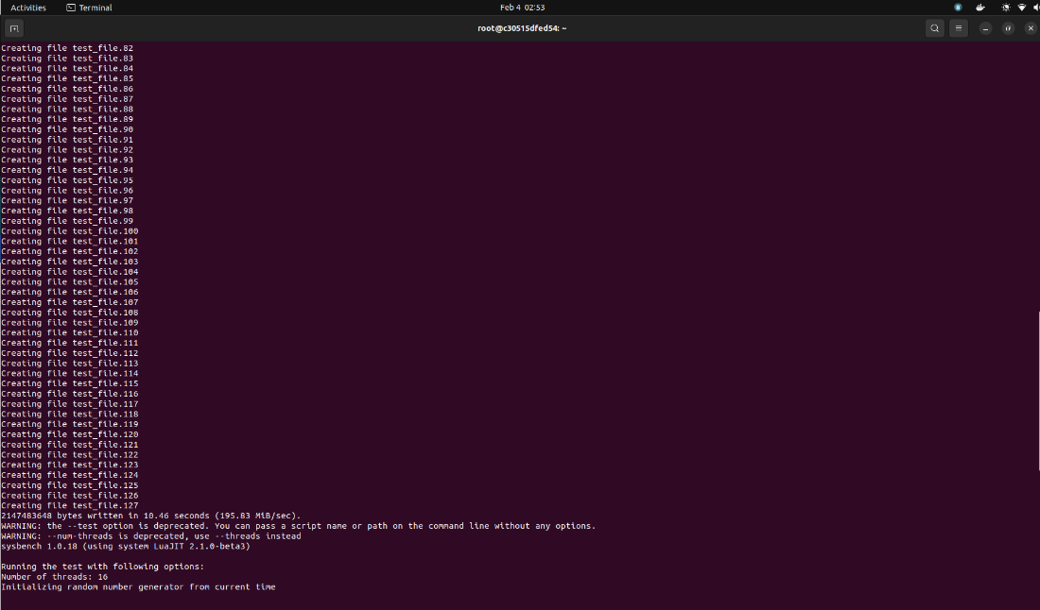

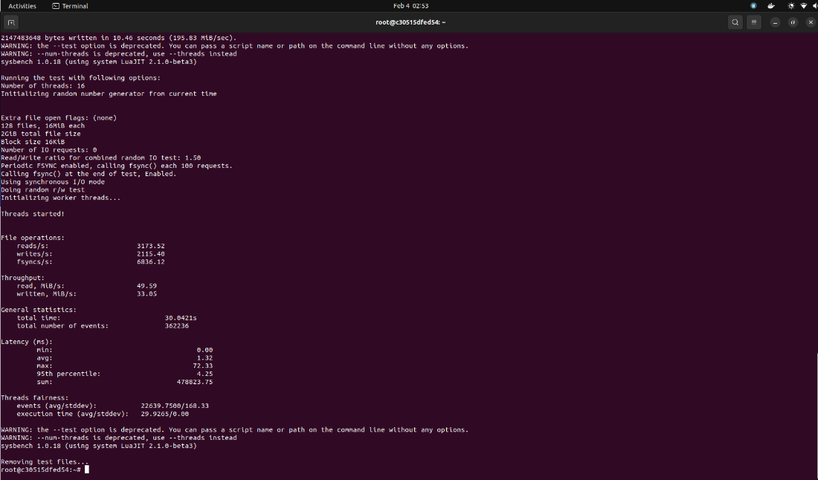

***Iteration 3***

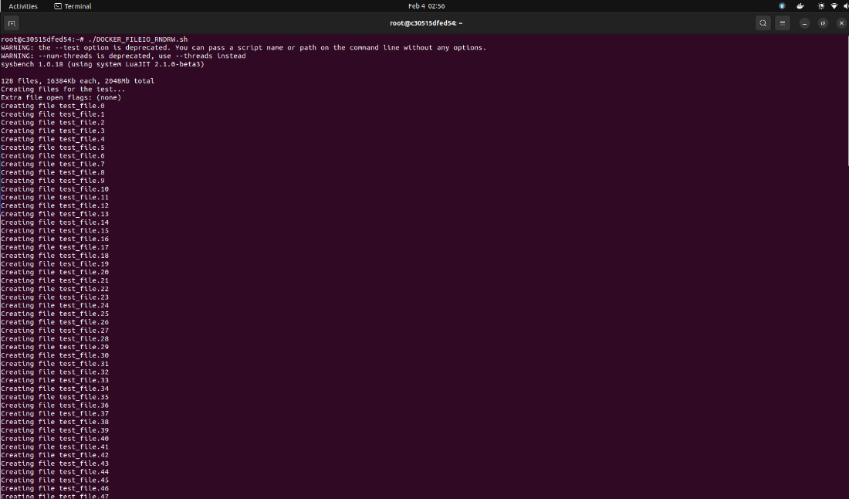

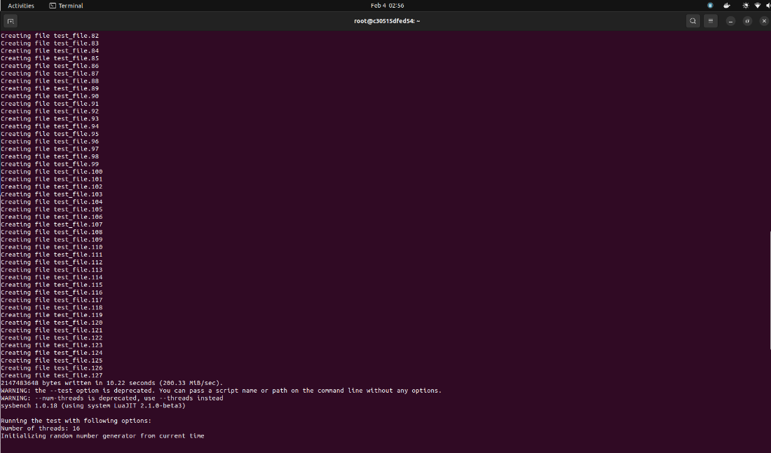

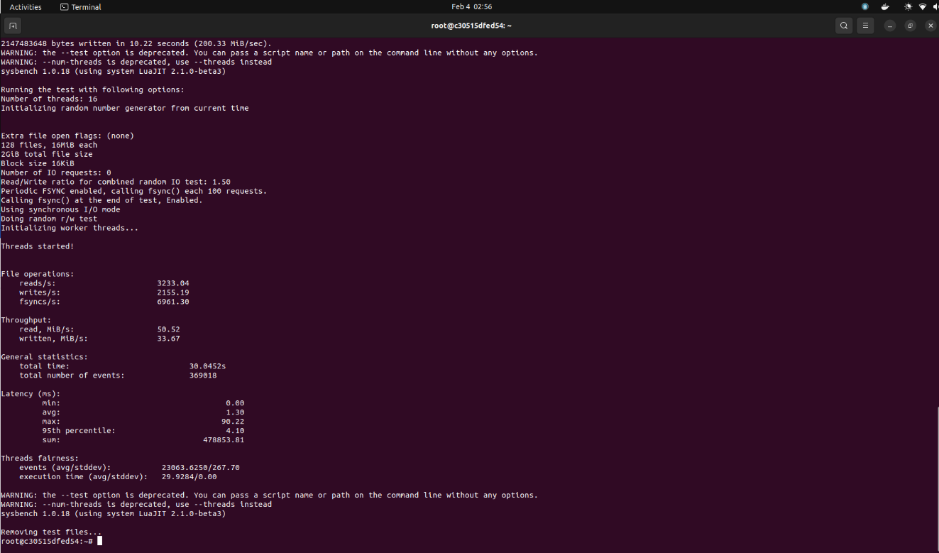

|  |  |  |
| --- | --- | --- |
| Combined run iterations | Results | |
| 1 | reads/s | 3127.10 |
| writes/sec | 2084.51 |
| fsyncs/s | 6735.04 |
| events/s | 11879.31 |
| 2 | reads/s | 3173.52 |
| writes/sec | 2115.40 |
| fsyncs/s | 6836.12 |
| events/s | 12057.61 |
| 3 | reads/s | 3233.04 |
| writes/sec | 2155.19 |
| fsyncs/s | 6961.30 |
| events/s | 1282.09 |

## Condition 4: 3GB RAM and 2 Cores on Docker

### CPU Testing

For CPU testing, we will be using 3 test cases to check the system performance with varying max-prime argument.

$ sysbench cpu --cpu-max-prime=<random_value> --num-threads=<random_value> --time=<random_value> run

#### Test Run 1: Prime Limit = 2000

Now, we will be running the test script having cpu-max-prime=2000

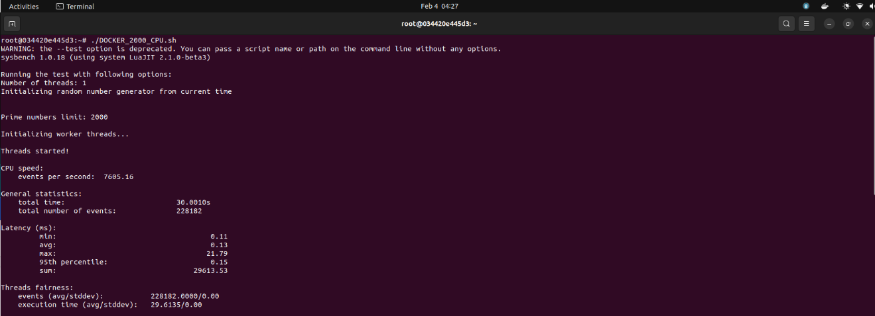

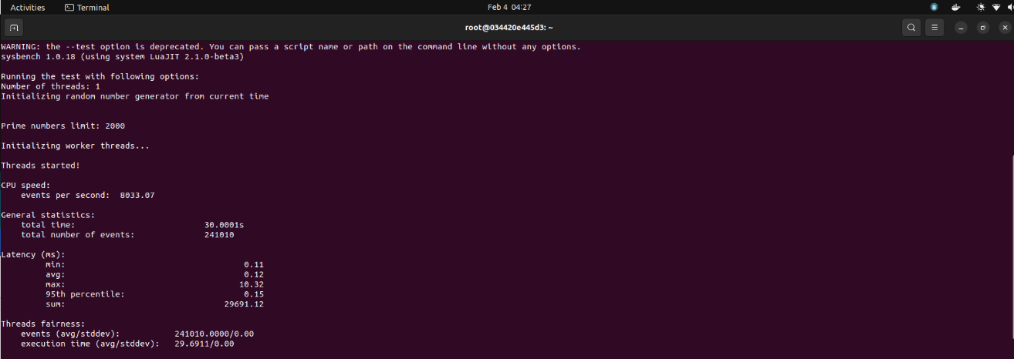

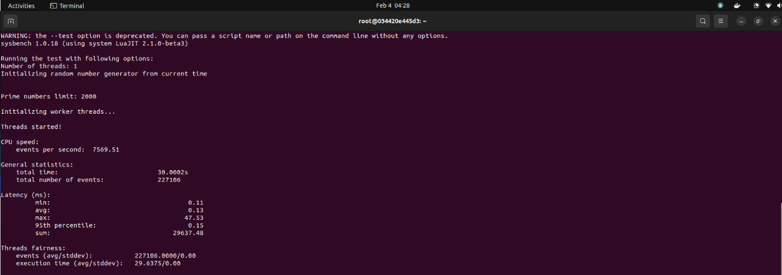

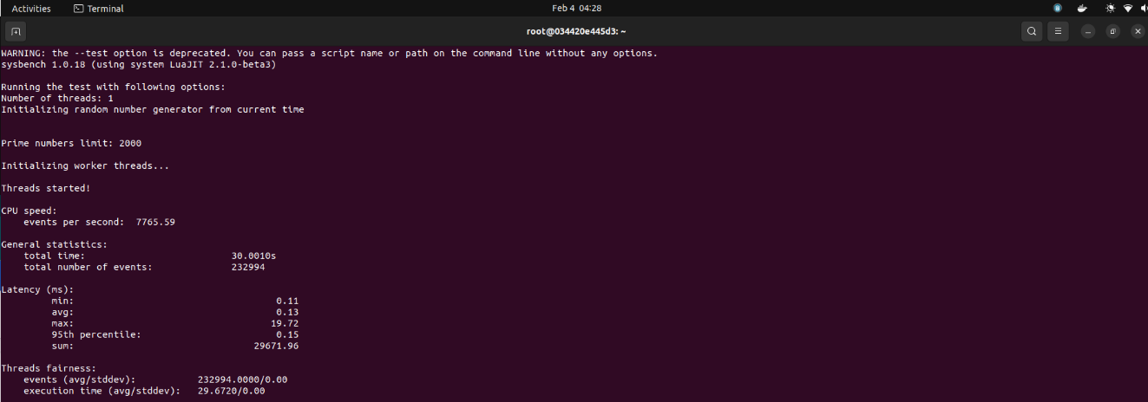

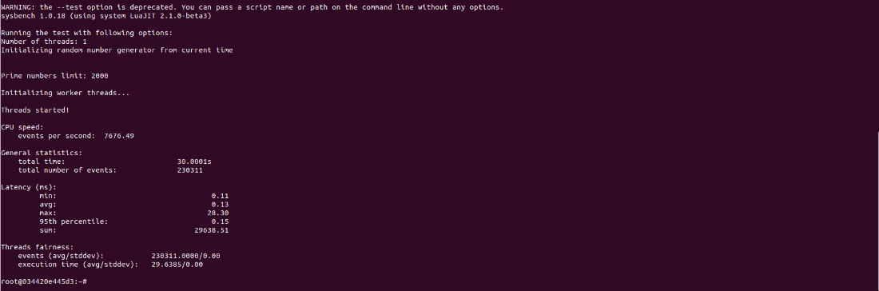

|  |  |
| --- | --- |
| Iteration Number | Number of Events per Second |
| 1 | 7605.16 |
| 2 | 8033.07 |
| 3 | 7569.51 |
| 4 | 7765.59 |
| 5 | 7676.49 |

Statistics for Test Run 1:

* Average number of events per second: 7729.96
* Maximum number of events per second: 8033.07
* Minimum number of events per second: 7605.16

#### Test Run 2: Prime Limit = 20000

Now, we will be running the test script having cpu-max-prime=20000

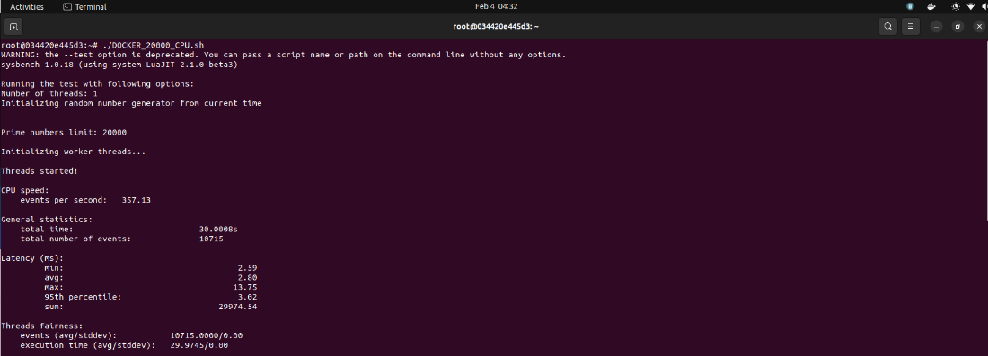

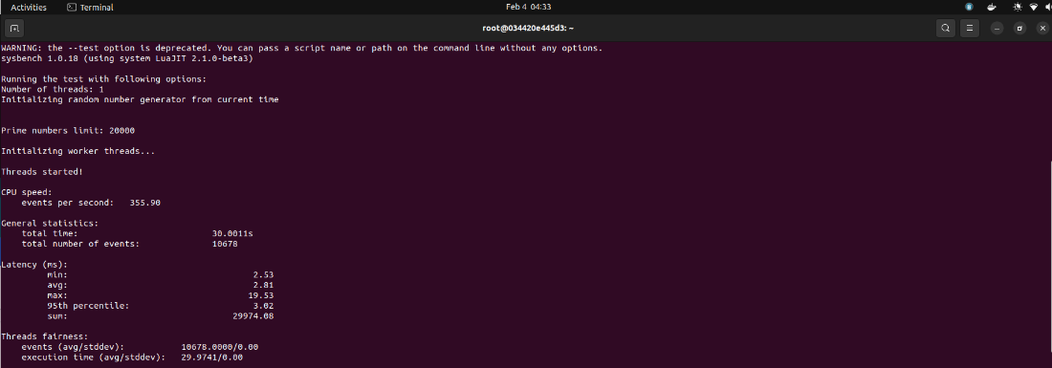

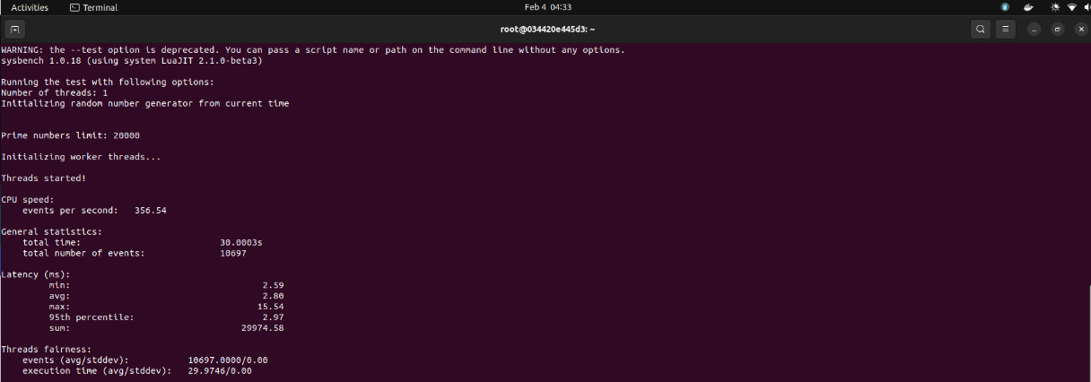

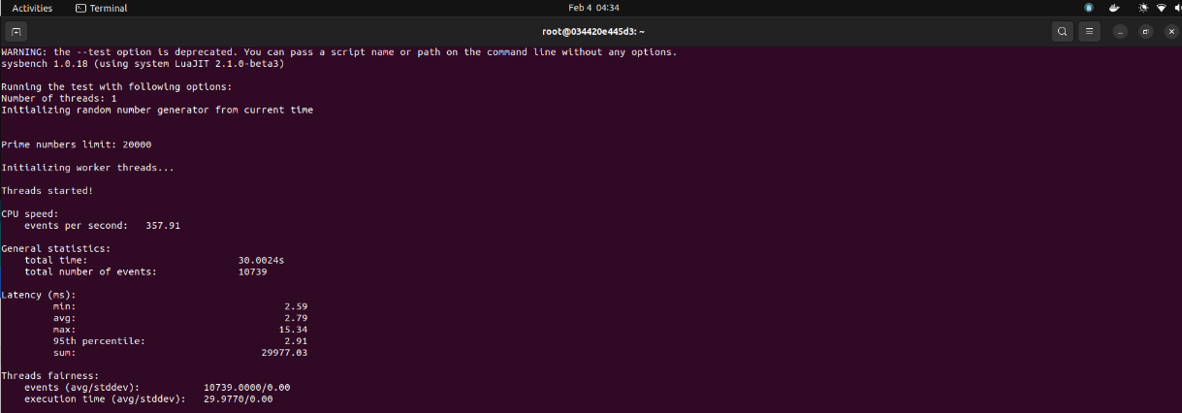

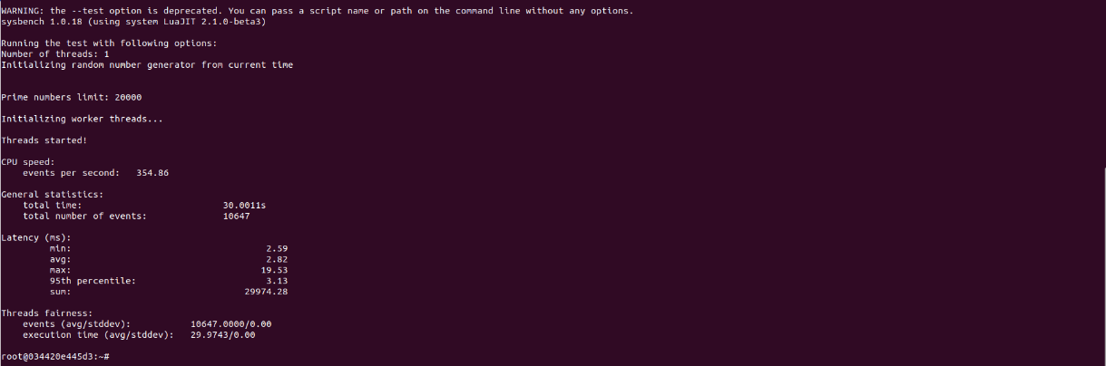

|  |  |
| --- | --- |
| Iteration Number | Number of Events per Second |
| 1 | 357.13 |
| 2 | 355.90 |
| 3 | 356.54 |
| 4 | 357.91 |
| 5 | 354.86 |

Statistics for Test Run 2:

* Average number of events per second: 356.47
* Maximum number of events per second: 357.91
* Minimum number of events per second: 354.86

#### Test Run 3: Prime Limit = 200000

Now, we will be running the test script having cpu-max-prime=200000

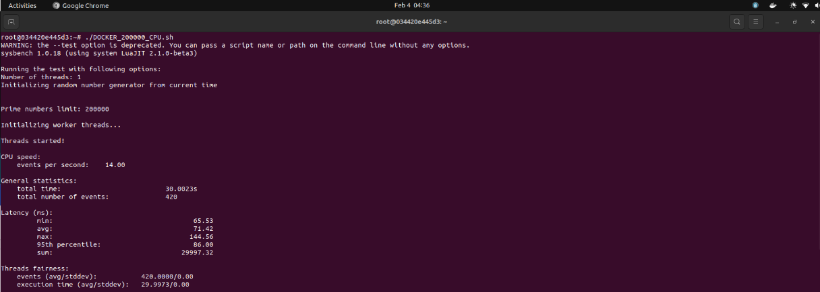

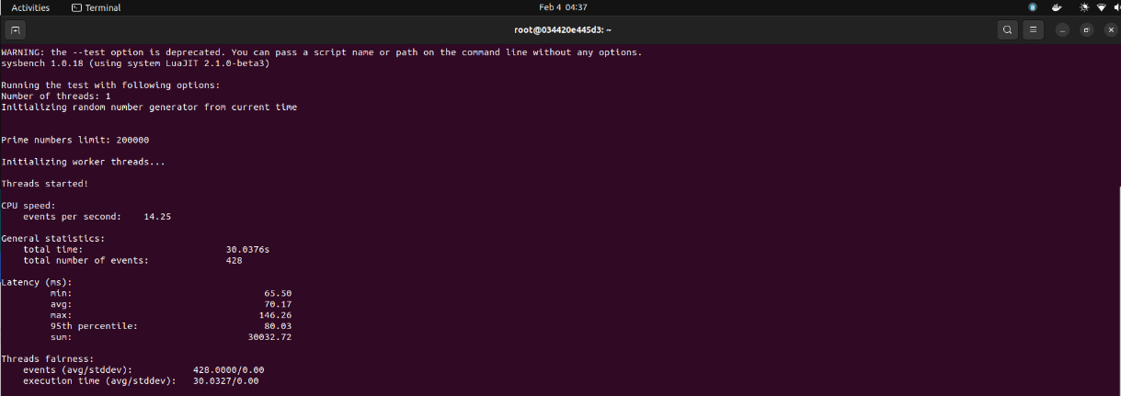

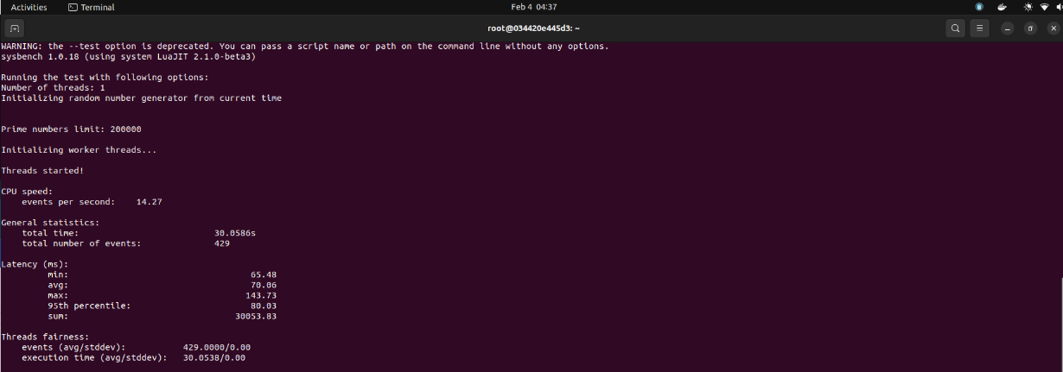

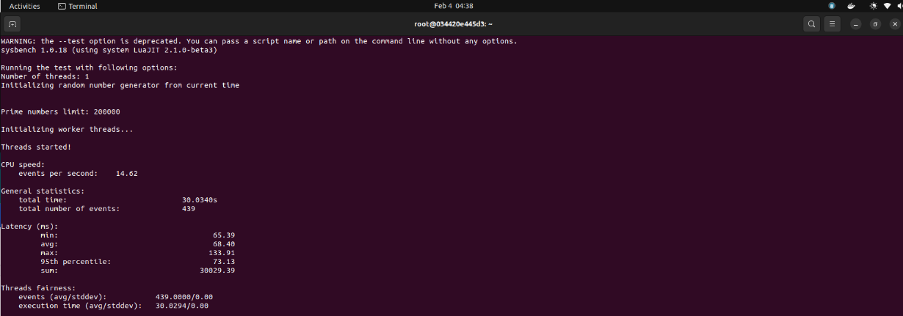

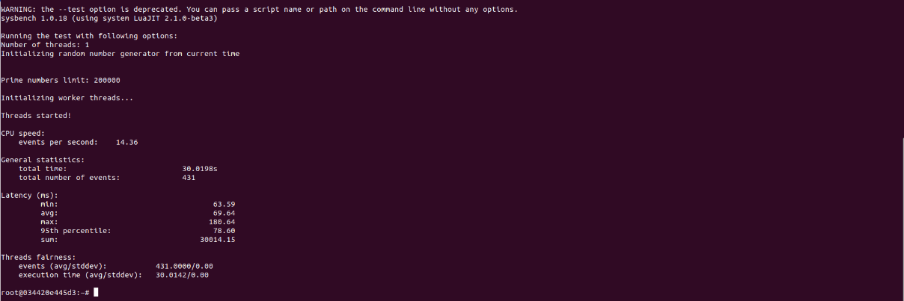

|  |  |
| --- | --- |
| Iteration Number | Number of Events per Second |
| 1 | 14.00 |
| 2 | 14.25 |
| 3 | 14.27 |
| 4 | 14.62 |
| 5 | 14.36 |

Statistics for Test Run 3:

* Average number of events per second: 14.30
* Maximum number of events per second: 14.62
* Minimum number of events per second: 14.00

### File I/O Testing

For file testing, we will be testing a system with sequential read-write and combined random read-write.

$ sysbench --num-threads=16 --test=fileio --file-total-size=2G --time=30 --file-test-mode=<test_mode> prepare

$ sysbench --num-threads=16 --test=fileio --file-total-size=2G --time=30 --file-test-mode=<test_mode> run

$ sysbench --num-threads=16 --test=fileio --file-total-size=2G --time=30 --file-test-mode=<test_mode> cleanup

#### Test Run 1: Mode = Sequential

Here, the sysbench is generating 128 files summing up to 2 GB

***Iteration 1***

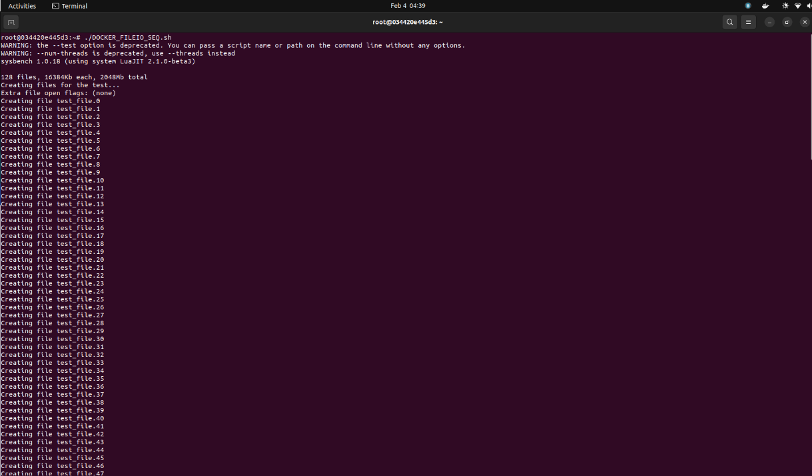

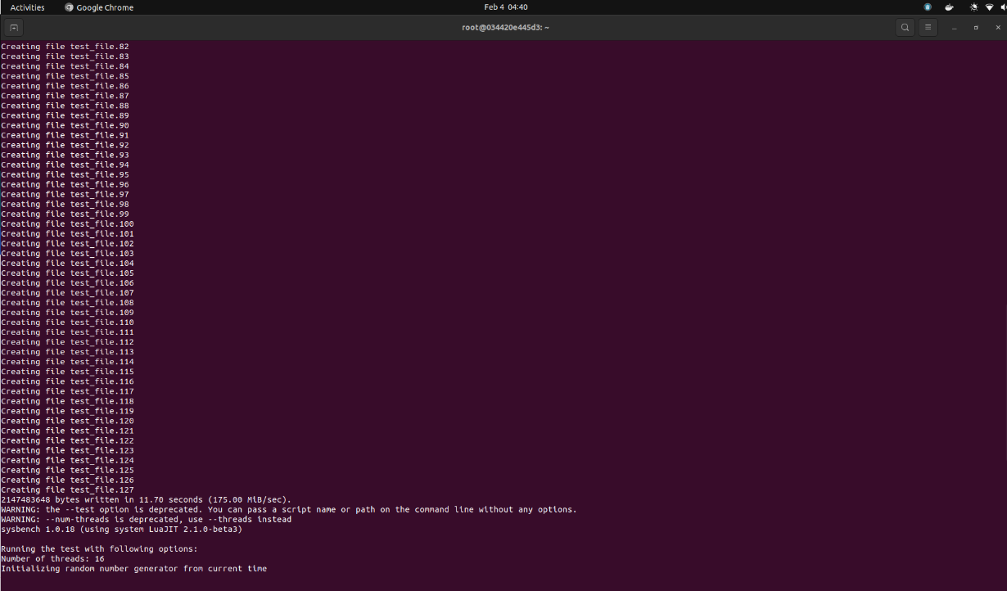

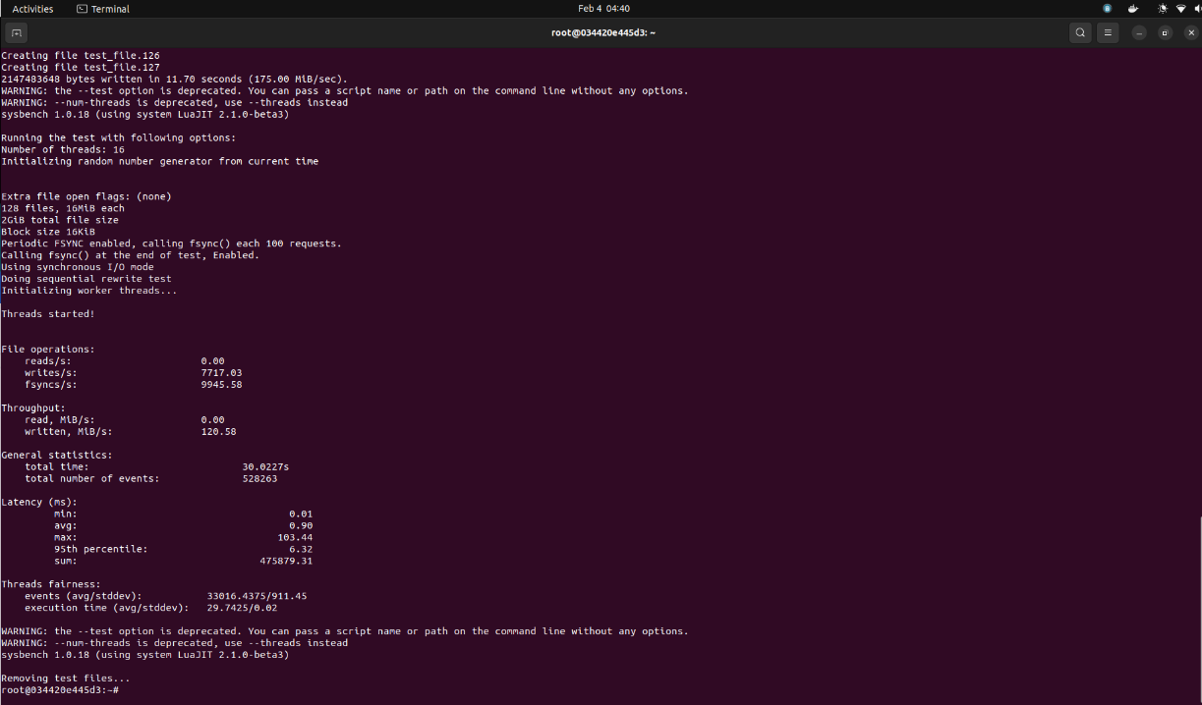

***Iteration 2***

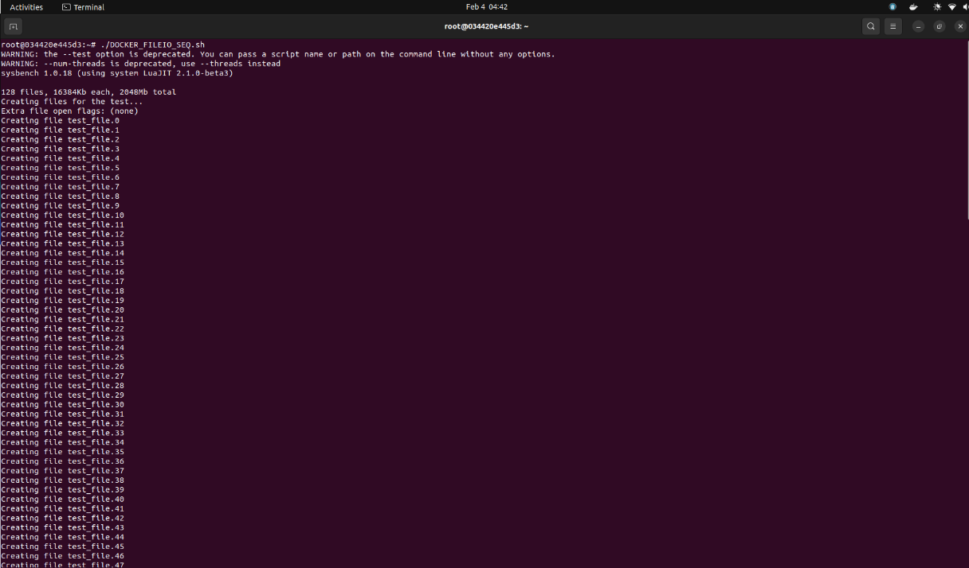

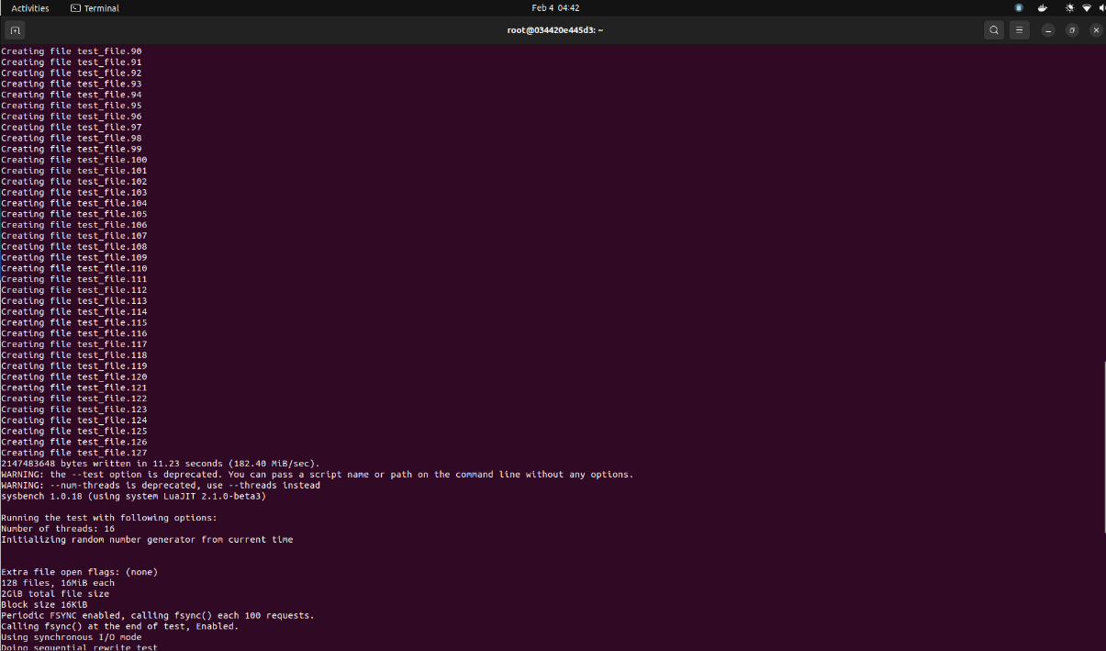

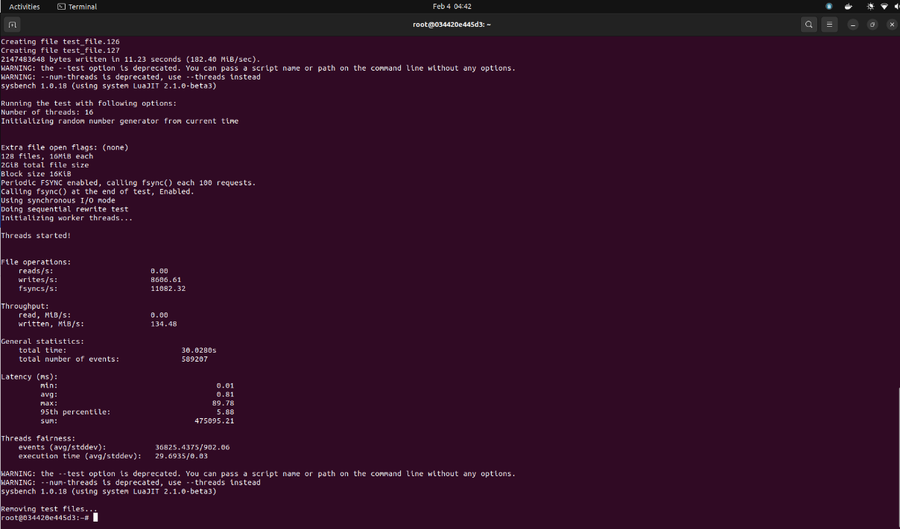

***Iteration 3***

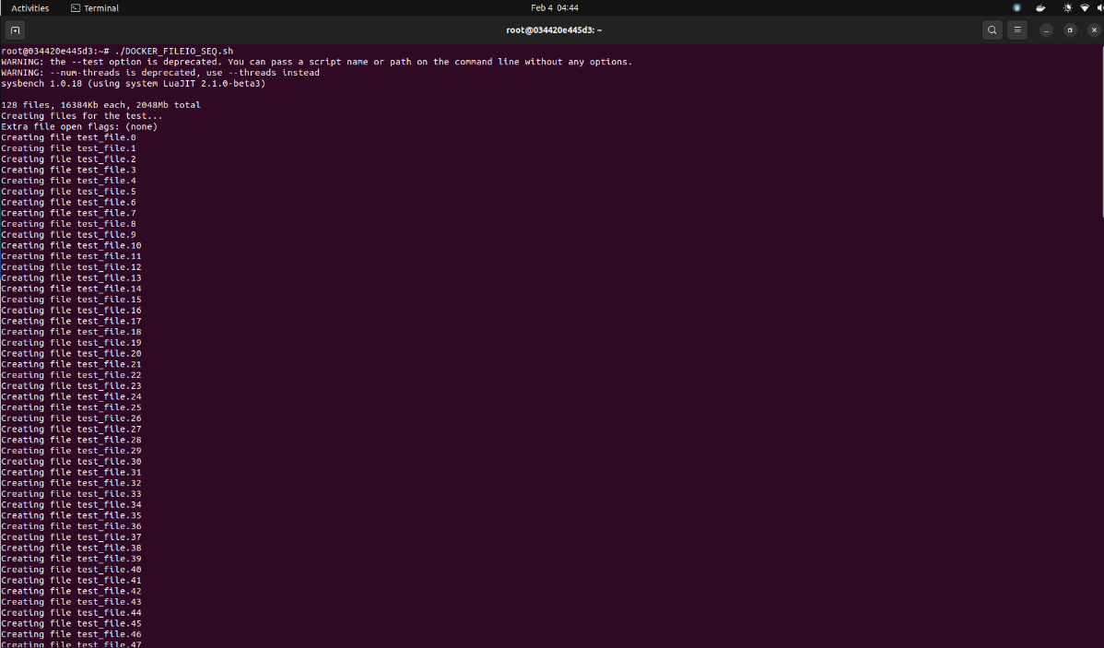

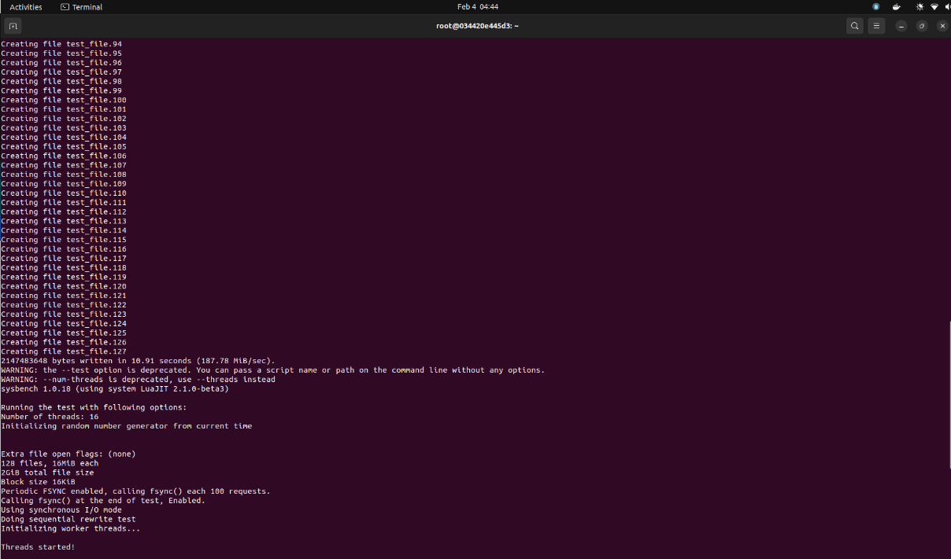

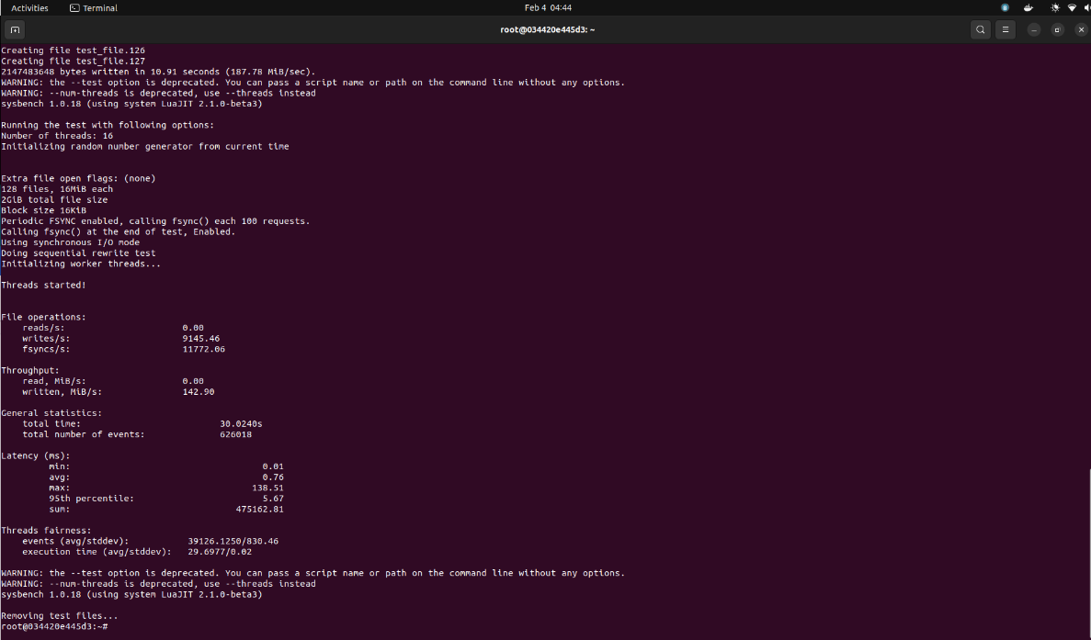

|  |  |  |
| --- | --- | --- |
| Serial run iterations | Results | |
| 1 | reads/s | 0.00 |
| writes/sec | 7717.03 |
| fsyncs/s | 9945.58 |
| events/s | 17595.45 |
| 2 | reads/s | 0.00 |
| writes/sec | 8606.61 |
| fsyncs/s | 11082.32 |
| events/s | 19621.92 |
| 3 | reads/s | 0.00 |
| writes/sec | 9145.46 |
| fsyncs/s | 11772.06 |
| events/s | 20850.59 |

#### Test Run 2: Mode = Combined Random

Here, the sysbench is generating 128 files summing up to 2 GB

***Iteration 1***

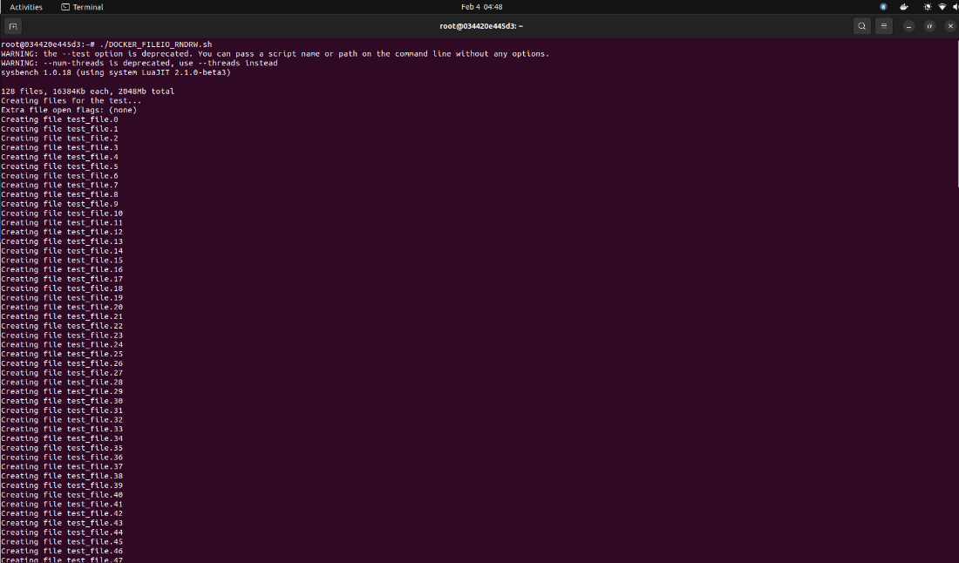

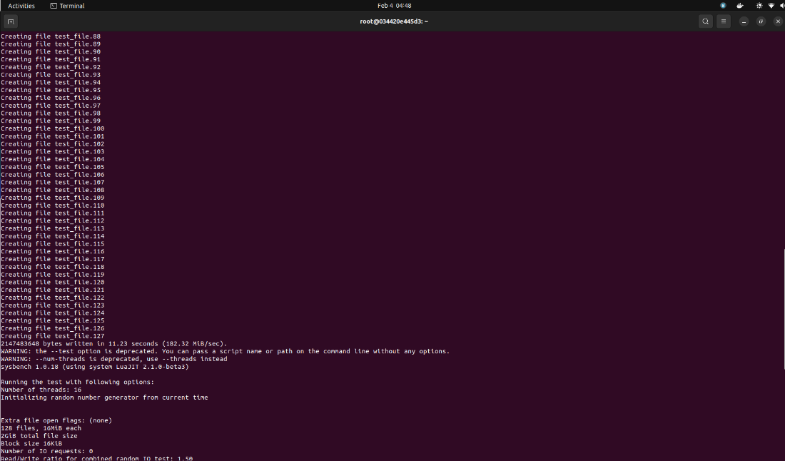

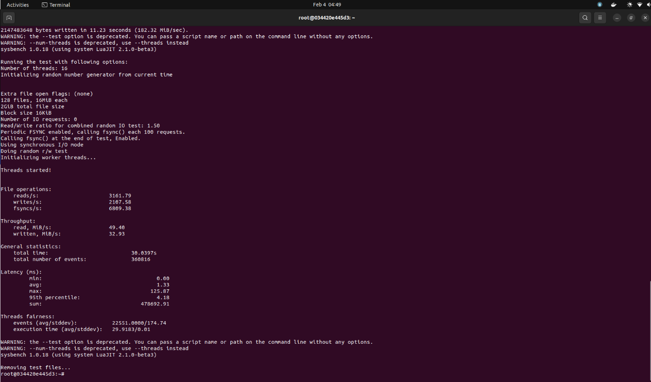

***Iteration 2***

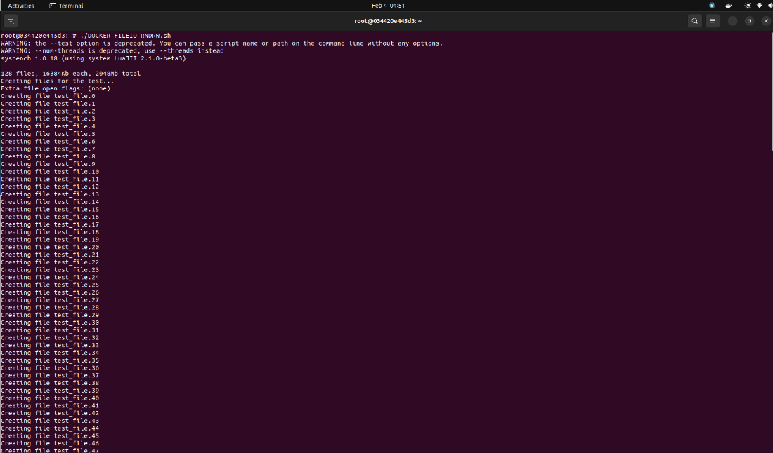

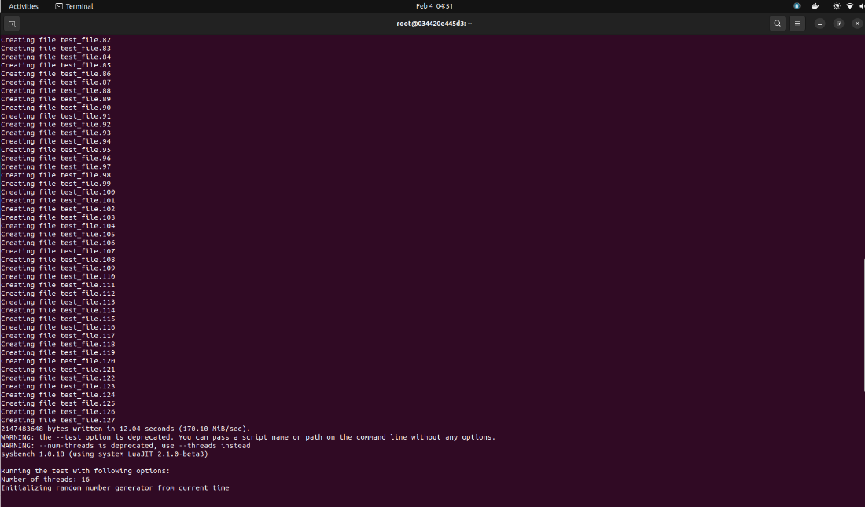

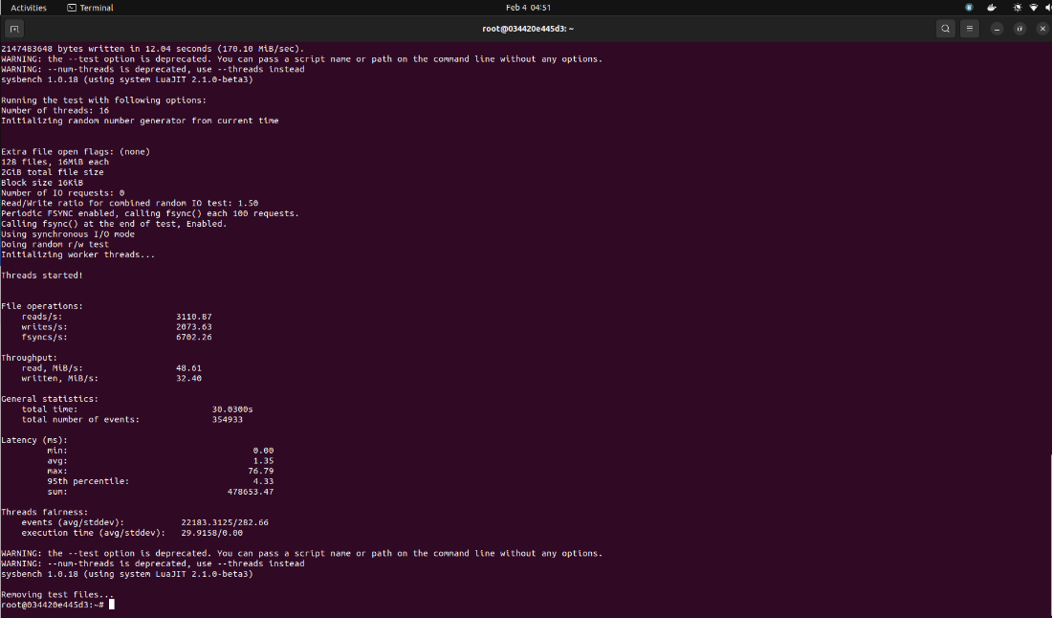

***Iteration 3***

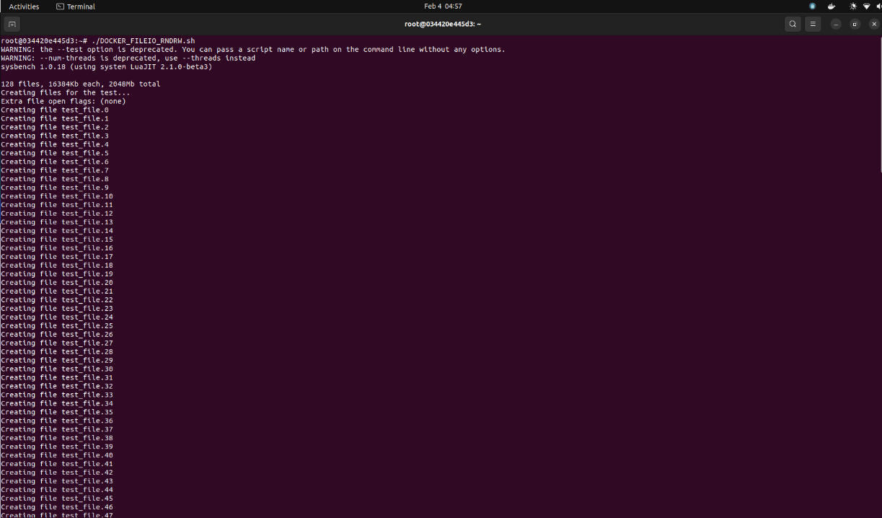

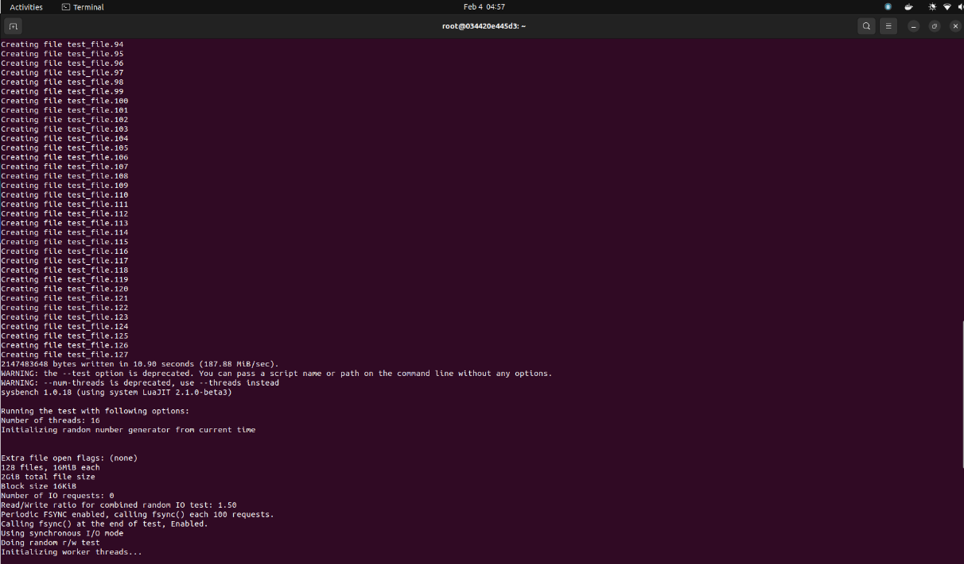

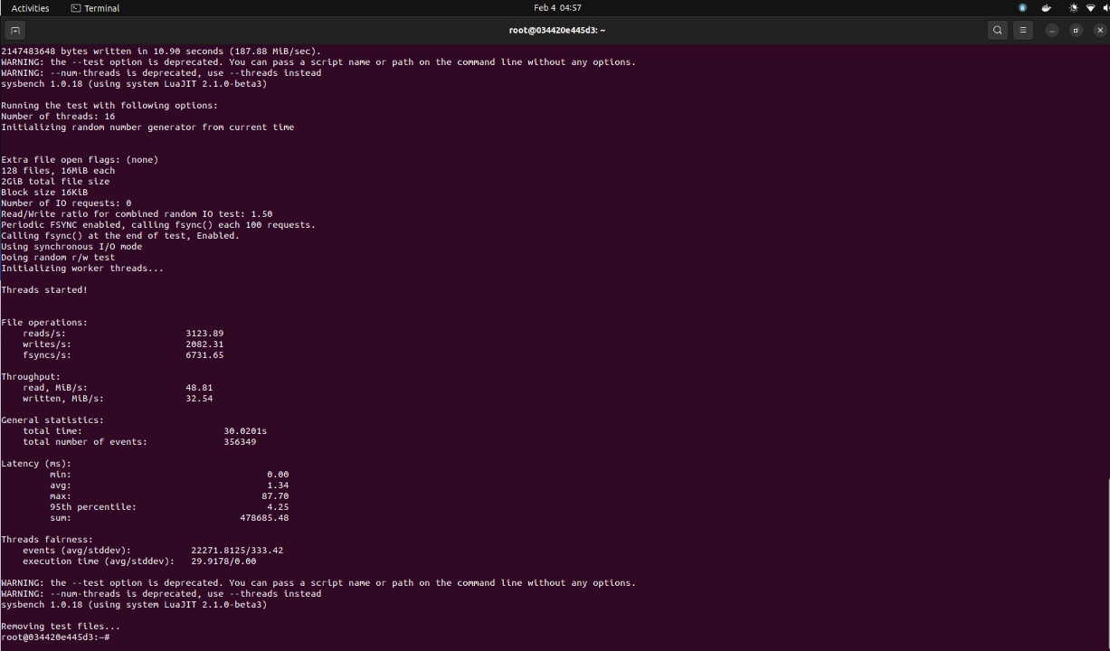

|  |  |  |
| --- | --- | --- |
| Combined run iterations | Results | |
| 1 | reads/s | 3161.79 |
| writes/sec | 2107.58 |
| fsyncs/s | 6809.38 |
| events/s | 12011.31 |
| 2 | reads/s | 3110.87 |
| writes/sec | 2073.63 |
| fsyncs/s | 6702.26 |
| events/s | 11819.28 |
| 3 | reads/s | 3123.89 |
| writes/sec | 2082.31 |
| fsyncs/s | 6731.65 |
| events/s | 11870.35 |

## Conclusion

As we increase the maximum prime number limit from 2000 to 200000, i.e., cpu-max-prime argument value, the number of events per second is decreasing. The same holds true for QEMU and Docker test environments. As we compare the QEMU with Docker, they have very close results and shows that QEMU is slightly faster. If we increase the system resources, there is no significant difference in the performances.

As we could gather, sequential rewrites are faster than combined random read and writes based on the number of events per second, writes per second and file syncs per second. We can additionally say that Docker was faster than QEMU. And even if we increase the system resources, there is no significant difference in the performances.

# Docker Container History

## Image 1: 2 Cores with 2GB RAM (docker_x2_2g)

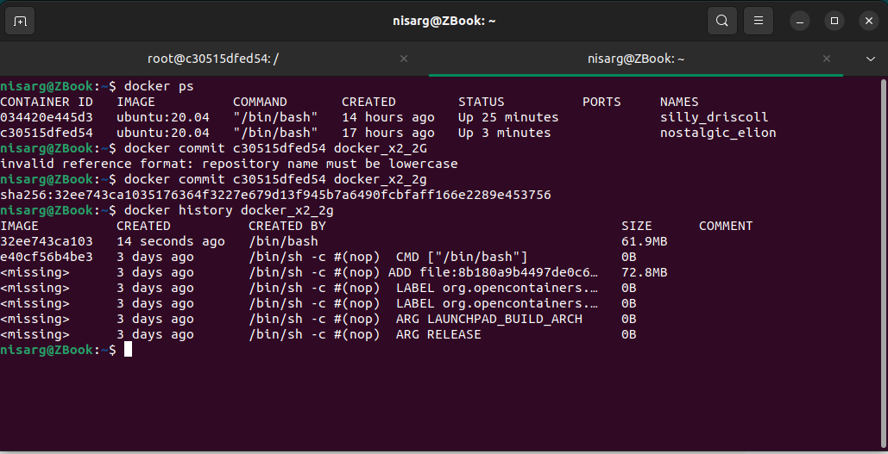

## Image 2: 2 Cores with 3GB RAM (docker_x2_3g)

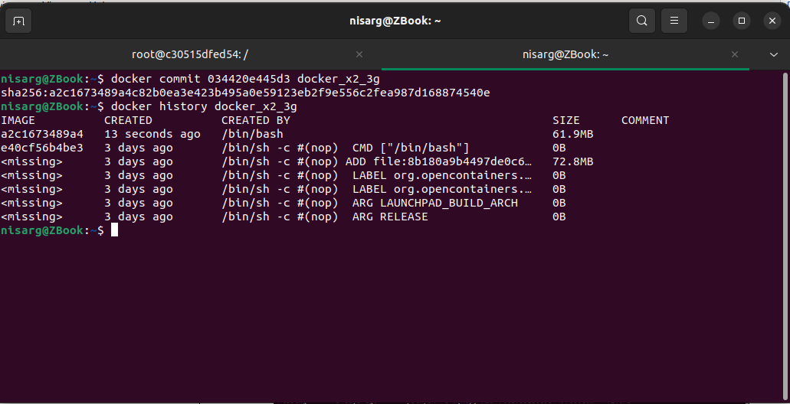

# Performance Analysis

In this section we are listing the disk and CPU utilization for QEMU and docker during the experimentations.

## QEMU Environment

### Disk Utilization

|  |  |  |
| --- | --- | --- |
| Configuration | Test Case | Results |
| 2GB RAM  2 Cores | Sequential Re-write | Read = 0 MiB/s  Write = 2936.75 MiB/s |
| Combined Random Read-Write | Read = 874.02 MiB/s  Write = 582.60 MiB/s |
| 3GB RAM  2 Cores | Sequential Re-write | Read = 0 MiB/s  Write = 3153.10 MiB/s |
| Combined Random Read-Write | Read = 999.73 MiB/s  Write = 666.50 MiB/s |

### CPU Utilization

|  |  |  |
| --- | --- | --- |
| CPU Usage | | 79.1% |
| Kernel Usage | User Level | 13.7% |
| System Level | 9.7% |
| Idle | 63.3% |

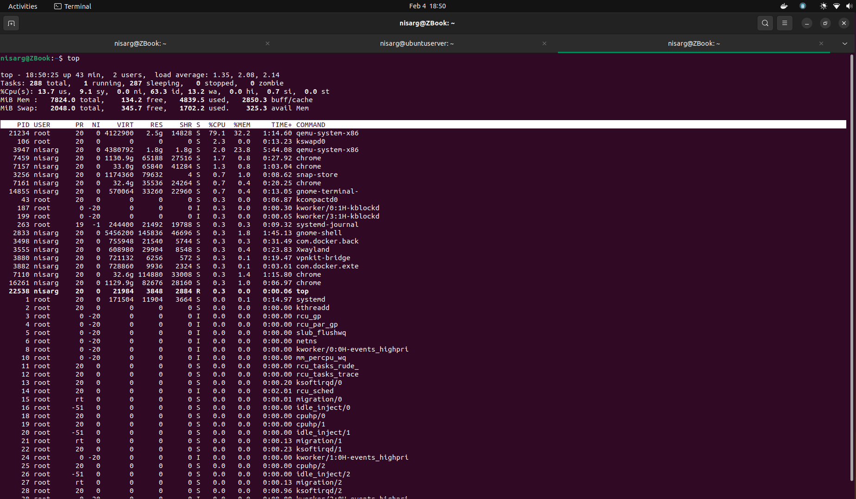

## Docker Environment

### Disk Utilization

|  |  |  |
| --- | --- | --- |
| Configuration | Test Case | Results |
| 2GB RAM  2 Cores | Sequential Re-write | Read = 0 MiB/s  Write = 9048.29 MiB/s |
| Combined Random Read-Write | Read = 3177.89 MiB/s  Write = 2118.37 MiB/s |
| 3GB RAM  2 Cores | Sequential Re-write | Read = 0 MiB/s  Write = 8489.7 MiB/s |
| Combined Random Read-Write | Read = 3132.18 MiB/s  Write = 2087.84 MiB/s |

### CPU Utilization

|  |  |  |
| --- | --- | --- |
| CPU Usage | | 33.3% |
| Kernel Usage | User Level | 38.5% |
| System Level | 30.8% |
| Idle | 23.1% |

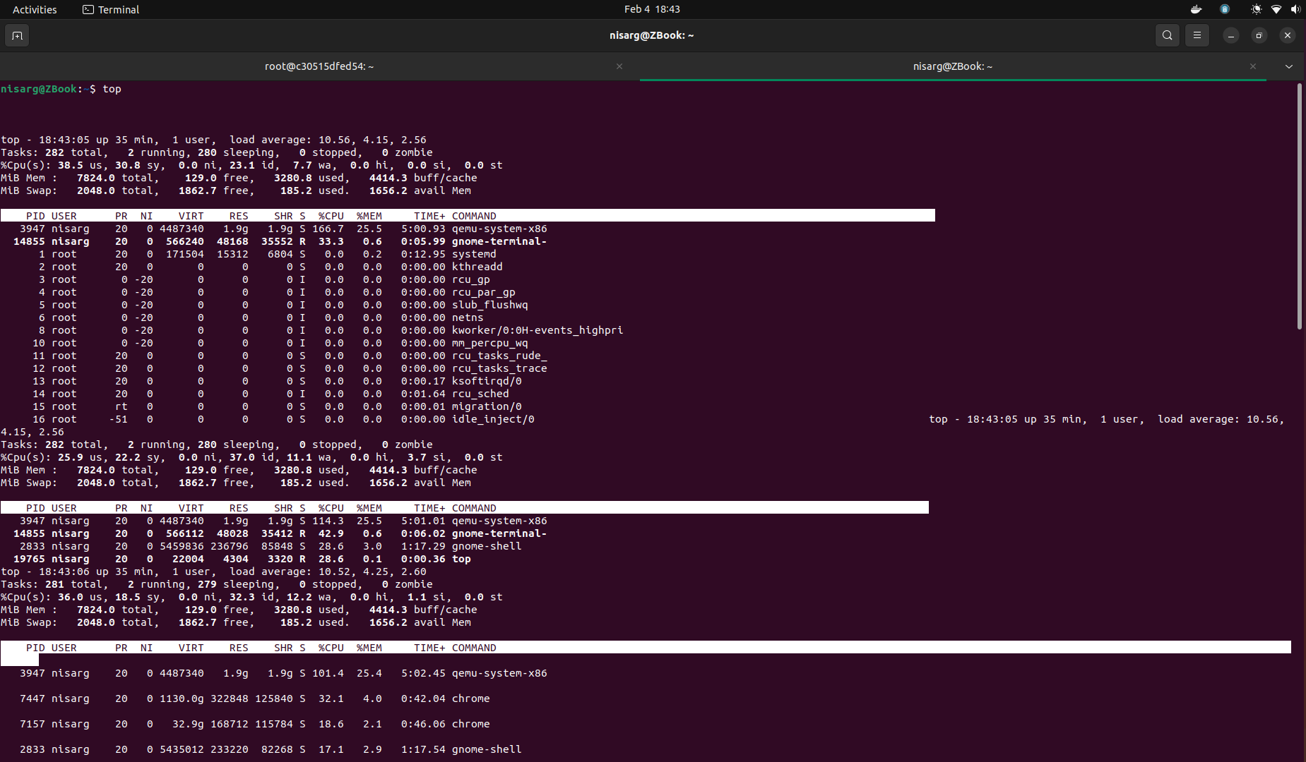

# Extra Credit

## Dockerfile

The dockerfile has config steps for building a docker image from Ubuntu 20.04 version with necessary test scripts. The test scripts and setup scripts need to be placed in the same folder.

$ docker build -f Dockerfile -t new_image .

$ docker run -it new_image

The above commands will build the docker image and spin it up with needed test scripts. We can run the test scripts using below command:

$ bash SETUP.sh

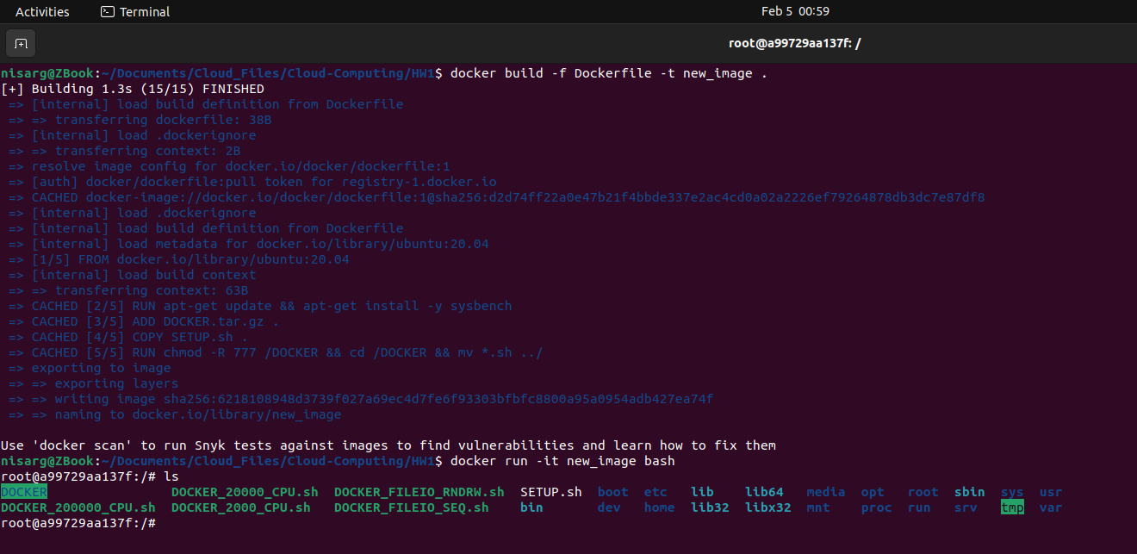

## VagrantFile

The vagrant is a cloud infrastructure resource manager by HashiCorp. It can be provisioned on top of various providers like VirtualBox, VMware, Docker, etc. Here, we have done using VirtualBox has the primary provider using **Ubuntu/Trusty64** as base image.

$ vagrant -v

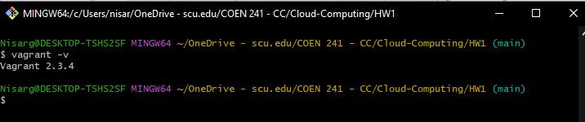

$ vagrant box add ubuntu/trusty64

Now, we need to create a VagrantFile using Ruby’s syntax and then use following command to spin up new VM.

$ vagrant up --provider=virtualbox

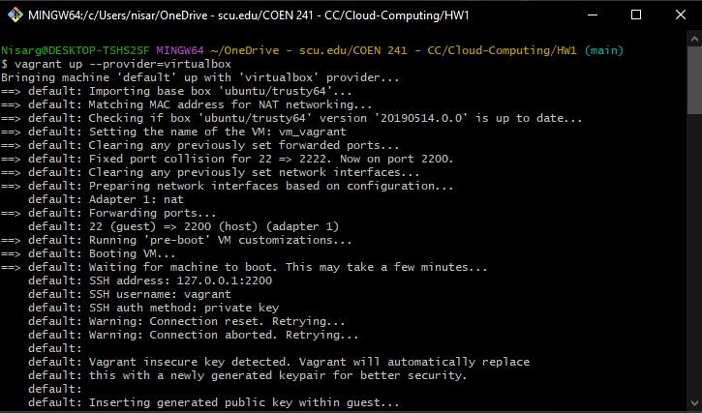

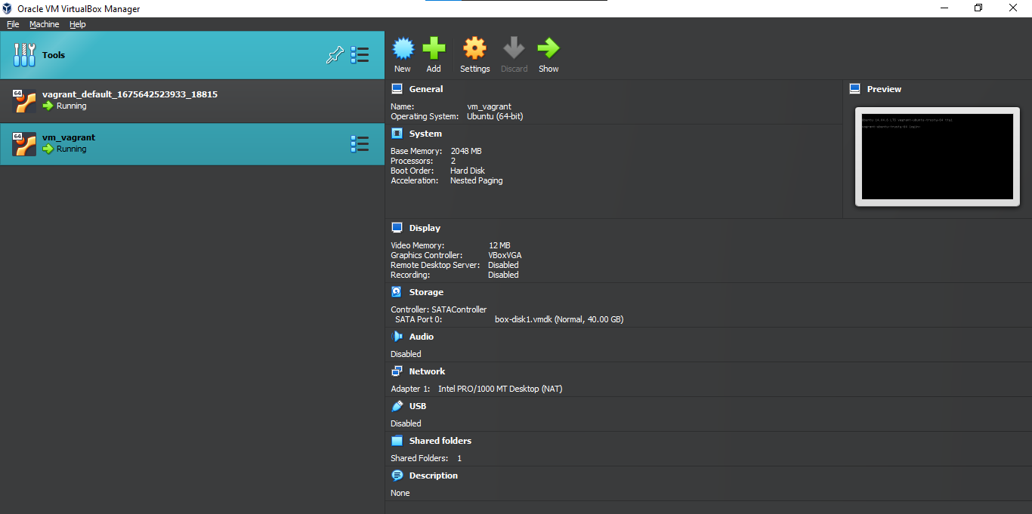

# Git Repository

|  |  |
| --- | --- |
| Account Name | bhalavat-nisarg |
| Repository Name | Cloud-Computing |
| Folder Containing HW | HW1 |
| Link to Repo | <https://github.com/bhalavat-nisarg/Cloud-Computing> |
| Commit ID |  |